Construction Maeconomics Conference 2018

Exceeding of approved budgets of public construction projects, according to categories of buildings

Jakub Stuchlík*1, Jana Frková2

1Czech Technical University in Prague, Faculty of Civil Engineering, Thákurova 7, Praha 6, 166 29, Czech Republic, stuchlik.js@gmail.com

2Czech Technical University in Prague, Faculty of Civil Engineering, Thákurova 7, Praha 6, 166 29, Czech Republic, e-mail address, [frkova@fsv.cvut.cz](mailto:frkova@fsv.cvut.cz)

Abstract

This article presents results of an analysis of key drawbacks in financing of construction projects from public sources in the Czech Republic. A sample of 194 public buildings that were constructed between the years 2008 and 2018 were categorized according to their purpose, architectural similarity and building technology and were analyzed for the most frequent causes of the delay in construction completion and increase in a final cost. More specifically, the buildings were classified into four categories: 1) **transport structures**, e.g. roads, motorways, etc., 2) **water management structures**, e.g. ponds, watercourses, etc., 3) **technological structures**, e.g. power plants, sewage treatment plants, etc., and 4) **other ground structures**, such as schools, apartment buildings etc. In summary, the most frequent reasons for non-compliance with the project budget are, for example, extra work, insufficient geological survey of the building, errors and changes in project documentation, budget deficiencies, or changes in technology during construction.

Keywords

Public building project; budget; non-compliance with the contract price

Introduction

The state should manage the redistribution of public finances in a way leading towards meeting the needs of the wider public, considering state's financial capabilities. Despite the efforts of state to keep maximal control throughout the whole process of public building construction, some serious errors occur repeatedly during the process, such as failure to comply with the contract budget, changes in the budget during construction, insufficient control over the implementation of the construction or changes in legislation, which results in significant cost of the construction itself [1].

The above-mentioned problem occurs not only in the Czech Republic, but also in other countries of the World, as indicated in the work of professor and scientist Bent Flyvbjerg from Oxford's Saïd Business School, who deals with the issue of management and financing of major world construction projects for a long time. Prof. Flyvbjerg has found that nine large construction projects (or “mega-projects”) out of ten are overpriced and, thus, only one such project can be completed in time and without additional costs. The usual increase of a project cost is up to 50% of the total price. As prof. Flyvbjerg adds, the major issues leading to a non-compliance with the contract price are interests of lobbyists, environmental and civic activists' demands, but also the failure of the investor to plan and control the implementation of the construction [2]. A good example can be a new concert hall in Hamburg (Germany), the Elbphilharmonie, which costed about 870 million EUR and took more than a decade to design and build. The construction of the building was officially ended in 2016. The original cost was estimated to 241 million EUR and the construction was scheduled to be finished by 2010. However, the project was exceptionally demanding due to its specific architecture and function, because it was designed to be the best concert hall of the World [3].

This article focused on a categorization of 194 public building objects, constructed in the Czech Republic in a period between 2008 to 2018, followed by analysis of a key events causing cost and schedule overruns.

Methodology

We analyzed a sample of 194 buildings whose financial value ranged from 220 thousand Czech crowns (CZK) to 38 billion CZK. Firstly, samples of the buildings were divided into four categories, according to their purpose, architectural similarity and building technology – **Figure 1**. Secondly the overall costs of similar buildings were compared within each of the four categories and the main reasons of building budget and schedule overruns were summarized.

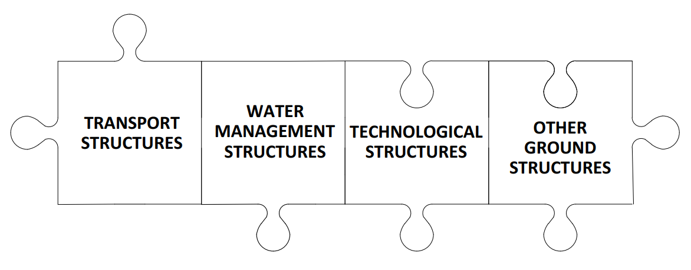

**Figure 1 - Building categories**

The buildings were classified into four categories:

1. **transport structures** - roads, motorways, bridges, metro, railways, railway stations, airports and airport areas, including runways, streets, sidewalks, car parks, public areas, parking areas, noise barriers.
2. **water management structures** - dykes, weirs, dams, ponds and river modifications, waterways including sewerage channels, chambers, harbors and facilities, long-distance pipelines.
3. **technological structures** - boiler houses, power stations, substations, production halls or chemical industry buildings.
4. **other ground structures** - residential houses, family houses, cottages, holiday homes, sports halls, swimming pools, hospitals, nurseries, schools, kindergartens, gymnasiums, sports halls, playgrounds, stadiums, theaters, cinemas, churches, exhibition grounds, department stores, hotels, guesthouses , hostels, office buildings, retaining walls, towers and masts, stables, huts, greenhouses, warehouses.

Among the most important samples in terms of the financial demands of the construction are: the construction of the combined (steam and gas)-cycle of the Počerady power plant, the D8 Lovosice - Řehlovice motorway section, the extension of the metro line “A”, the Blanka tunnel complex or the multifunctional KV arena located in Karlovy Vary city.

Results

Based on the aggregate analysis of samples of structures financed from public funds in the Czech Republic, it was found that, on average, six construction projects out of ten would fail to meet the contractual price.

After the division of the samples into the relevant categories (Table 1), the most expensive projects were found in the category of the transport structures, where seven buildings out of ten failed to comply with the contract price. The very opposite were project in the category of water management structures, where six buildings out of ten adhered to contract prices. The main reason for not complying with the contractual price for each category of buildings are mentioned below in the following text.

**Table 1 - Analysis of compliance with the contractual price of the public construction project budget in the Czech Republic.**

**Transport structures**

Out of 71 projects, some type of error leading to a failure to comply with the contract budget was found in 66% of them, as summarized in the Figure 1.

Examples of projects in this category include the road bypass around the city of Kolín, the Blanka tunnel complex, the I/38 road or the modernization of the Veselí nad Lužnicí - Soběslav railway line.

**Figure 1 – The main reasons of non-compliance with the contractual cost of transport structures, based on our own data analysis.**

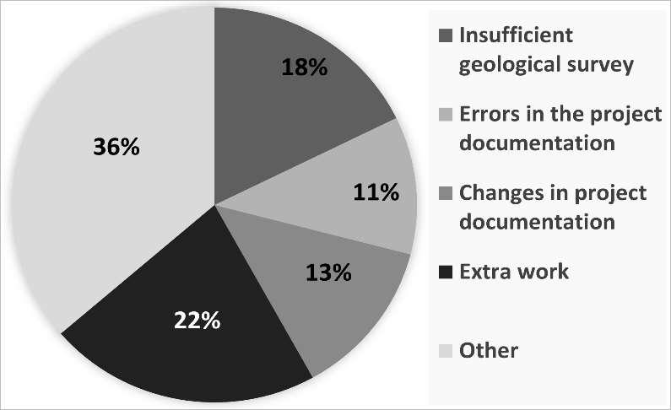

**Water management structures**

Out of the total sample of 14 projects, 43% were found to encompass an error leading to non-compliance with the agreed construction budget, as summarized in Figure 2. Approximately four projects out of ten were in breach of the contractual budget. Examples of projects in this category include: revitalization of Rokytka and Hostavický potok (brook), reconstruction of the pond “Jordán” in Tábor city, a construction of a sewerage system in the village of Půchov.

**Figure 2 – The main reasons of non-compliance with the contractual cost of water management structures, based on our own investigation.**

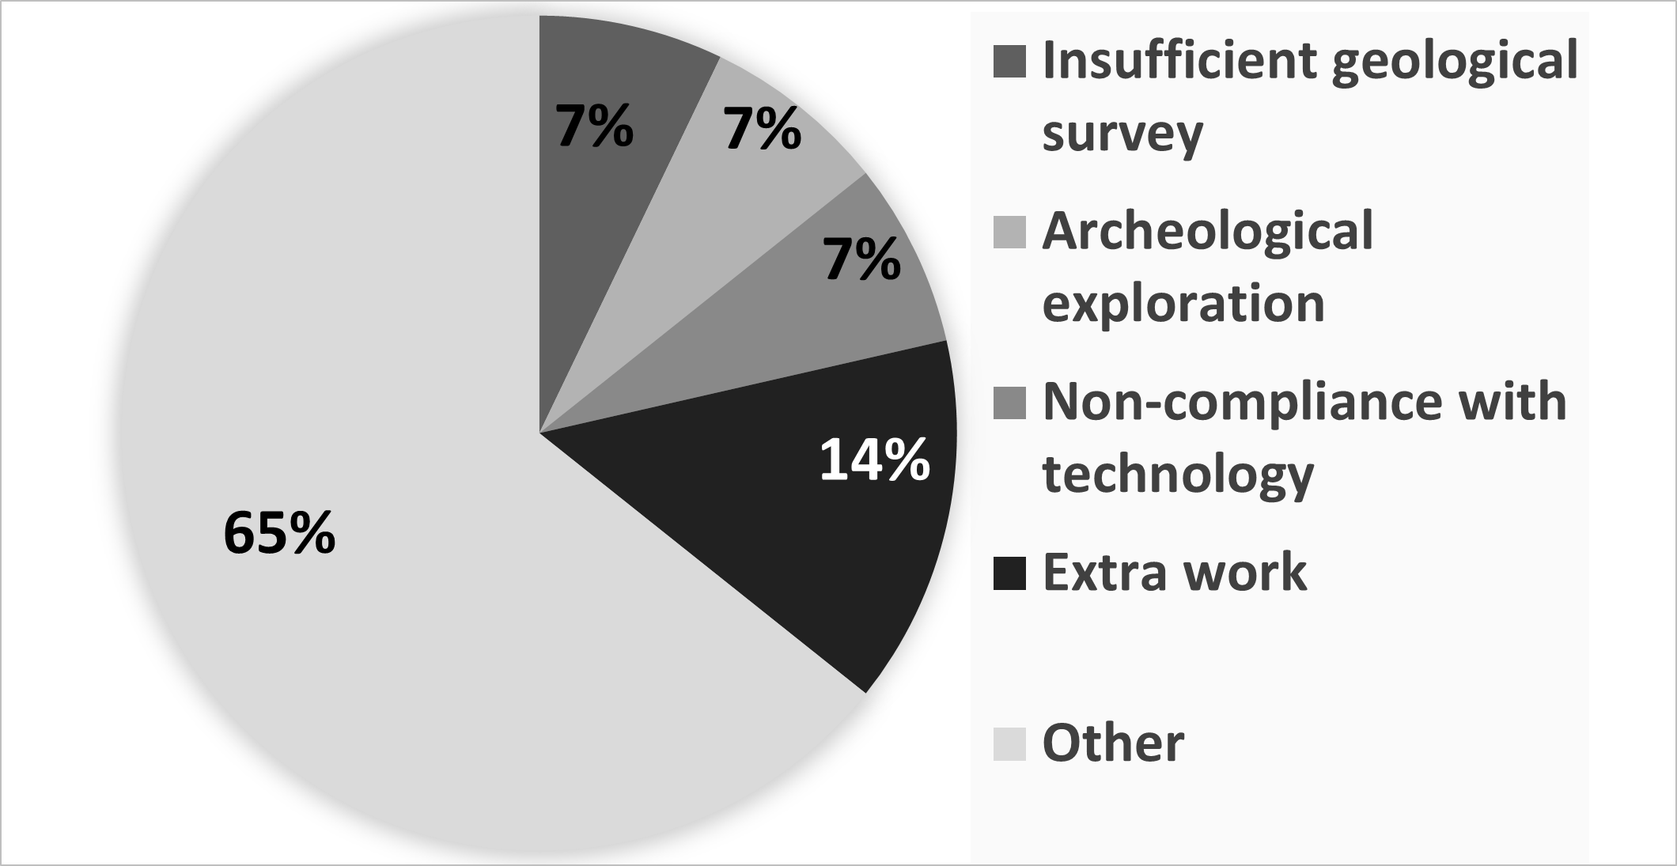

**Technological Structures**

Out of 12 projects analyzed, approximately 50% of them included an error leading to the failure to comply with the contract budget of the construction, as summarized in Figure 3. Five projects out of ten failed to comply with the contract price. This category includes buildings such as ZEVO CHOTÍKOV waste incinerator near Pilsen city, construction of a steam-gas cycle in Počerady, wastewater treatment plant and completion of the water supply and sewerage system in Zdíkov.

**Figure 3 – The main reasons of non-compliance with the contractual price for technological structures. Source - own investigation.**

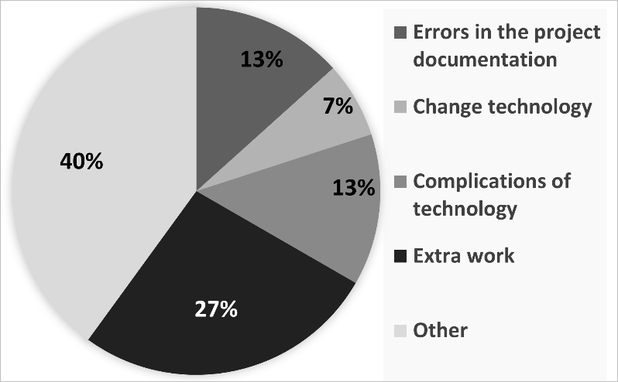

**Other ground structures**

Out of the 97 projects analyzed, about 65% included an error leading to a failure to comply with the contract budget; the main reasons are summarized in Figure 4. Roughly six projects out of ten did not comply with the project contract price. Examples of buildings in the category are: reconstruction of the home for seniors in Děčín, the judicial complex in Brno, construction of the Klatovy hospital, reconstruction of the historical monument of the Municipal Baths in Liberec.

**Figure 4 – The main reasons of non-compliance with the contractual price of the budget for other ground structures. Source - own investigation.**

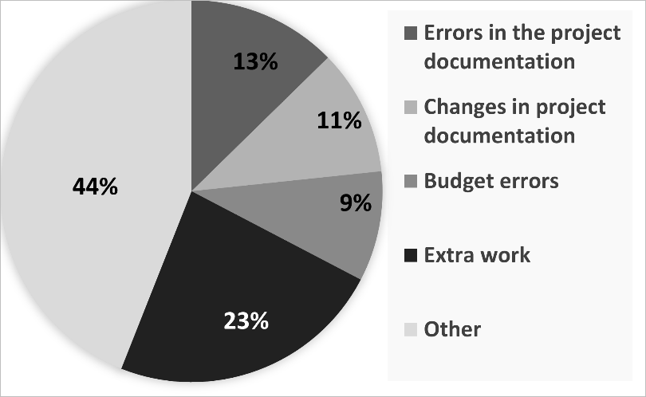

Conclusion and discussion

The paper investigated 194 public construction projects, executed between 2008 and 2018 in the Czech Republic. Samples of the buildings were divided into four categories - according to their purpose, architectural similarity and building technology.

The most frequent project budget overrun was observed in the category of transport structures, where seven buildings out of ten were overpriced. By contrast, in the category of water management structures the rise in budget was observed in “only” four buildings out of ten. Moreover, five technological structures out of ten and six other ground structures out of ten were found to be overpriced.

The main reasons for non-compliance with building budgets were mostly the extra works, errors in the project documentation of buildings, an inadequate geological survey or an archaeological exploration, and also non-compliance with construction technology, budget errors and complications with installed building technology. Other reasons for budget overrun included, for example, climate impacts (floods, frosts), unclear landowners (not explicitly identified), failure to observe the terms of subcontractors, subcontractors' insolvency, civil and environmental activistic organizations, absence of competitive environment for specific construction works, and legislation - value added tax, litigation.

The identified reasons for budget failure in the analysis are consistent with those identified for foreign projects, as Prof. B. Flyvbjerg [4] and Czech investigator Ing. Mirek Sponer [2], who works at the Masaryk University in Brno at the Department of Finance proposed, e.g. exaggerated ambitions of politicians, interests of lobbyists, failure of the investor to plan and inspect the contractors during construction, the method of awarding the tender (applies to the Czech Republic), and lack of invoved experts on the part of the investor. However, these reasons are objectively problematic to prove.

The analysis shows that for each selected category of construction the reasons for non-compliance with the contractual budget may be different. For this purpose, it is necessary to assign the project to the proper category, before starting an analysis of project cost and schedule overruns and comparison of projects with each other. The categorization of currently existing public projects can help to identify the main risk factors that could cause mistakes in planning and execution of a project in a selected category, and thus include precautions to minimize them. The very important actions, necessary for success of the project are especially well-prepared project documentation, proper and detailed geological exploration and the use of appropriate materials during construction of an object. On the other hand, a lack of qualified experts who are able and willing to participate in the project, may represent a major issue that slows down the whole project.

The paper presented a summary of the main reasons of project cost overrun within four categories of buildings, constructed in the Czech Republic, and paid from state funds.

**References**

[1] HROMADKA, V. et al. The efficiency and risks of megaprojects in the Czech Republic. Advances in Civil Engineering and Building Materials IV, 2015, pp. 237 – 240, DOI: 10.1201/b18415-53

[2] TRAMBA, D. Svět v opojení megaprojektů. ekonom.ihned.cz/c1-64326010-svet-v-opojeni-megaprojekty (13. 10. 2018)

[3] Elbphilharmonie. In: Wikipedia: the free encyclopedia [online]. San Francisco (CA): Wikimedia Foundation, 2001 [cit. 2018-10-05]. Dostupné z: <https://en.wikipedia.org/wiki/Elbphilharmonie>

[4] FLYVBJERG,B. What You Should Know about Megaprojects and Why: An

Overview. Project Management Journal, vol. 45, no. 2, 4-5-2014, pp. 6-19, DOI:10.1002/pmj.21409