Construction Maeconomics Conference 2018

**Decision making of municipalities in the current economic situation**

Matěj Buňat*1

1 CTU in Prague, Thakurova 2077/7, Prague 6, 160 00, Czech Republic, [matej.bunat@fsv.cvut.cz](mailto:matej.bunat@fsv.cvut.cz)

Abstract

*The investor, the designer, and the Building authority are subjects who decide about placing new buildings and approval of buildings. There are two possibilities of the placing: either on a greenfield or on a so-called brownfield.*

*Each project has a number of parameters. Each subject uses parameters to decide on the eventual implementation. The investor wants often the lowest prize. The designer wants to meet all the requirements of the investor, and the Building authority permits construction in accordance with the laws and documents issued. Representatives of municipalities must respect all the requirements of the Building Act, including related decrees.*

*The economic situation in the Czech Republic is at a higher level every year, and this is also reflected in the construction. Every year the number of building permits increases, and the total amount of construction works in the S-value is increasing.*

*On the other hand, the number of construction employees is decreasing. This is the reason why the so-called Construction 4.0. is started to be used. The new concept Construction 4.0. can achieve higher levels in towns and cities, avoids construction of new brownfields or the use of existing ones. Even the government inclines to reduce and meaningfully utilize the current brownfields, incl. housing construction.*

Keywords

Brownfield; Construction; Economic; Municipality; *Sustainable development.*

Introduction

The Czech economy has grown at an impressive pace since the second half of the 21st century. Czech construction industry is slowly recovering from the last seven years of economic crisis (2007-2015). This process results in increasing demand for construction works and building new objects (blocks of flats, offices, etc.). However, it is very important to choose the basic parameters of the construction, such as selecting a suitable location for the construction of the building or the price of the project.

Political freedom under construction is not complicated and comparable to neighboring more advanced countries such as Germany, Austria and France. Construction projects are now growing in terms of both financial and frequency volumes (Graph 1), despite the current rise in property prices and the rise in mortgage interest rates. Is it therefore advantageous to use brownfields and continue the construction, when there are many abandoned and unused objects and surfaces in almost every village?

The economic situation in the Czech Republic

The basic parameters for the economic results are shown in Table 1. From these data it follows that the construction of flats, family houses and utility networks is increasing every year. Despite the current problem of rising property prices and rising mortgage rates (interest rates), interest in mortgages is rising. Nevertheless, due to the increase in the CNB's requirements and the increase in real estate values ​​(the price of the loan), the number of negotiated mortgages for the first quarter of 2018 decreased by about 15% compared to last year. On the other hand, the number of construction projects grows annually, both in land and in engineering. The increase in volumes of orders and construction is supported by subsidy programs within the European Union, as well as by the efforts of developers to meet demand. As GDP grows every year in the Czech Republic, it has reached the 53rd place in the world. When added to the current almost zero unemployment, all of this supports at the same time a great demand for own housing.

Tab. 1: Economic indicators in the Czech Republic, according to the Czech Statistical Office [1], own processing.



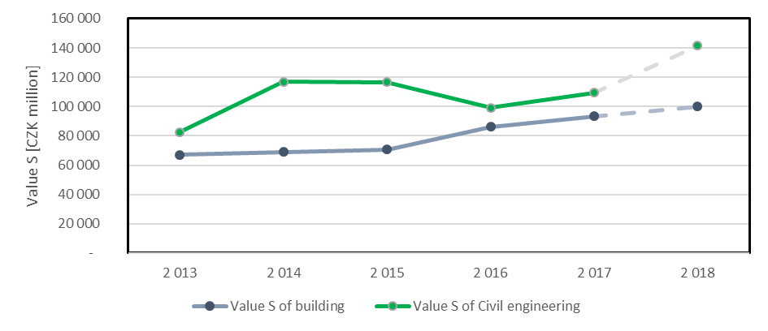

Graph 1: S-value development in the Czech Republic. (source: author)

Construction in Czech Republic

A few subjects are involved in the construction process. Subjects must deal with different construction parameters. Each of the subjects gets into the project at different stages of the construction phase). The following figure (Fig. 1) can be understood as a basic overview.

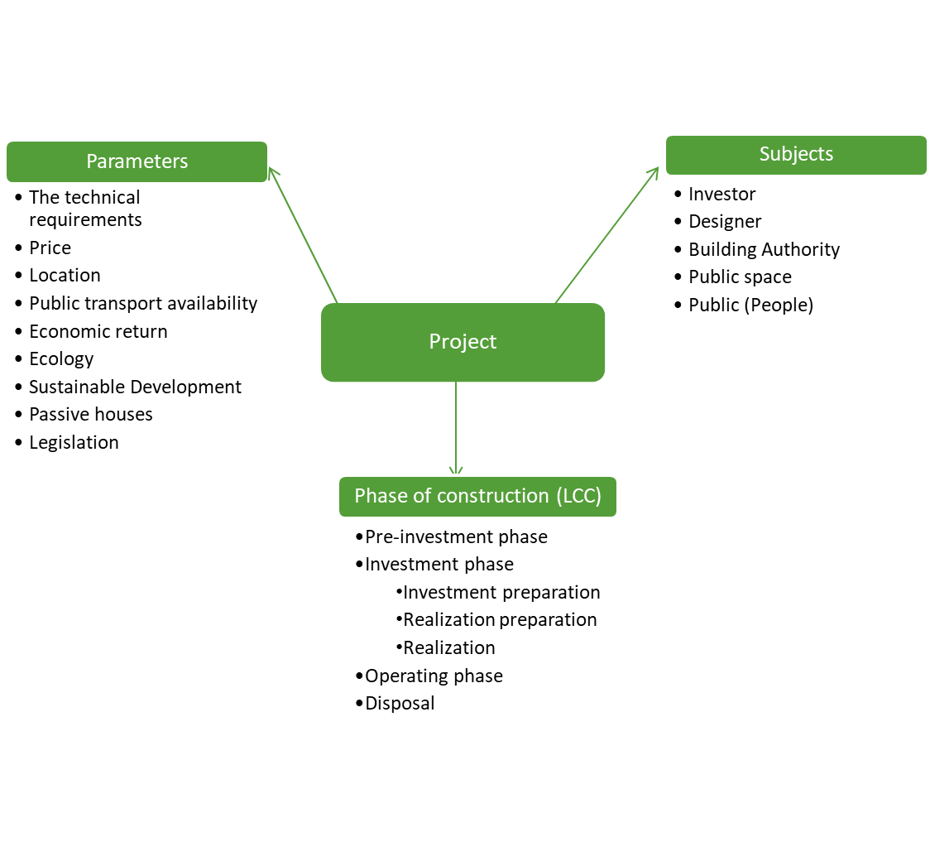

Fig. 1: Phase of construction parameters, subjects and needed for construction. (source: author)

Subjects

The main subjects of construction are not only investors, but also the builder (developer), designer and Building authority, but also the public space and people of the public space (the public). The problem of building new projects in the Czech Republic is largely influenced by the wide ignorance of the rights and obligations of the population. Through its actions, the public decides on the vitality of the physical public space - or its stagnation and decay. Most residents do not check the municipal board and therefore do not comment on new emerging objects. After building, the inhabitants will realize the crucial problem of this construction. After that, it will no longer be possible to destroy or modify the building. For this reason, residents are labeled as "silent" [2].

If the people expressed their opinion on the project in time:

* the problem would not have arisen at all
* the project would be replaced by another project

Parameters for construction

Technical requirements according to the law of the country, architectural features, construction system, passive houses, price, location, connection to public networks, public transport availability, return on investments and many others, always modified and specified for the project.

Another parameter needed for construction should be sustainable development thinking, which is starting to be addressed in developed countries. The basis for the construction and fulfillment of sustainable development is the creation of a territorial plan of different scope.

Spatial planning is and interdisciplinary activity, which offers the possibility of equal cooperation of engineers (in the fields of geodetic work, construction, traffic planning, water industry planning etc.) with architects, biologists, ecologists. Urbanism as a science started at the edge of 20th century [3]. Every municipality holds its own spatial plan and defines its basic framework for using the spaces, which can be divided into urbanized and un-urbanized.

Spatial plans of all extends should correspond with the idea of sustainable development. The theory of sustainable development tries to rebuild man`s relationship with nature. The task of this theory is to sustain the quality of the current and future generation`s lives in terms of time and space. The horizon of time formulates aims of responsibility and solidarity between the generations while the spatial horizon sets these aims for the communities, which share Earth as their homes (continents, regions, states etc.). [4]

The main requirement of the investors is the price, but it is very much influenced by the location in which the construction will be solved. The answer to the investors' basic requirement for site selection is not easy. Almost always there are two basic choices: construction on the so-called brownfield or greenfield land (OBR). That is, building on a greenfield or built-up area (brownfield). In view of all these facts, it is necessary to consider construction on a wider scale and to consider not only new construction (e.g. on a green meadow), but the possibility of revitalizing so-called brownfields.

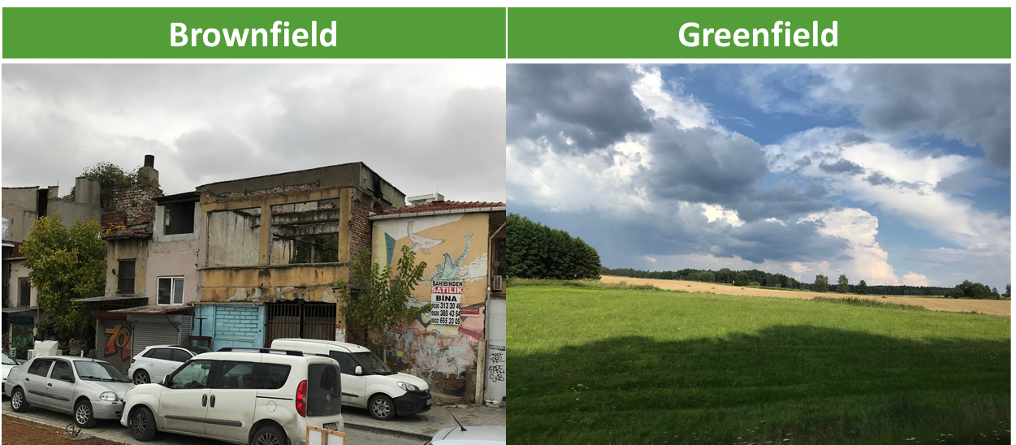

Fig.2: Comparison of the construction on the site brownfield or greenfield. (source: author)

The brownfield issue ([4]; [5]; [6]) is an integral part of the company not only in the Czech Republic but also worldwide; This claim supports the fact that a basic definition was created by a company in England [7]. Because the crucial fact that the brownfield issue is not properly addressed is the fact that there is no major definition. Because one is a multidisciplinary problem and each of the individual sectors adapts to its field, and nobody wants to define a clear one.

The situation abroad is very similar. There is little interest in the scholarly literature in connecting the topic of brownfields with economy. American authors [7] for example have troubles with defining brownfield, they base their definition on the degree of contamination of the areas and focus on counting the growing costs connected with revitalization of such areas, these costs grow as there is high pollution of the rock base. There authors [9] then search for solutions of the situation. In other articles it is concluded that using greenfield is the more effective choice of construction, because of the time needed for transport of the material through the city and because of possible reduction of greenhouse gases and pollution [10]. There is also no effective brownfield database. The benefit of such database is undoubted.

Positive and negative effects of construction on greenfield or brownfield

Positive and negative influences can be understood as positive or negative consequences of construction. Each construction brings with it countless positive things, such as new use of space, the construction of a missing infrastructure, a place to meet and meet people, a new cultural center, a new training center, a new apartment building. It is very often about the life of the inhabitants, the possibility of their development and the satisfaction of their needs. In some cases, the schema can be broken down because each project is original and therefore one single true variant can not be determined. However, with almost every positive influence, there is a negative effect on another subject. [5] To illustrate the positive and negative influences of construction on green meadow or brownfield, the following table was created (Tab. 2)

Tab. 2: Positive and negative influence of construction on brownfield or greenfield [4].

|  |  |
| --- | --- |
| Positive influences | Negative influences |
| Construction on the so-called greenfield | |
| Economic efficiency  Speed of construction  Creating a new part in an ideal urban layout | The necessary introduction of a new urban engineering  Refuse the perspective of object in cities  Sustainable Development and Environment |
| Construction on the brownfield | |
| Existence of transport and technical infrastructure  Possibility to develop densely built-up areas  Possibility of obtaining subsidies from public budgets  The public (increasing the reputation of the company)  Sustainable Development  Environment | Ownership relationships  A necessary multidisciplinary solution  Insufficient institutional support  Technological changes  Financial difficulty |

The result that revitalization of brownfields is beneficial from the environmental point of view. On the other hand, for the investor it means extension of the construction and not only the process of construction itself but also the time of pre-construction phase extends. Another negative effect is the owners of the surrounding lands do not have to agree with the construction on the brownfield. Regarding economic point of view, it depends very much on the point of view applied. From the investor`s point of view construction on brownfield can cause higher expenses but for the municipality (the state budget) it means lowering the costs as in the construction phase but also in the phase of following usage. When construction on a greenfield is taken into consideration is to be considered it is more convenient for the investor in terms of the pre-construction phase as well as the construction phase and furthermore for the investor there is the possibility of lowering the economic severity. [5]

According to CSU [1], the brownfield renewal price is on average 10% higher than greenfield construction. However, given the sustainable future, renewal is more than beneficial. Whether to repair the building itself or just use individual components (building materials or components) to recycle and reuse them.

When creating adequate grant programs, the same or lower total construction cost may occur. These programs can also be created by municipalities themselves. Because proper development should be one of the decision-making criteria to be addressed by the municipality.

Result of evaluation of construction projects

In general, every project can be evaluated from several points of view. A specific field of evaluation is following the rules, which are usually related to as 3E. Abbreviation 3E stands for economy, efficiency and effectiveness (Fig. 3). [5]

Fig.3: Princip of 3E.[11], own processing.

The 3E method considers minimalizing of expenses important when evaluating a construction as well as the economy of the building, it also seeks for using such means, so they are on optimal degree of gaining the aims. The efficiency along with using the means for best possible outputs is also taken into the process of evaluations. [11]

Conclusion

Every village in the world has been and still is developing according to a plan. For example, it is evidenced by the fragmentation of the old oriental table depicting the city of Nippur from the 2nd century BC. [12]. If that were not the case, there would be cities without schools, hospitals, or multi-user shops. Therefore, the lack of co-ordination would not prosper. It would be desirable to reduce the number of brownfields. At the same time, it would also raise the city's level.

A frequent objection of investors against construction on the brownfield plot is an increasing construction price. This is proven due to the completed construction. However, this is not a prerequisite, and there are also constructions that have subsequently been cheaper due to the use of parts of original buildings. Due to rather higher prices, it would be appropriate to create adequate grant programs. Subsidies may result in the same or lower total construction cost. These programs can also be created by municipalities themselves. Because proper development should be one of the decision-makers' criteria for the municipality to deal with.

According to the Czech Statistical Office [1], several building permits are being issued annually for reconstruction than for new construction. This makes it possible to state that people are interested in quality housing. Thanks to this we can also expect great interest in quality public space. Recent public opinion surveys conducted by IPSOS [13] show that almost 60% of Prague citizens strongly or rather believe that the metropolis should be built more. However, Prague will not be changed by new construction. This confirms the initial statement on the growing demand and use of brownfields to make the whole community more efficient.

In its own interest, the municipality should not only try to reuse existing brownfields, but also reduce the emergence of new ones. One of the appropriate options to prevent the emergence of new brownfield can be the usage of wooden constructions [14].

Another fact about construction industry is the reduction of the number of employees and the decrease of the number of students at the faculties of building schools. One reason for this is the gradual shift in robotization and cybernetics of some building practices. However, if new high-quality projects begin to be created, new brownfields can be confined within Construction 4.0. This is mainly due to better operation and possible repairs and maintenance.

References

1. ČSÚ. Stavebnictví. *Český Statistický Úřad* [online]. [cit. 2018-07-20]. at: <https://www.czso.cz/csu/czso/stavebnictvi>
2. VANĚK, M., ed. *Obyčejní lidé--?!: pohled do života tzv. mlčící většiny : životopisná vyprávění příslušníků dělnických profesí a inteligence*. Praha: Academia, 2009. Historie (Academia). ISBN 978-80-200-1791-8.
3. MAIER, K. Udržitelný rozvoj území. Praha: Grada, 2012. ISBN 978-80-247-4198-7.
4. BUŇAT, M. *Vliv implementace brownfield v městském inženýrství*. Praha, 2018. Diplomová práce. ČVUT
5. BUNAT, M. ALL-SOCIETY ECONOMIC BENEFITS THROUGH USAGE OF BROWNFIELD. *Business & IT*. 2018, **VIII**(1), 42-53. DOI: 10.14311/bit.2018.01.05. ISSN 25707434. at: <http://bit.fsv.cvut.cz/doi/bit.2018.01.05.html>
6. Brownfields příručka. In: Brownfields příručka [online]. [cit. 2017-04-17]. at: <https://fast10.vsb.cz/lepob/index2/handbook_cz_screen.pdf>
7. Cabernet. Cabernet [online]. [cit. 2017-03-20]. at: <http://www.cabernet.org.uk/>
8. ALBERINI, A., A. LONGO, S. TONIN, F. TROMBETTA, and M. TURVANI. The role of liability, regulation and economic incentives in brownfield remediation and redevelopment: evidence from surveys of developers. Regional Science and Urban Economics. 2005, 35(4), 327-351. DOI: 10.1016/j.regsciurbeco.2004.05.004. ISSN 01660462.
9. AMEKUDZI, A. a I. FOMUNUNG. Integrating Brownfields Redevelopment with Transportation Planning. Journal of Urban Planning and Development. 2004, 130(4), 204-212. DOI: 10.1061/(ASCE)0733-9488(2004)130:4(204). ISSN 0733-9488. at: http://ascelibrary.org/doi/10.1061/(ASCE)0733-9488(2004)130:4(204)
10. ELLERBUSCH, F. Brownfields: Risk, property, and community value. Local Environment. 2006, 11(5), 559-575. DOI: 10.1080/13549830600853486. ISSN 1354-9839. at: http://www.tandfonline.com/doi/abs/10.1080/13549830600853486
11. VLÁDA ČR. Metodika dodržování principů účelnosti, hospodárnosti a efektivnosti při hospodaření s veřejnými prostředky: Návrh. at: <http://www.korupce.cz/assets/protikorupcni-strategie-vlady/na-leta-2013-2014/metodika-dodrzovani-principu-3E---navrh.pdf>
12. PFAUNTSCH, R. Der Ingenieur als Stadtplaner: (Inženýr jako urbanista). In: Městský inženýr - městský architekt. Praha: Grand, 2017, ISBN 978-80-87438-88-6.
13. *Ipsos* [online]. 2017 [cit. 2018-10-14]. at: <https://www.ipsos.com/cs-cz>
14. BUŇAT, M. Využívání dřevěných konstrukcí z důvodu snižování vzniku brownfields. In: Dřevěné konstrukce a energeticky úsporné dřevostavby. Praha 6: České vysoké učení technické v Praze, Fakulta architektury, 2018, s. 8. ISBN 978-80-01-06468-9.