Construction Maeconomics Conference 2018
The teritorial energy politics according the Act 103/2015 Coll. Energy management
Michal Bačovský¹
¹The Czech Technical University in Prague, The Faculty of Civil Engineering, Thákurova 7, 166 29 Prague 6, The Czech Republic, bacovm1@fel.cvut.cz

Abstract
This article investigates the current state of the Territorial energy policies which are the basic documents for energy policy in the regions of the Czech Republic. The Territorial energy policies (TEPs) are required by the Act No. 103/2015 which is valid since July 2015. The region councils have the deadline to create the TEP of their region till the 4 years. The article overview the actual TEP in all the regions of the Czech Republic, compare the TEPs from different regions and suggest different approach to energy policy in the regions. The article reviews the current state of the TEP in all the regions.

Keywords
Territorial Energy Policy; State Energy Policy; Act No. 406/2000 Coll., on Energy Management; goverment regulation No. 232/2015 Coll., on the State Energy Policy and Territorial Energy Policy

Introduction
The energy policy becomes very important during the last years. The energy generation, distribution, consuming and energy pricing is both international and national topic. The collateral problems as greenhouse gases emissions, environment pollution and strong interest of general public enhanced the complexity of this issue. All participants (mainly energy suppliers, distributing companies, consumers, price makers, environment savings representatives) are interested on stable and transparent energy policy established in the long term perspective. This is a necessary condition for an adequate investment returning, the energy industry development, affordable energy price for final consumers and responsible environment protection.
The energy policy in the Czech Republic is ruled mainly by the Act No. 406/2000 Coll., on Energy Management (Act) and following government regulations and other relevant documents. Main ideas of the state energy policy are described in the State Energy Policy (SEP). To ensure the fulfilment of its long-term vision the SEP defines the Czech Republic’s strategic energy objectives and sets out strategic priorities within the term specified by law and also for the period in which there is usually an economic return on investments in all types of sources and networks and in which the basic characteristics of future development can still be reasonably predicted [1].
The Government of the Czech Republic approved the updated version of the SEP for the following 25 years in the May 2015. The main reason for the update of the SEP and its subsequent approval is a need for clearly formulated priorities and strategic objectives in the energy sector. This should give the stability to investors, citizens and state authorities in this highly turbulent and dynamic period [2]. Consequently the Act needed to be revised in order to reflect actualized SEP. The Act was amended and revealed as Act No. 103/2015 Coll. on Energy Management (in the next text Act No. 103). The Act No. 103 is valid from 1st July 2015.
The SEP contains the strategic energy priorities on the whole republic level and does not describe the local topics of energy policy. These should be detailed in the Territorial Energy Policies (TEPs) specified for each region of the Czech Republic.
The Czech Republic is divided into 14 regions (see the Figure 1 below), which are represented by the region leader and leaded by the region council. The region councils are partially independent on central government and can manage activities relevant for their regions and without influence to the others regions. According to the Act No. 103 the region council should create the TEP concerning the general approach to the energy policy formulated in the SEP. However TEP should be tailored for region needs and specifications with the perspective of 25 years. The TEP fulfilment should be reported with the period of 5 years to the Ministry of Industry and Trade (in the next text Ministry). The obligatory TEP structure is given by the government regulation No. 232/2015 Coll. on the State Energy Policy and Territorial Energy Policy (in the next text regulation No. 232 only). The regulation No. 232 is valid from the September 2015 [3]. The TEP is reviewed by the Ministry before is published on the region council website.
The very first TEPs were created according the Act after during the year 2001. The Act required that time TEP should be crated in the perspective of 20 years. The region council had to report to the Ministry the TEP fulfillment in regular 4 year basis. The content of TEP was described in government regulation No. 195/2001 Coll. The TEP was not reviewed by the Ministry before publishing.
The contemporary TEP is complex document approximately 200 – 300 pages including appendix. The TEP of given region is created by the private energy agency chosen by the public tender which is organized by the city council. The duration of TEP creating varies from 9 months to 15 months. The TEP creating is found by the city council and usually price is near to 1 million CZK. The city council can apply for dotation to cover the TEP costs. The semifinal version of the TEP is reviewed by the Ministry and the Ministry of the Environment. The Ministry verified the concordance between TEP contents and regulation No. 232 and the Ministry of the Environment conducts the Strategic Environmental Assessment. The final TEP is confirmed by regional council. Consequently the TEP published on website.

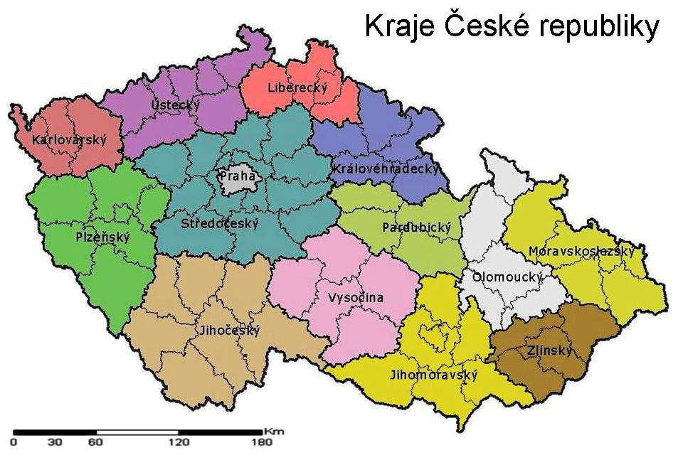
Figure 1: the regions of the Czech Republic; (source: http://www.zemepis.com/krajecr.php)
Methodology
The exploratory method was used to find the most actual version of TEP for each region. The TEP is public document and can be found on website of each regional council. The compare method was used to compare the content of the TEP from different regions. These comparing criteria were used:
a) the TEP author
b) the funding source
c) the recommendations in the TEP
d) the specific suggestions.

The TEP author is crucial for the quality of the TEP. All the authors must follow the given structure of the TEP chapters however there are many opportunities how to cope this task. The funding source has strong influence to the city council motivation for useful TEP. The recommendations included in TEP are the most important output for the city council and are the message of the TEP. The specific suggestions are a bonus which is not required. The suggestions show the level of author activity and professionalism.
In case the TEP is being prepared during the research, the business contract between the regional council and the TEP author was searched. The business contract of this type is a public document and should be available online in the Contract Register.
Results
The results overview is summarized in the table 2 below. The TEPs which meet the Act No. 103 and the government regulation No. 232 were finalized and published in 3 regions only (Vysočina, Olomoucký, Karlovarský). These three TEPs were compared. The TEP for Vysočina region was created by energy agency SEVEn Energy s.r.o. It was founded throw regional budget. The recommendations contained in the TEP reflect the region conditions – enhanced use the heating pumps and photovoltaics energy plans mainly for households in order to reduce energy demands. The TEP contain two specific suggestions – to build the heating supply system from nuclear power plan Dukovany to the town Brno and the heating supply system using vast heat from private factory KRONOSPAN in the town Jihlava. Brno is the second biggest town in the Czech Republic having 380 000 inhabitants. Jihlava is the capital town in Vysočina region having 51 000 inhabitants. The proposed heat supply system could cover the 30 % of total heat demand in Jihlava [4].
The TEPs for Olomoucký region and Karlovarský region do not contain any specific recommendations except of obligatory general formulations which do not reflect the region conditions [5], [6].
The TEP of Liberecký region was approved in the year 2015 short time before the Act No. 103 was revealed. The TEP of Liberecký region was not overwritten, because the Act No. 103 permitted to create new TEP within 4 years since the Act No. 103 was revealed. The actual version of the TEP of Liberecký region cannot be compared with the TEPs from other regions [7]. The similar situation was in Zlínský region, where the TEP was confirmed in July 2015 [8].
The TEP in the Prague was approved in the year 2013. The revised version according to the Act No. 103 was not found.
The TEP creation in the 6 regions (Středočeský, Moravskoslezský, Jihočeský, Kralovéhradecký, Ústecký, Jihomoravský) was began this year and the results will be published during the autumn 2018 or next year. All the TEPs of these regions will meet the Act No. 103 and the regulation No. 232.
The TEPs of the Plzeňský region and the Pardubický region are obsolete (from 2004 resp. 2003) and the revised versions of the TEPs should be prepared. However any information about actual version of the TEP nor about any progress in this matter was found on the website. The Contract Register does not contain any business contract for TEP neither for the Plzeňský region nor the Pardubický region.
Table 1: The overview of current state of TEPs in all regions
region | TEP validity |  | TEP author | TEP financial source | the recommendations | specific suggestions | note
Vysočina | 2017 | 2045 | SEVEn Energy s.r.o. and Energetická agentura Vysočina | regional budget | heating pumps; photovoltaics | HSS from Temelín; HSS from Kronospan factory
Praha | 2013 | 2033 | SEVEn Energy s.r.o. and Enviros s.r.o. | regional budget |  |  | managerial summary 21 pages
Středočeský | 2017 | 2041 | ENERGO-ENVI | - |  |  | will be published 12/2018
Moravsko-  slezský | 2020 | 2044 | Enviros s.r.o. |  |  |  | will be published 12/2019
Olomoucký | 2015 revision | 2040 | SEVEn Energy s.r.o. | Government program for supporting energy efficiency and renewable sources in 2016 | biomass;  wind power plants; photovoltaics; heating pumps | no
Karlovarský | 2017 revision | 2042 | E-resources, s.r.o. | Efekt | biomass; wind power plants; photovoltaics | no
Liberecký | 2015 revision | 2035 | Enviros s.r.o. | - | without details: heating pumps; photovoltaics; biomass | no | finished in 10/2015
Jihočeský | 2018 | 2043 | SEVEn Energy s.r.o. |  |  |  | will be published 12/2018
Kralovehra  decký | 2017 revision | 2040 | ENERGO-ENVI |  |  |  | will be published 12/2018
Ustecký | 2019 | 2043 | Enviros s.r.o. |  |  |  | will be published 3/2019
Plzeňský | 2004 |  | Tebodin Czech Republic s.r.o. |  |  |  | no information available
Pardubický | 2003 |  | EVČ s.r.o., CITYPLAN s.r.o. a ViP s.r.o. |  |  |  | no information available
Zlínský | 2014 revision |  | ENERGO -ENVI |  |  |  | confirmed in 7/2015
Jihomorav ský | 2018 | 2043 | SEVEn Energy s.r.o. |  |  |  | will be published 11/2018
Conclusion and discussion
The TEP should be basic document for energy policy in the given region for long term perspective. The TEP covers next 25 years and should meet the SEP. The TEP structure is defined by regulation No. 232 in order to include all important topics of regional energy policy. The TEP is reviewed by the MIT and the Ministry of Environment. The region council should report on regular basis the fulfillment of its TEP. The whole process of TEP creating and it’s result reviewing should ensure that TEP will be helpful for the region council and will be used for energy policy managing.
The TEP (as other strategic documents) is as useful as it helps to make good strategic decisions. The factors important for TEP were identified.
The motivation to create TEP is external. The TEP creation is required by the Act No. 103 and its content is given by the regulation No. 232 regardless the regional needs or abilities. The external motivation implicates usually the worse results comparing to the internal motivation.
The TEP is created by the energy agency which is external body to the city council. The energy agency is chosen by the public tender organized by regional council and meeting the Public tender Act. This Act do not allows any quality criteria to measure the applicants’ offers without risking any conflict with unsuccessful applicants. Only safe criterion is the offered price of the TEP creating.
The quality of applying energy agency can be assessed by the references and by the working team members’ qualification. The references are usually the strategic documents relevant fo energy politic or similar issue, which were created by the agency. The city council set the number and the maximal age of references in the conditions of public tender. The problem is that regional council cannot measure the quality of referenced documents. In case the regional council try to measure them, this effort will be unsuccessful because of quality criteria cannot be used. The team member qualification measurement is the same problem. The qualification minimal level can be set, however any applications above this level cannot be compared for better applicant choice.
The TEP costs can be found from regional budget or from the government dotation program called “Efect” ruled by the Ministry. The regional council can send the application to the Ministry and can expect with reasonable certain the finance. Considering this, the regional council is highly motivated to apply for dotation. On the other site the financial source for the TEP is not owned by the regional council and the motivation to watch the value for the money is reduced. The quality of the TEP is not crucial. In contrast the final version of the TEP must be approved by the city council. In other case the dotation finance would be returned to the Ministry.
All the TEPs should reflect the SEP and therefore all TEPs contain same recommendations as formulated in the SEP. The renewable sources using as far as it is economical and energy efficiency increasing especially by the building energy losses reducing. The differences are only the intensity of usage both this instruments. The Czech Republic is so small that one type of the recommendation is relevant for the whole area.
Any region of the Czech Republic cannot ensure all it’s energy needs independently to the other regions. There are regions which produce more electric energy (typically regions with nuclear power plans). All the regions are connected by the electric distribution net.
The TEP focused on the regional energy policy, however the most energy sources, distribution nets and energy consumers are private or state owned. The city council has very few instruments how to influence their energy management. Only estates owned by the regional council are high schools, hospitals and administrative buildings. The energy efficiency of these buildings is enhanced mostly by the measurement founded from government dotation programs (e.g. Efect, New green saving, heating source dotation, ect). The region council is reduced to applicant and administrative role. The energy management of the towns in the region is leaded by the city mayor without significant regional council influence.
The Slovak Republic with very similar energy infrastructure (70 years the part of former Czechoslovakia) does not use any territorial energy politics. The energy policy of the Slovak Republic is summarized in the “Energy policy of the Slovak Republic” created by the Ministry of Economy of the Slovak Republic [9]. The Austria does not use any territorial energy policies as well.
According to the author’s opinion the TEPs created separately for 14 regions of the Czech Republic should be replaced by one general SEP with brief chapters dedicated to each region if necessary. The quality of this overwhelming document will be guaranteed directly by the MIT and Ministry of Environment. The Czech Republic is too small to create 14 semi-independent documents about energy policy.

References
[1] The State Energy Policy. Ministry of Industry and Trade. Available online at: https://www.mpo.cz/assets/dokumenty/52841/60946/636123/priloha001.pdf (accessed 28th Sep. 2018)
[2] Ministry of Industry and Trade website. Ministry of Industry and Trade. Available online at: https://www.mpo.cz/en/energy/state-energy-policy/state-energy-policy--233258/ (accessed 28th Sep. 2018)
[3] Government regulation No. 232/2015 Coll. On the State Energy Policy and Territorial Energy Policy. The Government of the Czech Republic. Available online at: https://www.zakonyprolidi.cz/cs/2015-232 (accessed 12th Sep. 2018)
[4] Územní energetická koncepce kraje Vysočina, aktualizace 2017. Kraj Vysočina. Available online at: https://www.kr-vysocina.cz/assets/File.ashx?id_org=450008&id_dokumenty=4089004 (accessed 13th Sep. 2018)
[5] Územní energetická koncepce Karlovarského kraje, aktualizace 2017. Kraj Vysočina. Available online at: https://www.kr-karlovarsky.cz/samosprava/dokumenty/Stranky/koncepce/oblast-zivotni-prostredi/uzemni-energeticka-koncepce.aspx (accessed 13th Sep. 2018)
[6] Územní energetická koncepce Olomouckého kraje, aktualizace 2017. Olomoucký kraj. Available online at: https://www.kr-olomoucky.cz/uzemni-energeticka-koncepce-cl-538.html (accessed 13th Sep. 2018)
[7] Územní energetická koncepce Libereckého kraje, aktualizace 2015. Liberecký kraj. Available online at: https://sekretariat-reditele.kraj-lbc.cz/page1874/Uzemni-energeticka-koncepce-Libereckeho-kraje (accessed 13th Sep. 2018)
[8] Územní energetická koncepce Zlínského kraje, aktualizace 2014. Zlínský kraj. Available online at: http://www.eazk.cz/rubrika/energeticka-koncepce-zk/ (accessed 13th Sep. 2018)
[9] Energy Policy of the Slovak Republic. Ministry of Economy of the Slovak Republic. Available online at: https://www.mhsr.sk/uploads/files/47NgRIPQ.pdf (accessed 29th Sep. 2018)

