Construction Maeconomics Conference 2017
BREAKSDOWN OF ITEMS FOR AGGREGATE PRICING IN FIRE PROTECTION
Ing. Michal Strnad
Czech Technical University in Prague, Prague, Czech Republic, michal.strnad@fsv.cvut.cz

Abstract
In aggregate pricing, not only the calculation method, but also the degree of aggregation and various technical alternatives of implemented construction works must be considered. The setting of the total price per item is preceded by the specification of the building structure (masonry, floor), fire resistance of building structures, type of piping passing through the fire dividing structure and also the specification of the unit of measurement for each item.

Keywords
Aggregate pricing, fire safety devices, protection of piping crawl spaces.

Inroduction
Fire protection is a branch which touches upon a very wide spectrum of human activity and, therefore, its regulation base is extensive. To generate aggregate items and break down the items for their pricing the understanding of the function of fire safety devices is immensely important.

Fire safety of buildings
The fire safety of a building is ensured both by passive fire protection, i.e. a suitable situation and layout of the building and properly designed building structures, and by using active fire protection elements, i.e. technical fire safety devices and measures. These include electric fire alarm signalling systems, self-acting stationary fire extinguishers and fire ventilation systems.

Active fire protection
Active fire protection guarantees
- Fire detection
- Declaring an alarm
- Control over other devices via the electric fire signalling system
- Fast calling of fire-fighting units
- Self-acting extinguishing without human participation
- Heat and smoke extraction
- Better conditions for evacuation
- Reducing the amount of damage
- Reducing thermal loading of building structures
The list of tasks which must be solved within fire safety of buildings clearly shows that fire safety of buildings is an interdisciplinary branch, closely related to all professions participating in the design, approval, planning and implementation process of buildings. The requirements for power supply and power distribution, air conditioning and fire ventilation, equipment of buildings with fire safety devices, including their coordination and programming their interconnection with security and control systems, are continually made more specific and solved in more detail. The principles of uniform European fire testing and successive classification of building products and structures are promoted.
Fire safety must be secured not only in non-industrial and industrial buildings, but it has become a compulsory characteristic of underground and engineering structures as well. Road and railway tunnels, in particular, represent a major link of trans-European road and railway traffic routes with significant risk features manifested in emergency situations.

Passive fire protection
Passive fire protection guarantees
- Stability of buildings
- Division of buildings into fire compartments
- Safe escape routes
- Limitation of fire propagation onto neighbouring buildings
- Conditions for an efficient fire-fighting action

Passive fire protection is the cornerstone of fire safety of buildings. Active fire protection is also a very important part of fire safety, but it cannot function properly without well designed and, in particular, well implemented passive fire protection. As mentioned above, passive fire protection guarantees the stability of the entire building and divides it into fire compartments and escape routes. Therefore, passive protection mostly works with the material design of individual structures and with their logical arrangement. A key word in a fire safety design (FSD) is a fire dividing structure. It is a structure that separates fire dividing compartments and is defined by fire resistance with different properties expressed in minutes. An example of FSD and marking of individual structures is shown in Fig. 1. The figure shows fire compartments separated by fire dividing structures. The compartments are indicated by a thick red dot-and-dash line. In fire dividing structures, their required properties are defined by an abbreviation, e.g. REI45DP1. This means that the structure must not lose its stability (R) in 45 minutes, and then it must keep its integrity (E) and thermal insulation properties (I) for 45 minutes. DP1, in turn, classifies a structure in terms of fire resistance and flammability as non-combustible material. For more detail see the Chapter Classification of structures based on fire resistance and flammability.

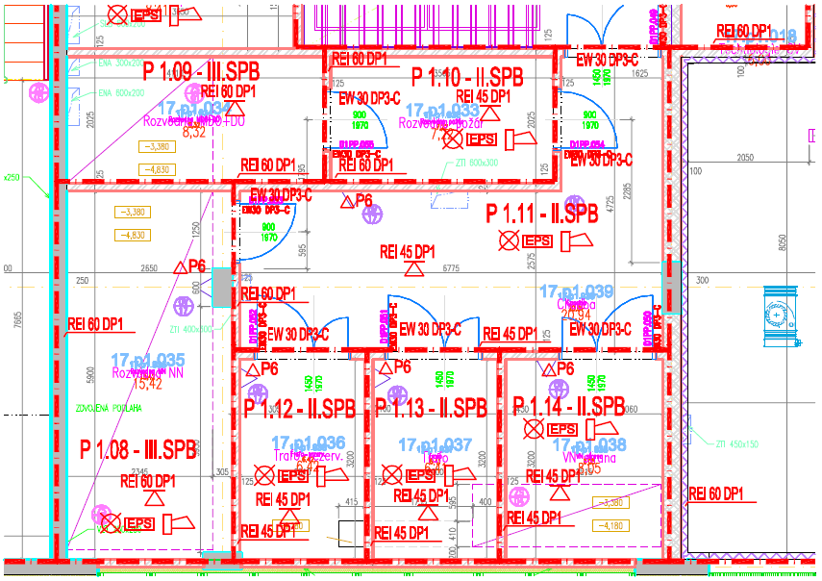
Figure 1: Example of a fire safety design (cut)

Types of building structures in terms of fire protection

In the Czech Republic, building structures are evaluated in terms of fire aspects based on which building materials and products they are composed of, or which reaction to fire class they exhibit (Figure 4). The purpose of the classification is to detect the behavior of building structures in a fire as a whole, i.e. in what way flammable building products used in the structure can increase the intensity of the fire and whether they can affect its load-bearing capacity and stability. On the basis of these criteria, structures are divided into DP1, DP2 and DP3 types in Czech technical standards.

Fire resistance of building structures
Fire resistance is the ability of building structures to resist the effects of a fully developed fire without particularly impairing their load-bearing capacity and stability, integrity and insulation ability.
All load-bearing and fire dividing structures must comply with the requirement for fire resistance, which is the time in minutes during which they must be able to resist the effects of a fire without compromising the required function. There may be several such functions identified by the so-called limit states. A load-bearing or fire dividing structure may have several functions; therefore, there may be a requirement for one or more limit states. The limit state of fire resistance takes into account the type of structure: whether it is load-bearing or non-load-bearing, a wall, column or a door. The ČSN EN 13501-2 standard defines a number of limit states, of which the four most frequently used are: R, E, I, W.

R – load-bearing capacity of a structure
E – integrity of a structure
I – thermal insulation of a structure
W – heat flux density or radiation by the surface of a structure
Sa, Sm – smoke tightness of a structure
C – self-closing device of fire closures
M – mechanical resistance

The combination of the above letters identifies the overall properties of a respective fire element. For example, a door is not load-bearing, but integrity and thermal insulation properties are required of it, i.e. EI plus a number indicating resistance in minutes. DP1 means, for example, that it must be made of sheet metal with non-flammable insulation (A1, A2). For a column, only one parameter, R – load-bearing capacity, is mostly used. A load-bearing wall or a floor structure can be, for example, characterized by the REI parameter – load-bearing capacity, integrity and insulation.

Fire compartments
Based on legislative requirements, buildings are divided into individual fire compartments. Fire compartments are separated by fire dividing structures (walls, partitions, ceilings) through which building services ducts, including various types of pipelines, pass.

Fire safety devices
Fire safety devices or measures are technical or organisational measures aimed at reducing the intensity of a potential fire and reducing the risks of damage caused by the fire to a building or its part.

The types of fire safety devices are:
- fire signalling systems (e.g. electric fire alarm signalling, remote transfer devices, devices for the detection of flammable gases and vapours),
- fire or explosion suppression systems (e.g. stationary or semi-stationary extinguishers, self-acting extinguishing systems),
- devices for smoke movement control in a fire (e.g. heat and smoke extraction devices, smoke flap including its control mechanism, smoke door, natural smoke exhaust systems),
- devices for the escape of people in a fire (e.g. fire or evacuation lift, emergency lighting, functional fitting of doors, safety and warning devices),
- devices for fire water supply (e.g. external fire water supply including overground and underground hydrants, filling stations and fire-extinguishing stands, internal fire water supply including wall hydrants, hose and hydrant systems, unwatered fire pipes),
- devices for limiting fire propagation (e.g. fire damper, fire door and fire closures for openings including their functional instrumentation, systems and elements increasing the fire resistance of building structures or reducing the flammability of building materials, water curtains, fire partitions and seals),
- backup power sources and means intended to ensure the serviceability of fire safety devices, sources or supplies of extinguishing agents for fire or explosion suppression devices and devices for fire water supply, fire-fighting water sources.

Dedicated types of fire safety devices are:
- electric fire alarm signalling systems,
- remote transfer devices,
- devices for the detection of flammable gases and vapours,
- stationary and semi-stationary fire extinguishers,
- automatic anti-explosion devices,
- smoke and heat extraction devices,
- fire dampers.

The design of a fire safety device (FSD) is an inseparable part of a fire safety design (FSD) and its minimum content is regulated by the requirements of the above standard.

Breakdown of items for aggregate pricing in fire protection
In setting aggregate prices, we must consider not only the calculation method, but also the degree of aggregation and various technological alternatives of implemented construction works. The aggregate price must include basic costs, overhead costs and a profit. It is important to specify the cost unit to which the price will be related. In the case of cumulated prices, this is a complex part of a building structure or a set of construction and assembly works. The price also includes the materials needed to manufacture the structure, including the main load-bearing material.
Due to the scope of devices limiting fire propagation, the breakdown of items for aggregate pricing in fire protection is limited to the protection of piping crawl spaces. The fire protection of piping crawl spaces includes:
  - Pipe seal
  - Pipe seal with construction fittings
  - Fire protection sleeve
  - Fire protection strip
  - Masonry partition

The basic classification of the protection of piping crawl spaces for aggregate pricing is structured according to the building structure (masonry, floor), fire resistance of building structures and the type of piping passing through a fire dividing structure.
The unit of measurement is a piece, which includes the cost of material needed for the execution of the piping crawl space protection on the one hand plus the wages cost.

Pipe seal
1 – fire protection gravel material, 2 – plates of mineral wool (reaction to fire class A1), 3 – piping, 4 – piping insulation of mineral wool, 5 – light partition, 6 – massive wall, 7 – massive floor, 8 –identification plate
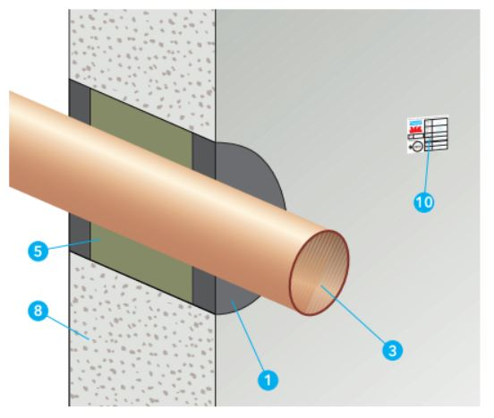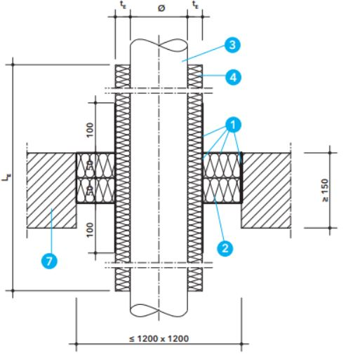
Figure 2: Pipe seal (Source: Promat s.r.o. [online]. [cit. 2017-10-29]. Available at: http://www.promatpraha.cz/downloads/get/cs-CZ/3A9D03F429C64E1DBD6F2D6EDC9329E8?rev=f08f8c66-1be8-4f58-b75a-7b98c3e1f43e)

- Vertical structures
  - EI 45
    - copper piping up to ∅ 32 mm, hole size < ∅ 0.009 m2
    - steel piping up to ∅ 42 mm, hole size < ∅ 0.012 m2
    - steel piping up to ∅ 160 mm, hole size < ∅ 0.046 m2
    - steel piping up to ∅ 220 mm, hole size < ∅ 0.071 m2

- Vertical structures
  - EI 90
    - copper piping up to ∅ 32 mm, hole size < ∅ 0.009 m2
    - steel piping up to ∅ 42 mm, hole size < ∅ 0.012 m2
    - steel piping up to ∅ 160 mm, hole size < ∅ 0.046 m2
    - steel piping up to ∅ 220 mm, hole size < ∅ 0.071 m2

- Vertical structures
  - EI 120
    - steel piping up to ∅ 48 mm, hole size < ∅ 0.017 m2
    - steel piping up to ∅ 106 mm, hole size < ∅ 0.022 m2
    - plastic piping up to ∅ 50 mm, hole size < ∅ 0.006 m2
    - copper piping up to ∅ 18 mm, hole size < ∅ 0.011 m2
    - Floor structures
  - EI 120
    - steel piping up to ∅ 48 mm, hole size < ∅ 0.017 m2
    - steel piping up to ∅ 106 mm, hole size < ∅ 0.022 m2
    - plastic piping up to ∅ 50 mm, hole size < ∅ 0.006 m2
    - copper piping up to ∅ 18 mm, hole size < ∅ 0.011 m2

- Vertical structures
  - EI 90, hole size < 1.2*1.2 m
    - steel piping up to ∅ 42 mm
    - steel piping up to ∅ 114 mm
    - copper piping up to ∅ 42 mm
    - copper piping up to ∅ 89 mm

  - EI 120, hole size < 1.2*1.2 m
    - plastic piping up to ∅ 50 mm

- Floor structures
  - EI 90, hole size < 1.2*1.2 m
    - steel piping up to ∅ 42 mm
    - steel piping up to ∅ 114 mm
    - copper piping up to ∅ 42 mm
    - copper piping up to ∅ 89 mm
  - EI 120, hole size < 1.2*1.2 m
    - plastic piping up to ∅ 50 mm

Pipe seal with construction fittings
1 – construction fitting, 5 - plastic piping, 6 – steel piping, 11 –identification plate
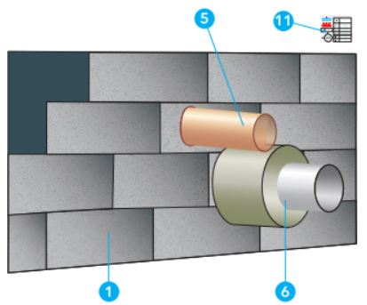
Figure 3: Pipe seal with construction fittings (Source: Promat s.r.o. [online]. [cit. 2017-10-29]. Available at: http://www.promatpraha.cz/downloads/get/cs-CZ/3A9D03F429C64E1DBD6F2D6EDC9329E8?rev=f08f8c66-1be8-4f58-b75a-7b98c3e1f43e)

- Vertical structures
  - EI 120, hole size < 1.2*1.2 m
    - steel piping up to ∅ 220 mm
    - copper piping up to ∅ 89 mm
    - plastic piping up to ∅ 50 mm
  - EI 60, hole size < 1.2*1.2 m
    - copper piping up to ∅ 89 mm
    - plastic piping up to ∅ 140 mm

Masonry partition
1 – fire protection mortar, 2 – fire protection sleeve, 3 – steel or copper piping, 4 – piping insulation of mineral wool, 5 - plastic piping, 6 – steel mesh, 7 – massive wall, 8 - massive floor, 9 –identification plate

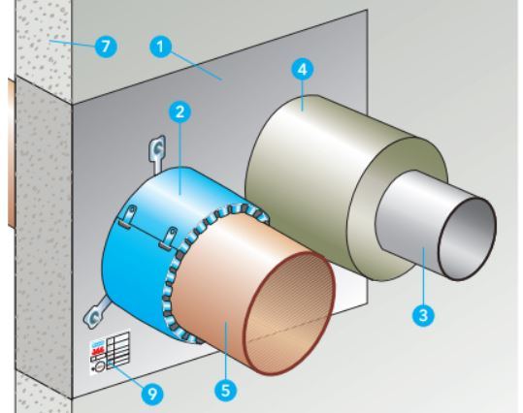
Figure 4: Masonry partition (Source: Promat s.r.o. [online]. [cit. 2017-10-29]. Available at: http://www.promatpraha.cz/downloads/get/cs-CZ/3A9D03F429C64E1DBD6F2D6EDC9329E8?rev=f08f8c66-1be8-4f58-b75a-7b98c3e1f43e)

- Vertical structures
  - EI 120, hole size < 1.2*1.2 m
    - steel piping up to ∅ 114 mm
    - copper piping up to ∅ 89 mm
    - plastic piping up to ∅ 50 mm
    - plastic piping up to ∅ 125 mm
    - Floor structures
  - EI 120, hole size < 1.2*1.2 m
    - steel piping up to ∅ 114 mm
    - copper piping up to ∅ 89 mm
    - plastic piping up to ∅ 50 mm
    - plastic piping up to ∅ 125 mm

Fire protection sleeve for plastic piping
1 – fire protection sleeve, 2 – assembly clips, 6 - plastic piping, 7 – massive wall or light partition, 8- massive floor, 10 –identification plate
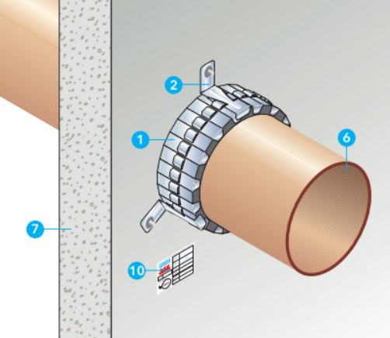
Figure 5: Fire protection sleeve (Source: Promat s.r.o. [online]. [cit. 2017-10-29]. Available at: http://www.promatpraha.cz/downloads/get/cs-CZ/3A9D03F429C64E1DBD6F2D6EDC9329E8?rev=f08f8c66-1be8-4f58-b75a-7b98c3e1f43e)

- Vertical structures
  - EI 45
    - plastic piping up to ∅ 80 mm
    - plastic piping up to ∅ 160 mm
  - EI 60
    - plastic piping up to ∅ 80 mm
    - plastic piping up to ∅ 160 mm
  - EI 90
    - plastic piping up to ∅ 80 mm
    - plastic piping up to ∅ 160 mm

- Floor structures
  - EI 45
    - plastic piping up to ∅ 80 mm
    - plastic piping up to ∅ 160 mm
  - EI 60
    - plastic piping up to ∅ 80 mm
    - plastic piping up to ∅ 160 mm
  - EI 90
    - plastic piping up to ∅ 80 mm
    - plastic piping up to ∅ 160 mm

Fire protection strip
1 – fire protection strip, 2 – fire protection material, 5 – plates of mineral wool, 6 – piping, 12 –identification plate
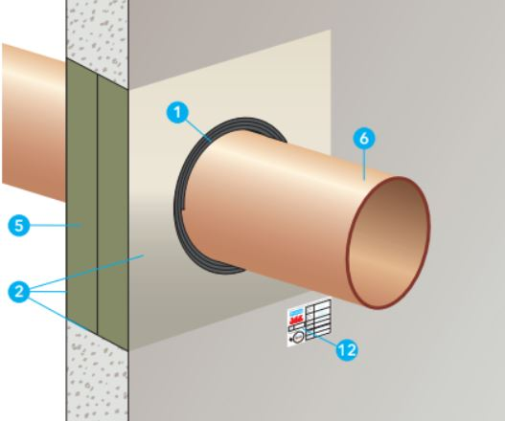
Figure 6: Fire protection strip (Source: Promat s.r.o. [online]. [cit. 2017-10-29]. Available at: http://www.promatpraha.cz/downloads/get/cs-CZ/3A9D03F429C64E1DBD6F2D6EDC9329E8?rev=f08f8c66-1be8-4f58-b75a-7b98c3e1f43e)

- Vertical structures - thickness >100 mm
  - EI 90
    - plastic piping up to ∅ 63 mm
    - plastic piping up to ∅ 90 mm
    - plastic piping up to ∅ 125 mm
    - plastic piping up to ∅ 160 mm
    - steel piping up to ∅ 125 mm
    - steel piping up to ∅ 220 mm
    - copper piping up to ∅ 50 mm
    - copper piping up to ∅ 90 mm
  - EI 120
    - plastic piping up to ∅ 63 mm
    - plastic piping up to ∅ 90 mm
    - plastic piping up to ∅ 125 mm
    - plastic piping up to ∅ 160 mm

- Vertical structures - thickness >150 mm
  - EI 90
    - plastic piping up to ∅ 63 mm
    - plastic piping up to ∅ 90 mm
    - plastic piping up to ∅ 125 mm
    - plastic piping up to ∅ 160 mm
  - EI 120
    - plastic piping up to ∅ 63 mm
    - plastic piping up to ∅ 90 mm
    - plastic piping up to ∅ 125 mm
    - plastic piping up to ∅ 160 mm

- Floor structures - thickness >150 mm
  - EI 90
    - plastic piping up to ∅ 63 mm
    - plastic piping up to ∅ 90 mm
    - plastic piping up to ∅ 125 mm
    - plastic piping up to ∅ 160 mm
    - steel piping up to ∅ 125 mm
    - steel piping up to ∅ 220 mm
    - copper piping up to ∅ 50 mm
    - copper piping up to ∅ 90 mm
  - EI 120
    - plastic piping up to ∅ 63 mm
    - plastic piping up to ∅ 90 mm
    - plastic piping up to ∅ 125 mm
    - plastic piping up to ∅ 160 mm

Fire protection sleeve for plastic piping
1 – fire protection sleeve, 2 – fixing elements, 3 - plastic piping, 5 – sealant, 7 – fire protection gravel material, 8 – plates of mineral wool (reaction to fire class A1), 9 – mineral wool (reaction to fire class A1), 13- massive wall, 13- massive floor

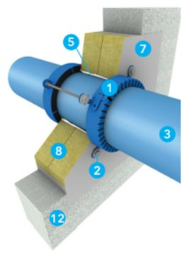
Figure 7: Fire protection sleeve (Source: Promat s.r.o. [online]. [cit. 2017-10-29]. Available at: http://www.promatpraha.cz/downloads/get/cs-CZ/3A9D03F429C64E1DBD6F2D6EDC9329E8?rev=f08f8c66-1be8-4f58-b75a-7b98c3e1f43e)

- Vertical structures
  - EI 90 – EI 120, partition size < 1.8 m2
    - plastic piping up to ∅ 50 mm
    - plastic piping up to ∅ 125 mm
    - plastic piping up to ∅ 160 mm
    - plastic piping up to ∅ 200 mm
    - plastic piping up to ∅ 250 mm
    - plastic piping up to ∅ 315 mm

- Floor structures
  - EI 90 – EI 120, partition size < 1.8 m2
    - plastic piping up to ∅ 50 mm
    - plastic piping up to ∅ 125 mm
    - plastic piping up to ∅ 160 mm
    - plastic piping up to ∅ 200 mm
    - plastic piping up to ∅ 250 mm
    - plastic piping up to ∅ 315 mm

1 – fire protection sleeve, 2 – fixing elements, 3 - plastic piping, 5 – sealant, 7 – fire protection gravel material, 8 – plates of mineral wool (reaction to fire class A1), 9 – mineral wool (reaction to fire class A1), 13- massive wall, 13- massive floor
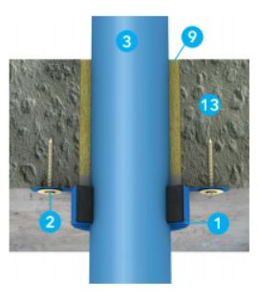
Figure 8: Fire protection sleeve (Source: Promat s.r.o. [online]. [cit. 2017-10-29]. Available at: http://www.promatpraha.cz/downloads/get/cs-CZ/3A9D03F429C64E1DBD6F2D6EDC9329E8?rev=f08f8c66-1be8-4f58-b75a-7b98c3e1f43e)

- Vertical structures
  - EI 90 – EI 120, partition size < 3.75 m2
    - plastic piping up to ∅ 50 mm
    - plastic piping up to ∅ 125 mm
    - plastic piping up to ∅ 160 mm
    - plastic piping up to ∅ 200 mm
    - plastic piping up to ∅ 250 mm
    - plastic piping up to ∅ 315 mm

- Floor structures
  - EI 90 – EI 120, partition size < 3.75 m2
    - plastic piping up to ∅ 50 mm
    - plastic piping up to ∅ 125 mm
    - plastic piping up to ∅ 160 mm
    - plastic piping up to ∅ 200 mm
    - plastic piping up to ∅ 250 mm
    - plastic piping up to ∅ 315 mm

Conclusion
The main expected benefit of the study is the use of calculated aggregate cost items of fire-fighting measures in branches of building structures for residential and civic buildings. Aggregate items will primarily find their application in construction cost planning, project cash-flow setup, facility management, and will be used by investors.

Acknowledgement details
This study was supported by the Grant Agency of the Czech Technical University in Prague, grant No. SGS17/023/OHK1/1T/11.

References
- Strnad, M.: Řešení přesahu požárně nebezpečného prostoru/Solving the Overlap of Fire Hazardous Space (in Czech). In Průmysl, energetika, stavebnictví. Praha: ČVUT, Fakulta stavební, Katedra ekonomiky a řízení ve stavebnictví, 2015, part 1, ISBN 978-80-01-05784-1.
- Matějka, P. - Hlaváčová, A. - Schneiderová Heralová, R. - Löwit, H. - Vojta, J. - et al.: Zvyšování efektivity výstavbových projektů/Enhancing the Effectiveness of Development Projects (in Czech). 1 edition Praha: Nakladatelství ČVUT, 2014. 128 p. ISBN 978-80-01-05608-0.
- Schneiderová Heralová, R. - Charvát, P. - Strnad, M. - Měšťanová, D. - Vitásek, S. - et al.: Oceňování staveb a veřejné zakázky/Pricing Buildings and Public Works (in Czech). Praha: Česká technika - nakladatelství ČVUT, ČVUT v Praze, 2014. 100 p. ISBN 978-80-01-05639-4.
- Schneiderová Heralová, R. - Střelcová, I. - Brožová, L. - Strnad, M.: Oceňování v rámci výstavbového projektu (propočty, položkové rozpočty)/Pricing in the Framework of a Development Project (Calculations, Item Budgets) (in Czech). Praha: Česká technika - nakladatelství ČVUT, ČVUT v Praze, 2013. 220 p. ISBN 978-80-01-05226-6.
- ÚRS Praha, a.s., Rozpočtování a oceňování stavebních prací/Budgeting and Pricing of Construction Works (in Czech). Praha, 2012. ISBN 978-80-7369-442-5.
- Czech National Council. Act No. 133/1985 Coll., on Fire Protection.
- Ministry of the Interior. Act No. 246/2001 Coll., on Setting Conditions for Fire Safety and State Fire Supervision Performance.
- Ministry of Local Development. Decree No. 501/2006 Coll., on General Land Use Requirements.
- Ministry of Local Development. Decree No. 137/1998 Coll., on General Technical Requirements for Construction.
- Fire Rescue Service of CR. [online]. [cit. 2017-10-20] Available at: http://www.hzscr.cz/
- Parliament of the Czech Republic. Act No. 183/2006 Coll., on Spatial Planning and Building Regulations (Building Act).
- ČSN 73 0802 – Fire Safety of Buildings – Non-Industrial Buildings.
- ČSN 73 0833 - Fire Safety of Buildings – Residential and Accommodation Buildings.
- ČSN 73 0804 - Fire Safety of Buildings – Industrial Buildings.
- Promat s.r.o. [online]. [cit. 2017-10-29]. Available at : http://www.promatpraha.cz/downloads/get/cs-CZ/3A9D03F429C64E1DBD6F2D6EDC9329E8?rev=f08f8c66-1be8-4f58-b75a-7b98c3e1f43e)

