Construction Maeconomics Conference 2017
BIM as significant innovation in Czech construction business that is coming
Filip Kessler¹, Pavel Kovář²
¹Department of Economics and Management in Civil Engineering, Faculty of Civil engineering, CTU, Thakurova 7, Prague 6, 160 00, Czech Republic, filip.kessler@gmail.com
²Department of Economics and Management in Civil Engineering, Faculty of Civil engineering, CTU, Thakurova 7, Prague 6, 160 00, Czech Republic, Pavel.Kovar@hilti.com

Abstract
Building Information Management (BIM) is the phenomenon with massive impact on many processes in civil engineering business and throughout the whole construction life cycle. We have asked a few companies in Czech construction business with theirs recent experience with BIM implementation and it seems that BIM brings new approach to many systems and processes in civil engineering. According to their experience it brings more precise work with project documentation and reduces collisions in construction phase. And also Czech public authorities reacted on the new situation and accepted strategic concept for BIM.

Keywords

Innovation; coordination; BIM (Business information management), BIM in practice,

Introduction

BIM as the main innovation in recent years that is coming into Czech construction practice is very widely interpreted in many different fields in construction process. Therefore it is significantly important to investigate how much BIM influence current construction systems and relations in different parties in construction business.
Each party in construction business has a different approach to BIM technology but when there is constant pressure from public sector it really helps the matter itself.

Methodology
In order to decide whether BIM is significant innovation for Czech construction business we have decided to determine those criteria:
Criteria 1: BIM will bring important and worth change in delivery system in Czech construction business
Criteria 2: The degree of innovation using BIM brings significant savings and stabilizing effect in Czech construction business

BIM in practice – without BIM and now
The situation in the Czech construction sector is not ideal in recent years. The enormous pressure on the price has caused a rapid decline in quality of project documentation. The project documentation is not obligatory for the contractor of the building (unless TDI requires it) and hence exchange of materials for the cheaper ones than the materials proposed in the project to keep the original price.
This results in a low quality of the structure that will eventually result in increased costs for the operation of the building, which, as we know, can cost for up to 70% of the total life cycle cost. Investors and also the public sector, become aware of the benefits of BIM that can save operating costs or increase the sales price if it is a development.
The Ministry of Industry and Trade, which is the main body for implementing the BIM in the public sector , decided in 2016 that all public contracts should be designed and implemented within the BIM within 5 years.
Several conferences were held with leading designers, contractors, and material suppliers to discuss in which form implement the BIM in the state sphere and whether construction market is ready for the BIM. That decision of the Ministry of Industry and Trade could support the growth of BIM projects in the private sector as well.
Thanks to BIM, the whole situation on the Czech construction market could stabilize in terms of prices. As the fundamental feature the Building Information Modeling (BIM) contains a whole range of information on each individual element, of course, according to the LOD (level of detail), the entire process from the project to the operation of the construction should be simplified. The cost of a BIM project documentation may be up to 70% higher than the current project documentation cost.
Price increase is logical due to the increased workload on this documentation. To persuade an investor to invest more in BIM documentation can be hard if he does not understand the benefits that this can bring. But when they understand how the whole project is structured, that elements and building materials are designed so that everything works in the best possible way, than it is not possible the construction to be realized in a different standard than the design documentation.
When the investor decides to invest more in the design phase in order to save more on implementation and operation, it is not possible to change anything on the construction site compared to the project documentation.

BIM documentation from the perspective of the investor
The BIM project documentation has an insignificant benefit for the investor in terms of cost savings, both in the realization and operational phases of the building. Thanks to the information and the detailed sophisticated 3D model, it is possible to save on additional costs for construction collisions that are already revealed in the project design.
The structure is modeled to make it as efficient as possible. Even taking into account this fact, an investor is able to achieve higher sales prices if it is to sell it on the market. Throughout the investment phase, the cost of the project becomes much more transparent and more accurately predictable.

BIM documentation from a designer perspective
Designers have a higher income from BMI than from the standard documentation. First of all, BIM documentation is priced higher than normal documentation. This is mainly due to the increased labor- intensity and the larger invested time fund.
The solution of collisions and changes on the costruction site is also part of the documentation. Thanks to the exact model, these additional works from the point of view of the designer, which are not expected to predict, are basically disregarded. It is often the case that the designer invests a lot of hours in a normal project to solve critical situations on a site that the investor is no longer willing to pay. Thanks to BIM, the designers save costs even through the collaboration of all professions on one model at one time. See Fig. 1 Joint co-operation also solves the coordination of professions, which were solved in the current project only after the documentation has been drawn up in one. All this collaboration is solved using the Revit server.

Figure 1 Project cooperation

BIM documentation from the point of view of the contractor
This part of the construction process is probably the least prepared from the BIM point of view. If the contractor decides to build a BIM building, it requires a lot of investment in employee training, new hardware and software. If the contractor invests in this, BIM will bring him tremendous benefits.
In the tender phase, it is a standard that contractors make a bid not from the complete documentation. It is often a better project study, which does not contain all the necessary details to determine the correct final price.
Then it happens that the competed price is much lower than the real cost of realization. The BIM project does not allow that. The contract specifies exactly what information must be contained in the tender documentation. So contractors are not forced to think and price imaginative solutions, but price a really designed construction from precisely specified materials. Thus, there is no phase in which contractors have more work to perform on the construction, which they then enforce on the investor.
Figure 2 BIM in sanitation

BIM documentation from the point of view of the material supplier
Today's standard, at least for professions, is that material suppliers are working together with the designer on the project. Material suppliers often solve specific design details for the designer, saving designers’ time and, last but not least, also finance. They often do this service without payment, and seeing that their material will be sold on site. Today's approach, however, does not give suppliers any assurance that, while specifying their project materials, they will actually be used on site. BIM changes this situation and the material in the project is likely to be used.

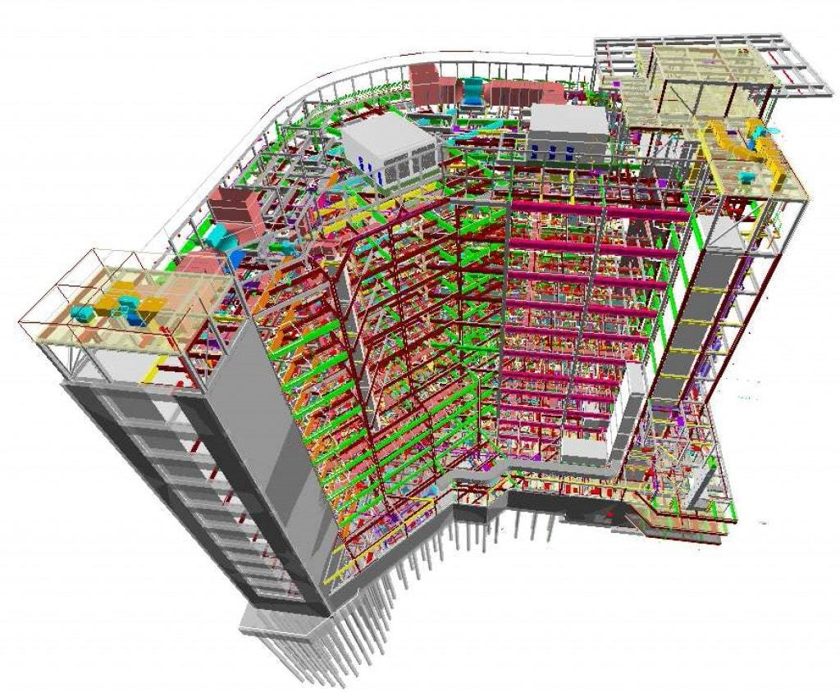
Figure 3 BIM designed construction

Concept of implementing BIM in Czech Republic - Approved
[1] Czech government at its meeting at the end of September 2017, approved the Concept of Implementation of the BIM Method in the Czech Republic. This concept works with two periods: 2018 – 2021 and 2022 - 2027 and contains main topics important for successful BIM implementation.
The main topics related to the implementation of the BIM therefore include chapters that pay attention to the requirements of the construction products and construction elements for the BIM creation, the BIM in relation to the budgets, costs and schedules of the building, the BIM and the Facility Management, or the binding of BIM to the geographical information systems (GIS). Other key issues in the implementation of BIM will undoubtedly include standards and technical standards, creation and ownership of data models, copyright, and BIM is also significantly affected by public procurement in the construction sector. Equally important will be access to education.

Conclusion
In this article we have proved that BIM in Czech construction practice means massive innovation mainly in large structures with various cooperating professions. BIM also brings better position mainly for public investor even though it means more expensive project documentation at the beginning of the construction life cycle.
We meet both criteria we set at the beginning of this article.

Acknowledgement
This article is supported by the CTU student grant n. SGS17/019/OHK1/1T/11

References

- http://www.czbim.org/1-5099-aktuality-ceska-republika-udelala-zasadni-krok-na-ceste-k-digitalizaci-nejen-stavebnictvi.aspx.

