Construction Maeconomics Conference 2016
Better energy performance of family houses by utilization of New Green Savings Programme
Šárka Konášová
CTU in Prague, Faculty of Civil Engineering, Thakurova 7, Praha 6, 166 29, Czech Republic,
sarka.konasova@gmail.com, (tel. +420 724 503 591)

Abstract
This paper focuses on the reconstruction of family houses in order to reduce the energy performance of buildings by utilization of subsidy programs. One of the most current subsidy programs in the Czech Republic is New Green Savings Programme. New Green Savings programme offers a new round of subsidies to promote energy efficiency in the building sector. In the first part of the article, the subsidy programs for energy savings are described and evaluated to show which of them is more suitable for the reconstruction of the family house. The second part of this paper contains a case study for demonstration the amount of subsidy, which could be obtained from New Green Savings Programme.

Keywords
energy performance; family house; New Green Savings Programme

Introduction
The objective of this paper is to demonstrate comprehensive overview for private investors who want to improve the environment, increase the value of their property, and reduce acquisition costs or operating costs of the building. Nowadays, many people without proper knowledge of subsidies have concerns about their private and professional life. Every citizen of the Czech Republic should know at least some basic information about the European Union and subsidy programs, which may be used in the future to improve their private lives or their business.

Subsidies from European funds in the Czech Republic
The EU regional policy works on the principles of solidarity when richer countries support a development of poorer countries. Richer countries contribute a larger sum to the EU budget. Based on this principle the European Union tries to improve a quality of life in all EU countries, e.g. to reduce unemployment and improve the environment.
Since 2004, the Czech Republic has played part of the revenue to the EU budget annually. Given that the vast majority of programs for the period 2004 - 2006 has been completed drawing of interim payments, accounted for the dominant portion of revenue programs from 2007 - 2013. The volume of the interim payments at the current programs during 2012 reached the amount of CZK 79 billion, well above the amount of interim payments for the year 2011 (41.7 billion CZK) [1]. This significant increase in the volume pumping cohesion funds was primarily caused by the resumption drawing of some operational programs.
Revenue from EU structural and investment funds are divided into individual operational programs in the Czech Republic. The EU funds represent a tool of implementation of regional policy. Thought funds, the financial resources are reallocated to reduce social and economic disparities between members of the European Union and their regions.

National subsidy program for reconstruction of family houses
There were many EU subsidies programs supporting improvement of the building energy performance, but none of them was suitable for construction or reconstruction of family houses. Therefore, the Ministry of the Environment came with the Green Savings Programme, which was renamed for the current programming period 2014-2020. The new name is New Green Savings Programme (NGSP). In 2015, the State Environmental Fund added other program to NGSP called Boiler Subsidy [2]. This subsidy aims to reduce emissions from local heating of households constipating to high concentration of pollutions.

New Green Savings Programme
This program of the Ministry of the Environment, administrated by the State Environmental Fund, supports the construction and reconstruction of family houses and apartments in order to minimize their energy consumption and to promote the usage of renewable energy resources. These steps to improve the energy efficiency of buildings also have benefits for the Czech economy based on the fact that construction and reconstruction support the growth of the business sector not only in the construction industry but also in many other types of industries. Furthermore, this program creates tens of thousands of jobs and contributes to increase the GDP. Thanks to NGSP, the Czech Republic will be able to fulfill all obligations under Europe 2020. The main objective of NGSP is to improve the environment of the Czech Republic by reducing the production of greenhouse gasses, pollutions, and the consumption of fuel and energy (in final energy consumption of households, which use for heating and hot water). The amount of subsidy depends on the level of complexity of the undertaken building work [4]. The maximum amount of subsidy for the family house is 50% and CZK 5 million [5]. For the reimbursement of costs, all products and technologies have to meet the minimum quality standards. If an applicant chooses different ones, which are not on the List of Products and Technologies, has to show the quality standards of used products and technologies.
Given the subject of this article, this research is focused on subsidies for family houses, which are divided into the following basic support areas [5]:
- A. Reducing energy performance in existing family houses
- B. Building family houses with very low energy performance
- C. Efficient use of energy resources

Family house reconstruction case study
This part of the article demonstrates the possibility to obtain the subsidy from NGSP for reconstruction of family house in Radnice City as a case study. The two-storey family house will be completely reconstructed. The family house is located in 334 Nadrazni Street, Radnice City, Pilsen Region.

Due to the oncoming reconstruction of this building, the energy performance of the object will be significantly reduced based on replacement of windows and doors, better thermal insulation of building envelope, floors, roof, and purchase of heating pump (air-water). Heat recovery ventilation will also contribute to the reduction of energy consumption. Furthermore, social equipment and modification of layout will be modified to fulfill needs of the family. The purpose of this reconstruction is to modernize the whole building.

Energy assessment of existing and new structure of family house

An integral part of subsidy application for New Green Savings Programme is the energy assessment of the building. The calculation was prepared on the basis of valid legislation [6]. The Energy Performance Certification of a building requires multipage calculation. To be able to calculate it, it is necessary to know the volume of the building, the total area of building envelope, the total energy reference area, and the heat transfer coefficient of every surface of the structure [7]. The heat loss is calculated from the coefficient of heat transfer and surface area. All heat losses of individual structures are added, and the result is total heat loss of the building. The heating source and its efficiency must be known. It is necessary to calculate the need for heating for each month in the year considering the calculation and source of cooling, ventilation, hot water, and lighting system. The result of these calculations is the Energy Performance Certificate.

According to the procedure described above, the energy assessment of existing structure was calculated. The complete documentation of existing and the new structure of the family house was submitted to the energy specialist, who elaborated Energy Performance Certificate (EPC), Figure 1.
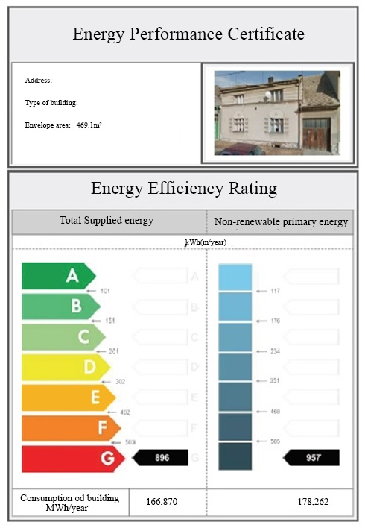

Figure 1: Energy performance certificate of existing structure

From Figure 1, it can be seen that the existing structure was categorized G (least efficient) with consumption 166.870 MWh/year. The same process of assessment of existing structure was used for the new structure of the family house to obtain EPC, Figure 2.

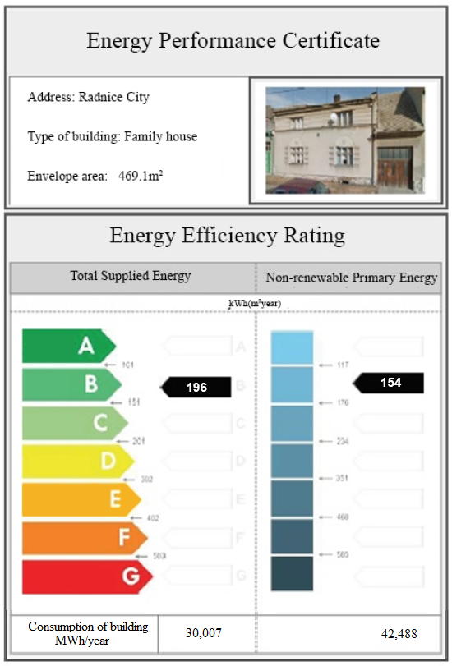

Figure 2: Energy performance certificate of new structure

By implementation of austerity measurements, the object moves into category B (very efficient). The family house after reconstruction will have energy demands only 30,007 MWh/year. This will reduce the energy performance of buildings by 83%.

The calculation of annual energy savings in CZK

For the purpose of this work, it was necessary to quantify the annual energy savings of new structure in comparison to existing one. It was based on the real cost of energy before implementation of austerity measurements when the building had the energy performance of 167 MWh/year according to EPC. The annual costs of electricity were CZK 19,985, and solid fuel amounted to CZK 22,000. The operating cost for energy totaled CZK 41,985. The new structure of family house will have energy performance less than the existing one by 83%, which represents a considerable energy savings. Energy performance of building will be 30 MWh/year.

It was estimated that future energy costs of building will drop to CZK 7,550/year with regard to energy consumption and energy performance of the building after reconstruction. This estimation is more pessimistic due to higher energy prices. The optimistic estimation should be around CZK 6000/year based on installation of new more energy efficient appliances in the house after reconstruction. The average of these two mentioned variants will be applied in further calculation. On basis of this procedure, the amount of energy costs will be CZK 6,775/year, which is 84% less than energy costs of existing building.

Calculation of costs in relation to energy savings
New Green Savings Programme determines a maximum amount of subsidy per m² of definite type of construction depending on the degree of reduction of energy performance of family house. The amount of subsidy from New Green Savings Programme is demonstrated in Table 1. Only energy saving related costs are calculated, not the whole reconstruction costs.

Table 1: The calculation of the subsidy amount according to New Green Savings Programme
Investment | m² | Subsidy amount per m² | Total subsidy amount
Windows | 16 | 3 800 | 60 800
Roof | 120 | 800 | 96 000
Facade | 140 | 800 | 112 000
Ground area | 93 | 1 200 | 111 600
Ceilings and others constructions | 300 | 550 | 165 000
Head recovery ventilation |  |  | 105 000
Preparation of subsidy dossier |  |  | 25 000
Total NGSP (CZK) | 675 400
The total amount of investment in order to improve the energy performance of family house is demonstrated in Table 2. Only the costs associated with energy savings are considered. The total amount of subsidy is determined from Table 1 (New Green Savings Programme) with combination of heating pump subsidy (Boiler Subsidy Programme). The amount of private investment is discounted from the total costs of investment by subsidies.
Table 2: The total amount of costs, subsidies and self-investment
Investment | Costs | Subsidies | Private investment
Windows | 150 000 | 60 800 | 89 200
Roof | 450 000 | 96 000 | 354 000
Facade | 145 000 | 112 000 | 33 000
Ground area | 200 000 | 111 600 | 88 400
Ceilings and others constructions | 250 000 | 165 000 | 85 000
Head recovery ventilation | 150 000 | 105 000 | 45 000
Heating pump Boiler subsidy | 252 000 | 130 000 | 122 000
Preparation of subsidy dossier | 25 000 | 25 000 | 0
Total (CZK) | 1 622 000 | 805 400 | 816 600
The amount of the subsidy from New Green Savings Programme reaches almost 50% of all costs (CZK 675,400 to CZK 694,600 of self-investment). In combination with Boiler subsidy, the subsidies summed CZK 805,400.

Conclusion
This article is focused on subsidies to increase energy performance of family houses. This subject is very topical with regard to obligations of the Czech Republic to meet the targets of Europe 2020. To be able to meet these targets, the Czech Republic has to support financially privet investors to invest in energy saving measures of buildings via subsidies.
The object of this work was to provide a comprehensive overview for potential investors to obtain basic information about subsidies from the European Union and the Czech Republic. It is important to choose a suitable subsidy due to intentions of investor. The case study demonstrated that is possible to pay back up to 50% of costs of investment to energy saving measures of buildings by utilization of New Green Building Savings Programme and Boiler Subsidy. Hopefully, this research motivates investors to participate on the NGBS Programme to improve a quality of living and the environment.

Acknowledgement details

This paper was supported by the CTU Student Grant Competition, grant no. (SGS16/021/OHK1/1T/11).

References
- Urbanek, V. (2013) Czech Republic in 2012 received EU funds by 73.8 billion more than they paid, Journal of Macroeconomics
- Government of the Czech Republic (2014) Policy Statement of The Government of The Czech Republic, Press Advisories
- European Commission (2010) Europe 2020 - A European strategy for smart, sustainable and inclusive growth, EC report, Brussels
- Ministerstvo obchodu a prumyslu (2014) National Energy Efficiency Action Plan of the Czech Republic, pursuant to Article 24(2) of Directive 2012/27/EU of the European Parliament and of the Council of 25 October 2012 on energy efficiency
- NZU (2015) Nové podmínky programu Nová zelená úsporám: Dostupnější dotace, jednodušší počty a rychlejší administrace, Available online at: http://www.novazelenausporam.cz/clanek/nove-podminky-programu-nova-zelena-usporam-dostupnejsi-dotace-jednodussi-pocty-a-rychlejsi-administrace/
- Český statistický úřad [online] Česko NUTS2 , 2015. Update: 9.5.2015 [cit.2.8.2016] Available online at: https://www.czso.cz/csu/czso/cz-nuts2
- Český statistický úřad [online] Kraje NUTS3, 2015. Update: 18.3.2015 [cit. 2.8.2016], Available online at: https://www.czso.cz/csu/rso/kraje_nuts3

