Construction Maeconomics Conference 2016
Review of modern technologies for ascertaining location for cost reduction purposes
Jakub Przeczek*¹, Petr Matějka²
¹CTU in Prague, Faculty of Civil Engineering, Department of Construction Management and Economics, Thakurova 7, Prague, 166 29, Czech Republic, jakub.przeczek@fsv.cvut.cz
² CTU in Prague, Faculty of Civil Engineering, Department of Construction Management and Economics, Thakurova 7, Prague, 166 29, Czech Republic, petr.matejka@fsv.cvut.cz

Abstract
The paper describes and evaluates modern technology of ascertaining location. This text explores the options for cost reductions in constructions of transportation infrastructure. Technology which can be used for such reductions is presented along with case studies. The case studies show cost efficiency of using modern technology in clear figures.

Keywords
Localization systems, RTLS technology, safety, LCC

RTLS technology
ISO (International Organization for Standardization) and ETC (International Electro Technical Commission) define RTLS (Real Time Location System) under the number ISO / IEC 24730 series as follows. RTLS systems are wireless systems capable of localizing the position of any object within any given area (locally/small scale, regionally/large scale, globally) in real time or nearly real time. The location of given object is derived from measurements of physical qualities of radio connection with object. [1, p. 10]
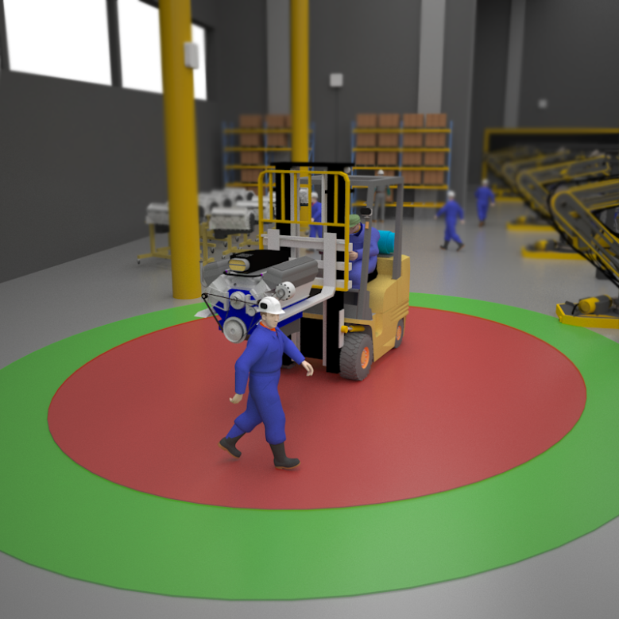
RTLS system for locating persons or machines is used for example in hospitals where the equipment is very costly and it is necessary to protect it from danger or theft. RTLS is also used in shopping centres for protection of employees. Employee in danger simply pushes a button and alarms security guards, letting them know the exact place of problematic situation to solve. RTLS technology can be used for protection of health or possessions. Objects under surveillance are tagged by RTLS-tags. This enables the location system to look up given object easily. As far as safety is concerned, the system can also be used to track people inside a building, e.g. in case of fire. The system is able to inform if there are any people in the building, and if necessary, also where they are located. It is also notable how useful the system can be in production business. Belt conveyor based processes in car production are marked by high levels of precision. Even the smallest delay can result in massive financial losses. RTLS is used to secure safe passage of fork-lift trucks in places with high risk of collision. RTLS does more than locate objects – its transmitter and receiver can communicate. It is an active way of acquiring location. When a fork-lift approaches an obstacle, the system can be programmed to stop its motion. This situation is pictured in fig. 1. The operator's helmet carries an RTLS receiver. When the operator approaches a fork-lift (also equipped with RTLS technology) in a preset distance, the driver is alarmed of possible collision. When the distance is smaller than acceptable, the machines stop automatically. [1, p. 9; 15; 16]
Fig. 1: RTLS in production processes (source: ttp://www.sewio.net/use-cases)
The base functionality of RTLS operates with radio wave measurements. There are many technologies which use RTLS, e.g. WLAN (Wireless Local Area Network), RFID (Radio Frequency Identification) or Bluetooth. Location can be acquired by means of RTLS in several possible ways, e.g. angle measuring of radio wave source, measurements based on response time or signal strength at its arrival. [1, p.11]
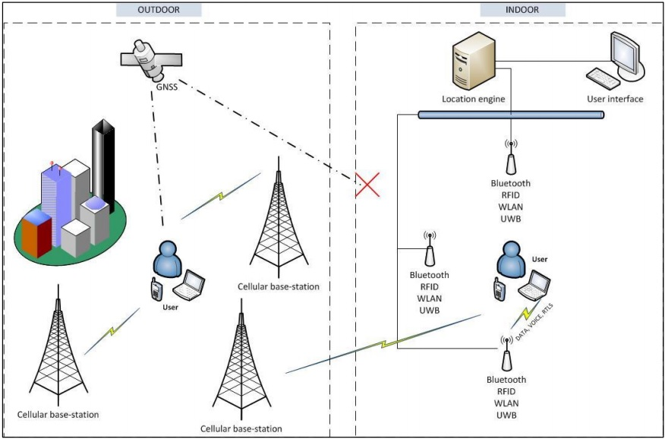
The most widespread technologies used for location are based on satellite signal. However, such systems cannot be used for location in enclosed space because it is necessary for the technology to receive signal from at least four satellites in the sky which see the place at the same time. This limits the use of satellite technology and practically excludes it from use in enclosed spaces. RTLS, on the other hand, uses signals from transmitters located near the object. That makes RTLS ideal for indoor usage. Also, both systems are based on principles so different that they cannot reasonably compete. Tracking objects indoors via satellite is currently impossible, however, it is just as unrealistic to think of RTLS transmitters located universally around the world. That explains how the systems cannot be fully interchangeable despite the fact that RTLS can be used even outdoors to a limited extent [1, p. 11]. Fig. 2 compares satellite based and RTLS based location systems.
Fig. 2: Comparison of GNSS and RTLS localization systems (source: [1])
Fig. 2 shows satellite location system on the left. The tracked object is located outdoors, which makes satellite location possible. The right half of the picture shows enclosed space of an office. The brackets of outdoor and indoor space in the picture clearly demonstrate that satellite signal cannot permeate space enclosed by walls whereas the same is possible for radio signal.
Among RTLS' biggest advantages in the field of construction belongs the advancement of safety of work. Construction as a field of human activities is one of the most dangerous businesses, there is a higher number of lethal injuries. Fig. 3 shows a helmet equipped with RTLS transmitter.

Fig. 3: Safety helmet equipped with RTLS transmitter, produced by Sewio Networks s.r.o. (source: Ing. Milan Šimek, PhD., CEO Sewio Networks s.r.o.)
There is a number of advantages that ensue from equipping a company, its workers and construction sites with RTLS. The system may be set up to warn construction workers when there is danger of collision with a construction machine. RTLS acquires data concerning workflow and may be helpful for streamlining construction processes. With RTLS data, the site manager may mark a dangerous place on the site in digital blueprints. When a worker approaches such dangerous place, he will be warned by light or sound signal. It is necessary that the site is covered by a sufficient number of transmitters and receivers so that the system can operate at its best.
An example of such situation can be seen in source video [2]. Among other information, the demonstration shows a walkthrough of marking and securing a dangerous place. The place is marked by a tablet in digital construction documents. When a worker enters the dangerous place unaware, he is alarmed of his mistake by means of light signal on his vest. The video also shows how RTLS tracks construction data in real time.
Fig. 4 shows a situation where it is useful to improve work security with RTLS technology. The operator wants to commence work. The parameters of the machine do not allow him to see the place where his colleague is. The operator forgets to make sure that he can safely run the machine and that he does not put anybody around in danger. Accidents can often happen under these circumstances. However, when equipped with RTLS transmitters that keep track of movement of other objects with RTLS, it is possible to block some functions of machines if circumstances show potential danger. Before functions are blocked, a signal (e.g. sound) informs about dangerous situation.
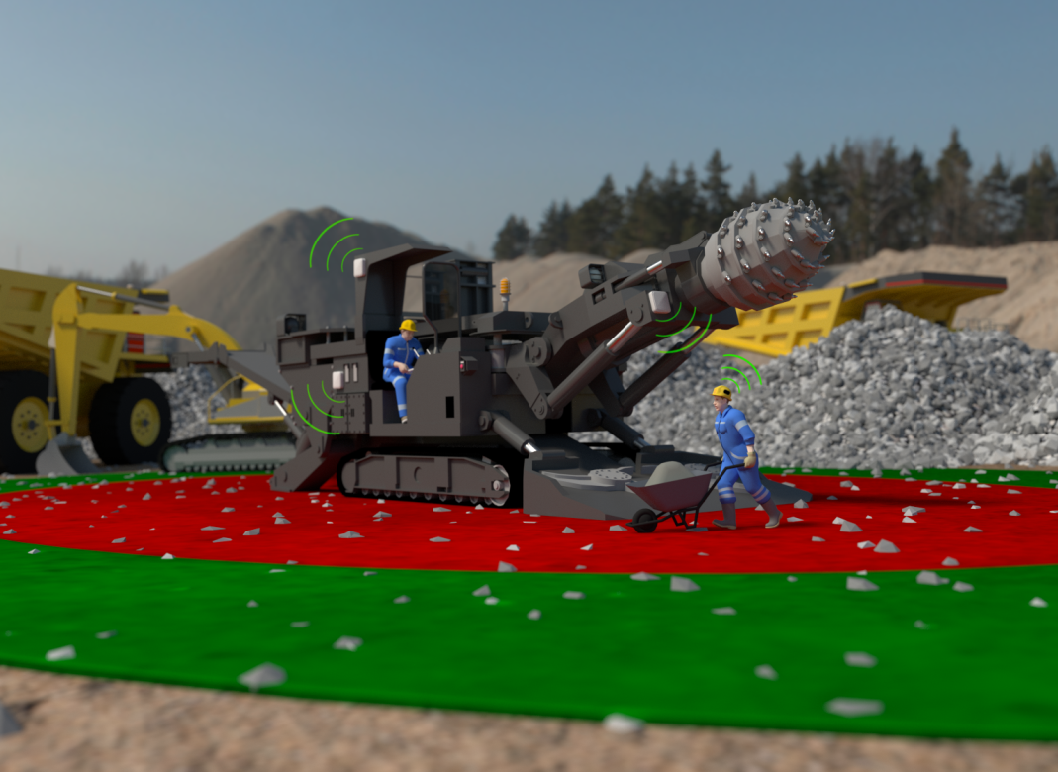
Fig. 4: RTLS usage for improvement of work safety and health protection at construction sites where heavy machinery is operated (http://www.sewio.net/use-cases/)

Case study results
Case study information was acquired from construction of a tunnel in Povážsky Chlmec, part of highway construction D3 Žilina in Slovakia. The tunnel is 4.25 km long. The assumed time to finish construction is 1095 days, the tunnel is expected to be ready for use on 30th June 2017. The tunnel will include two tubes – north tube in the length of 2,252 m and south tube in the length of 2,189.4 m. The tunnel is exploited using NATM – sequential excavation carried out by drilling and blasting. The contracting company is HOCHTIEF CZ a.s. [3, p. 81, 82]
The following graphs demonstrate advantages of RTLS use. Thanks to RTLS but also other factors there are substantial advantages and time saved during construction. The average price of tunnel shaft with similar parameters was ascertained. The price for a tunnel with qualities such as were designed is 1,250 mil. CZK, average costs are at 1,213 mil. CZK. Then it was necessary to figure out the costs of construction carried out with RTLS and compare the data. Sewio Networks s.r.o. specified the costs of RTLS equipment (hardware, installment, cablework, server, infrastructure) at 1.8 mil CZK for the required tunnel length. The graphs of total costs follow.

Without use of RTLS technology
With use of RTLS technology (technology costs included)
Figure 5: Average costs of tunneling works and primary support carried out by NATM method (source: authors)
Figure 5 shows that the savings with given shaft parameters are 236 mil. CZK.
RTLS related savings
RTLS related costs
Figure 6: Comparison of average savings when drilling and preliminary support is carried out with usage of RTLS technology, and the costs of RTLS technology acquisition (source: authors)
Figure 6 shows a comparison of expected average costs, the difference between the average costs with and without RTLS technology is 235 mil. CZK in favour of RTLS-technology assisted even when we account for the costs of technology acquisition.
Without use of RTLS technology
With use of RTLS technology
Figure 7: Average costs per meter of tunnel shaft with and without RTLS, using NATM method (source: authors)
Figure 7 shows the difference per meter of tunnel shaft and primary support at 95,000 CZK.

Conclusion
Using new technologies for directing and locating construction machines is often connected with high acquisition costs. However, it is necessary to state that the advantages of using such technologies are substantial. The case study in this paper demonstrates that the costs of acquisition can be marginal when compared to the total savings that modern technology may bring in a large project. It is always necessary to determine the usefulness of technology acquisition with regard to potential future projects. It does not seem frugal for a self-employed construction worker who only owns an excavator and mostly works in small scale constructions, to spend money on modern technology. Yet.

References
- Altalo I.: Technology behind Real-Time Location Systems, [Bachelor’s Thesis], Oulu, Technology Oulu University of Applied Sciences, Degree Programme in Information, 2012, Available online: <https://www.theseus.fi/bitstream/handle/10024/45658/Alatalo_Ilari.pdf?sequence=1 >
- Redpoint Positioning, Redpoint & Skanska deploy Indoor GPS for Construction Safety [online], 2016 [cit. 15. 2. 2016], Available online: < https://www.youtube.com/watch?v=Vi0WEQQmzPY >
- Tunel, ČASOPIS ČESKÉ TUNELÁŘSKÉ ASOCIACE A SLOVENSKEJ TUNELÁRSKEJ ASOCIÁCIE ITA-AITES, Česká tunelářská asociace a Slovenská tunelárska asociácia ITA-AITES, 24. ročník, č. 3/2015, Praha, 2015, MK ČR E 7122 ISSN 1211 – 0728, Available online: <http://www.ita-aites.cz/files/tunel/2015/150902_tunel.pdf >

