Construction Maeconomics Conference 2015
The environmental assessment tool for pavement rehabilitation variants and life cycle costs
Vaclav Snizek*¹, Jan Valentin²
¹Czech Technical University in Prague, Thakurova 7, Prague 6, 166 29, Czech Republic, vaclav.snizek@fsv.cvut.cz
²Czech Technical University in Prague, Thakurova 7, Prague 6, 166 29, Czech Republic, jan.valentin@fsv.cvut.cz

Abstract
Construction and rehabilitation of road network and transportation infrastructure is a necessity, which every developed European country is facing on a daily basis. The reason is the fact that transportation and the corresponding infrastructure are important factors in the dynamics of economic development with a direct impact on employment rate and also on mobility stimulation related to people and goods. Therefore, it is necessary to ensure sustainable and economically acceptable development of construction and maintenance of roads, highways, railways and bridges. One of the tools to ensure sustainable development and bridging the contradiction between economic growth and environmental protection is maximum use of building materials recycling. Particularly in connection with roads, we are talking about recycling of asphalt and cement concrete roadways. Although recycling of pavements has been successfully applied in most of Western European countries for several decades, in the Czech Republic the usage of recycling as an effective modern way to restore the road faces certain barriers. This approach is beneficial also in removing these imaginary barriers especially with emphasizing environmental impact and achievable effects in terms of total life cycle costs of transportation infrastructure. The paper aims to present a software tool for evaluation of environmental impact caused by pavement rehabilitation. It consists of a comparison of various technological rehabilitation methods. There is a traditional way (mill and fill) of rehabilitation included, but also cold recycling methods as well as traditional way with non-standard volume of RAP material. Application also allows economical comparison of selected rehabilitation variants

Keywords
road; rehabilitation; recycling; emissions; OptiRec

Introduction
Pavement recycling technologies represent a modern approach mainly for pavement reconstruction. Besides the traditional Mill & Fill / Mill & Replace method (cold milling of the required part of the asphalt pavement and replacing the milled structure by new structural layers), these are hot and cold recycling methods performed usually in-situ or in-plant. The particular methods have their given technological specification which differs particularly by way of application, as well as material and construction machinery utilised. As a consequence, the methods are not always mutually substitutable and universally applicable. Their applicability and suitability are determined by experts on the basis of technical standards or regulations, practical experience concerning the local conditions of the project and respect to the technical tradition.
The completion of each technological version has a certain environmental impact. If we focus on greenhouse gas emissions, this particularly concerns CO₂, NO_{x}, volatile hydrocarbons, CO and solid particles. Such harmful substances are released into the atmosphere during each of the partial pavement reconstruction processes – starting with the production / refinement / extraction or processing of the construction materials applied (bituminous binders, hydraulic binders, aggregate and others). It is the activity associated with securing the material that is subsequently incorporated in the project that is the most critical emission burden for the environment. Besides the aforementioned activities, harmful substances are also emitted when the reconstruction is completed – construction machinery operation - demolition work, material crushing and screening, subbase levelling, material and mix transport or laying, [1].

SW tool OptiRec
Developed calculation tools OptiRec CR and OptiRec MF, allow to the user to obtain an important comparison of the technological options selected on the basis of the environmental impact, time or economic demands of pavement reconstruction by various recycling approaches. The tools are innovative in their approach to the evaluation of technological variants and universality of settings, quantity of construction machinery included in the database, with the option of choosing any proprietary machinery set, [2].

OptiRec MF (Mill & Fill)
The OptiRec MF software version primarily handles rehabilitation of flexible pavements by the traditional Mill and Fill / Mill & Replace technology. It is currently the standard and most common solution of pavement rehabilitation in the form of milling off the required layers of a flexible pavement (most often the surfacing) and replacement thereof by new structural layers. The method is effective but quite demanding of material resources in particular. As a consequence of cost savings in the field of reconstructions and the requirement for environment-friendly methods, alternative and equally effective solutions are being sought, like e.g. the aforementioned cold recycling (in-place, in-plant), or hot recycling in situ or a combination of the methods available.
Summary of advantages and disadvantages – traditional reconstruction methods for flexible or semi-rigid asphalt pavements, [3], [4]:
+ universally applicable anywhere;
+ possible use for local roads (streets) in urban areas;
+ many years of experience;
+ relatively low requirements for machinery during completion;
- high requirements for material resources – large quantities and demanding logistic transfers (aggregate, bitumen);
- economically more demanding.

OptiRec CR (Cold Recycling)
The OptiRec CR software application handles primarily pavement reconstructions by detaching and mixing, applying cold recycling approaches, most frequently in-situ or in-plant. There are primarily the technological options as listed below for the individual methods:
1/ Detaching and mixing the material of the existing structure of the selected layers (e.g. re-shaping)
2/ Recycling with the application of hydraulic binders (R) – cement or cement suspension
3/ Cold recycling (CR) in various forms using bituminous binder or a combination with hydraulic binder: (a) bitumen emulsion, (b) bitumen emulsion and cement (lime), (c) bitumen emulsion and cement suspension, (d) foamed bitumen, (e) foamed bitumen and cement (lime), (f) foamed bitumen and cement suspension

Cold in-place recycling (in-situ)
It is a recycling technology performed by construction machinery during the overpass of damaged or milled-off road surface. The key machine is the recycler (special equipment), which is connected to the reservoir of the binder (tanker truck), water (tanker truck), or if necessary to cement slurry mixer (special equipment). A grader, compactors and rollers supplement the convoy, ensuring equal distribution and compaction of newly paved asphalt cold mix. Old and unsuitable material is re-evaluated by recycling process, and then build-in into the new road structure. After detaching of structural layers and adding binders, additives, mixing and subsequent compacting, the newly paved layer and thus the entire carriageway the gain again required load-bearing capacity. Recycling on the construction site minimizes the needs of material transportation between the plant / factory and the construction site.
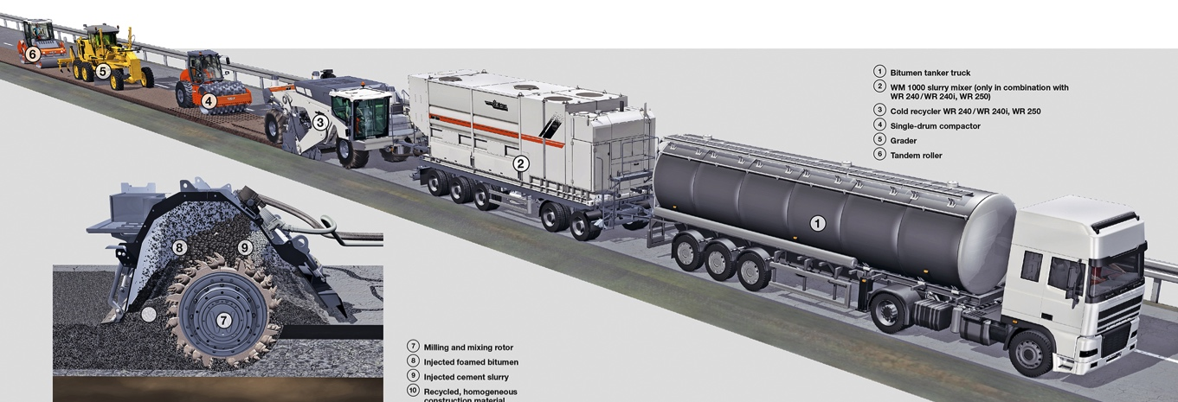
Figure 1: Cold in place recycling – foamed bitumen, cement suspension (example set of machinery), [5]

Cold in-plant recycling
This recycling technology is not performed by construction machinery during overpass of damaged road surface but by the mobile cold recycling mixing plant placed on site facility or stockpile near the construction site. The key element is the mobile cold recycling mixing plant (special equipment) for production of cold mixes. As in case of traditional rehabilitation technology (Mill & Replace), the first step is to mill-off the damaged layer/s of asphalt road surfaces. Milled material is then transported to a site facility or stockpile to the mobile mixing plant. If necessary, binders and additives are added during the mixing process to create a new valuable cold mix material. New asphalt mixture is then transported back to the job site for installation. Recycling in-plant reduces the amount of material transported between production plant and the construction site.
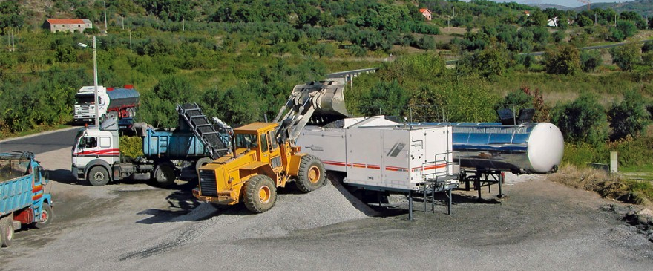
Figure 2: Cold in-plant recycling on job facility, [6]
In comparison to the traditional reconstruction technology, recycling technologies have a number of advantages and some limitations. In the case of cold recycling, they are as follows, [3]:
+ the reconstruction method with lowest energy requirements;
+ minimized time demands of the reconstruction;
+ small quantities of material transported from and to the site when compared to the traditional mill & fill method;
+ minimized need for new virgin materials;
- challenging application in roads with a high quantity of street inlets and other entry points to engineering networks;
- need to use special machinery (recycler/mobile mixing plant) in the machinery set.

Cold in-plant recycling presents compare to cold in-place recycling following facts, [5]:
+ higher quality of newly mixed asphalt material thanks to the possibility of selection and pre-treating of input materials;
+ possibility of continuous control of the quality and characteristics of input and final products;
+ easy adjustment of mixing formula in relation to the quality of input materials;
+ improved quality of mixing – adjustments can be made to the mixer, especially to mixing time
+ stockpiling capabilities – input materials can be placed in stockpile and used when required;
- necessity of transport between job site and site facility or plat (both ways)

Example of the Practical Application of the Software Tool
A road requiring reconstruction of the asphalt surfacing by one of the technological options, either cold recycling or traditional mill & fill reconstruction method with a new asphalt layer, was chosen for the a suitable explanation how the OptiRec tool works and what might be its advantages. This chapter aims to utilise the OptiRec applications in order to assess the selected reconstruction options. The options will be compared on the basis of the total CO₂ generated during the production of the materials incorporated (asphalt mixes, hydraulic binders and bituminous binders) and CO₂ produced by the machinery during the work completion as such. Apart from CO₂, other emissions of greenhouse gases (particularly NO_{x}, volatile hydrocarbons, CO, solid airborne particles) will be assessed as well. For the purposes of demonstrating the calculation tool results, a project with the following input parameters was chosen (see Table 1).
Table 1: Basic project pavement data
Type of road | Asphalt pavement (interurban)
Length of the section  Width of the rehabilitated road  Rehabilitation depth | 1 000 m  10 m  120 mm (mill&fill)  120 mm (cold recycling)

The road intended for reconstruction is a hypothetic example of a road with a minor traffic load (mainly by heavy loaded vehicles). The end of the pavement surfacing life is indicated by defects like e.g. deep cracking in the asphalt layers, deep pavement corrosion etc.. The pavement surfacing consists of asphalt concrete of total thickness 120 mm. The base layer consists of a layer of mechanically compacted aggregate on a protective layer from crushed gravel. The total thickness of the pavement structure is 350 mm.
Table 2: Equivalent CO₂ for particular input materials and mixes, [7], [8]
Cold recycled mix component | Density (t/m³) | CO₂  (kg/t) | Data source
Water  Cement CEM II 32.5 R  Bitumen emulsion (C60B7)  ACsurf 11  ACbin 16  ACbase 16 (not in project) | 1,00  1,25  1,00  2,36  2,34  2,32 | 0,0003  980  221  40*  37,9*  34,9* | IVL  IVL  Eurobitume  Benninghofen, OptiRec  Benninghofen, OptiRec  Benninghofen, OptiRec
* Values for the assumed option of natural gas mixing plant heating
Table 3: Basic data of fuel (production and consumption) [7], [8]
Substance | Density (t/m³) | CO₂  (kg/l) | Data source
Diesel – refining | 0,84 | 0,26 | Afteroilev
Diesel – consumption | 0,84 | 2,66 | MŽP ČR

Mill & Fill (Mill & Replace)
Within the framework of the traditional asphalt pavement reconstruction method, the whole thickness of both surfacing asphalt layers is supposed to be milled away, whereas selective milling is not used. The base layer of the compacted aggregate is retained. A prerequisite for this is sufficient bearing capacity and flatness of the area. The extracted material will be transported to a landfill or mixing plant (the distance of 30 km was chosen). Subsequently, a typical paver will lay two new structural asphalt layers ACbin 16 and ACsurf 11. The original vertical alignment of the pavement will be retained mainly because of possible bridge structures. With respect to the nature of the reconstruction technology, the OptiRec MF will be applied.

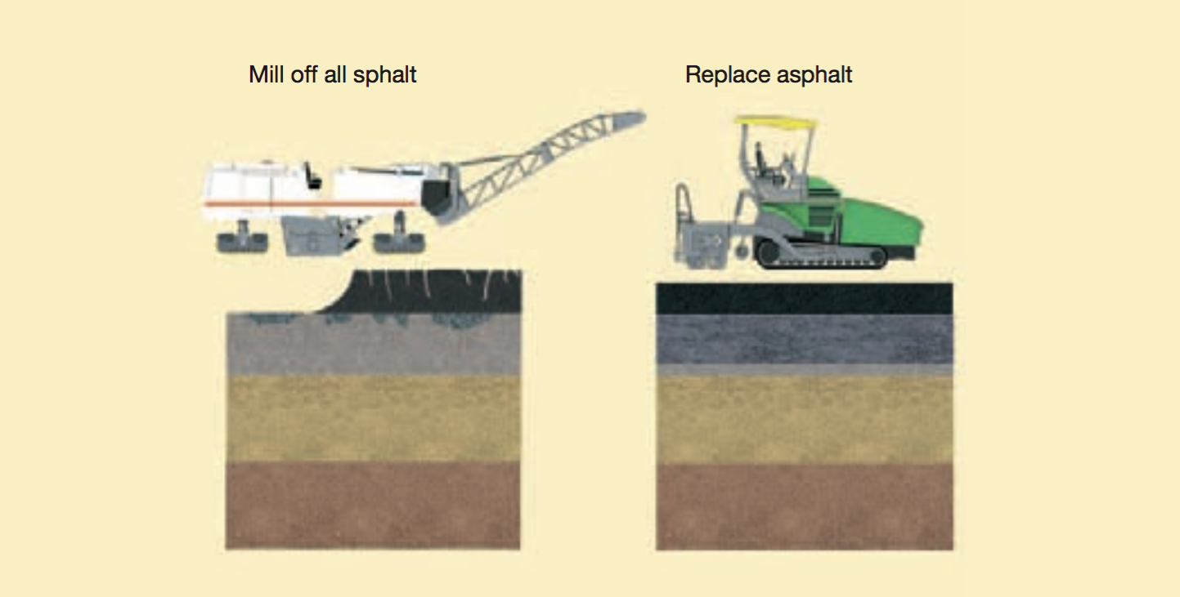
Figure 3: Traditional way of road rehabilitation (Mill & Fill) [5]
Sequence of the reconstruction steps:
1/ Milling 120 mm of the surfacing (wearing and binding courses)
2/ Transportation of the extracted material to a stockpile / mixing plant (30 km distance)
3/ Transport of ACbin mix from the mixing plant to the site (30 km distance)
4/ Application of tack coat of cationic bitumen emulsion
5/ Laying the ACbin mix, with a thickness of 80 mm
6/ Transport of ACsurf mix from the mixing plant to the site (30 km distance)
7/ Application of tack coat of cationic bitumen emulsion
8/ Laying the ACsurf mix to the thickness of 40 mm

Together with the information on dimension parameters and pavement structure composition, the list of the steps is used as underlying information for working the OptiRec tool.
Table 4: Traditional option for pavement reconstruction – pavement design
Original pavement design | Activities during the rehabilitation works | New pavement design after the rehabilitation works
40 mm – ACsurf 11  80 mm – ACbin 16  150 mm – mechanically bond granular material  200 mm – Ga (31.5mm) | Cold milling and later new paving  Cold milling and later new paving  -  - | 40 mm - ACsurf 11  80 mm – ACbin 16  150 mm – mechanically bond granular material  200 mm – Ga (31.5 mm)

A traditional reconstruction of the pavement asphalt surfacing can be divided into two basic steps – cold milling and new asphalt mix paving and compaction. Both steps are performed by a set of machines consisting primarily of standard machinery used in road construction (sweeper truck, tipper truck, paver, rollers etc.). During the milling, the crucial type of used machinery is the cold milling machine, which if special equipment is attached, can be used partly as a recycler (e.g. during cold recycling). The asphalt mix is laid to the necessary thickness by an asphalt paver supplied with fresh hot asphalt mix, transported straight from the mixing plant. The following table 7 indicates the average fuel consumption and emissions of individual piece of building machinery in this type of reconstruction. All values have been calculated with the OptiRec MF software.
The fuel consumption by machinery in a hypothetical project is indicated both for individual machines and as a total for the entire project. The quantity of CO₂ generated is indicated identically (table 5). A graphic rendition of the table is given in figure 4.
Table 5: Total released CO₂ emissions and fuel consumption on a hypothetical project
Used machinery | Consumption (l)* | Released emissions CO₂ (t)
Milling:  Sweeper truck  Cold milling machine  Tipper truck 1  Paving and compaction:  Tipper truck 2  Bitumen sprayer  Asphalt paver  Tandem roller 1  Tandem roller 2  Static roller | 26,44  810,53  5631,76  5638,15  21,23  364,64  112,00  112,00  101,25 | 0,0775  2,3668  16,4447  16,4634  0,0620  1,0647  0,3270  0,3270  0,2957
TOTAL | 12 818 | 37,4288

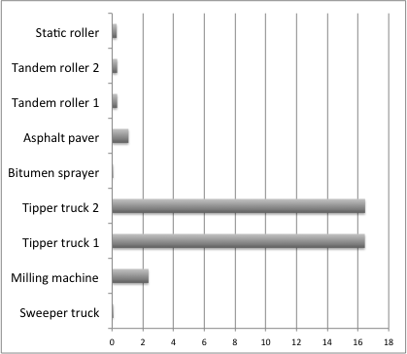
Figure 4: Total release of CO₂ emissions produced by the used machinery (t)
Table 6: Total CO₂ emission related to the materials used in the hypothetical project (t)
Type of used asphalt material | CO₂ (t)
Paved mix:  ACsurf 11  Bitumen emulsion  ACbin 16  Bitumen emulsion | 37,82  2,210  71,23  2,210

Cold in-plant recycling – option with foamed bitumen and cement
In the case of rehabilitation by application of cold recycling, the chosen technical option is a technology applying foamed bitumen with residual bitumen content of 2 % and additional 1 % cement. Recycling of the milled off material from 120 mm thick asphalt layer will be proceeded by mobile cold recycling mixing plant on the site facility - 3 km away form job site. The new asphalt layer ACsurf 11 of a total thickness 40 mm will be paved on the top of the newly installed cold recycled binder course with the thickness of 80 mm.
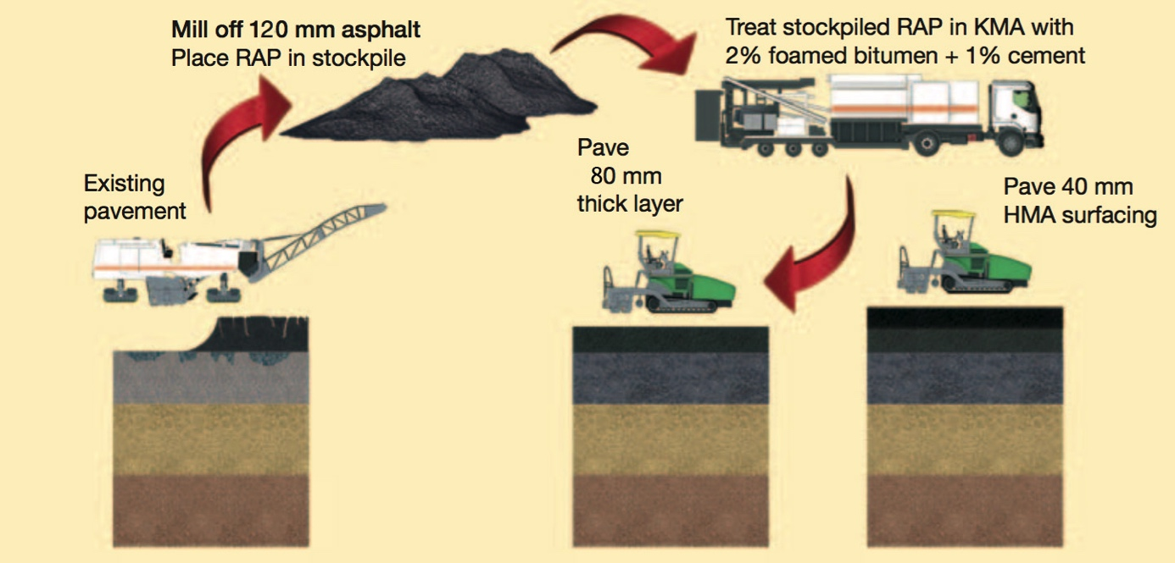
Figure 5: Cold in-plant recycling scheme [5]
Sequence of steps:
1/ Milling off 120 mm of the surfacing (wearing and binding courses)
2/ Transportation of 2/3 of the extracted material to a site facility / stockpile (3 km distance)
3/ Transportation of 1/3 of the extracted material to a landfill / mixing plant (30 km distance)
4/ In-plan cold recycling of extracted material – added 2.0 % by mass of foamed bitumen (expressed by means of residual bitumen), 1 % by mass cement
5/ Transportation of newly recycled mixture form the site facility to the site (3 km distance)
6/ Tack coat by cationic bitumen emulsion
7/ Paving cold asphalt mix, 80 mm
8/ Transport of ACsurf 11 from the mixing plant to the site (30 km distance)
9/ Tack coat by cationic bitumen emulsion
10/ Laying ACsurf 11, 40 mm
Together with the information on dimension parameters and pavement composition, the list of the steps is used as underlying information for working the OptiRec tool.
Table 7: Cold recycling option for pavement reconstruction – pavement design
Original pavement design | Activities during the rehabilitation works | New pavement design after the rehabilitation works
40 mm – ACsurf 11  80 mm – ACbin 16  150 mm – mechanically bond granular material  200 mm – Ga (31.5mm) | Milling, recycling, paving  Milling, recycling, paving  -  - | 40 mm - ACsurf 11  80 mm – cold recycled mix  150 mm – mechanically bond granular material  200 mm – Ga (31.5mm)
With respect to the recycling and paving works, this example employs OptiRec CR (recycling works) and subsequently, OptiRec MF (milling the wearing course and subsequent paving this and recycled layer)
Table 8: The content of binders and water in cold recycled mixtures
Component | Content in the mix (% by mass)
Bitumen emulsion (C60B7)  Cement CEM II 32.5 R  Water | 2,5 (2,0 % residual binder)  1,0  3,0 %

Average fuel consumption and CO₂ emission production for particular machines used for the project is summarized in table 9. The follow-up table 14 then shows together with figure 6 total numbers for each machine related to the whole project.
Table 9: Total released CO₂ emissions and fuel consumption on a hypothetical project
Used machinery | Consumption (l)* | Released emissions CO₂ (t)
Milling:  Sweeper truck  Cold milling machine  Tipper truck 1  Recycling:  Mobile CR mixing plant  Wheel loader  Paving and compaction:  Tipper truck 2  Bitumen sprayer  Asphalt Paver  Tandem roller 1  Tandem roller 2  Static roller | 26,53  810,53  2 252,70  368,94  96,55  2 266,12  21,23  364,64  112,00  112,00  101,25 | 0,0775  2,3668  6,5779  1,0773  0,2819  6,6171  0,0620  1,0647  0,3270  0,3270  0,2957
TOTAL | 6532,49 | 19,0749

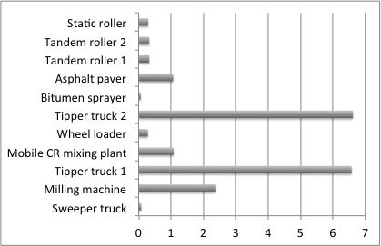
Figure 6: Total release of CO₂ emissions produced by the used machinery (t)

Table 10: Total CO₂ emission related to the materials used in the hypothetical project (t)
Component for cold recycled mix | Content in the mix (% by mass) | CO₂ (t)
Cold recycling:  ¹ Water  ² Cement CEM II 32,5 R  ⁴ Bitumen (for foamed bitumen)  Asphalt paving:  Bitumen emulsion  ACsurf 11  Bitumen emulsion | 3,0  1,0  2,5  -  -  - | 0,02  19,57  14,22  2,21  37,82  2,21
Data source: 1-IVL;2-Athena & IVL; 3-Athena & IVL; 4-Eurobitume; 5-Eurobitume

Summary
The table below contains an overview of applicable technological options with a focus on CO₂ production. The table also contains the presumed quantities produced per square metre of the project completed by the technology in question. This means the total quantity of CO₂ generated (released) in relation to the production of the materials incorporated as well as the emissions resulting from the operation of construction machinery during the reconstruction.
Table 11: Technical rehabilitation options – focus on individual production (release) of CO₂
Used technology for rehabilitation | CO₂ (t)  material | CO₂ (t)  machinery
MF – traditional approach of pavement rehabilitation  CR in-plant – cold recycling with foamed bitumen and cement | 115,69  78,27 | 37,43  19,07

Not only CO₂ counts to harmful greenhouse gas emissions released during production of building materials, their use, transport and fitting in structures. Another risk to the environment can be identified mainly with other greenhouse gases like NO_{x}, volatile hydrocarbons, CO or solid particle matters. This comprehensive information about the burden of the environment together with economic and material related seriousness (demand) is given by the software solutions OptiRec.
Table 12: Technological options and the overall emission comparison
Used technology for rehabilitation | CO₂ (t)  total | NO_{x} + HC (t)  total | CO (t)  total | PM (t)  total
MF – traditional approach of pavement rehabilitation  CR in-plant – cold recycling with foamed bitumen and cement | 153,12  97,34 | 35,09  29,93 | 77,84  55,06 | 0,85  0,90

Conclusion
The computing tool for assessment of energy consumption and emission release of different solutions of asphalt pavement rehabilitation represents an effective instrument for evaluating technological options of pavement reconstruction. The evaluation of individual options is presented by the values of emitted harmful substances (CO₂, NO_{x}, volatile hydrocarbons, CO and solid airborne particles). Users also receive information about the economic requirements, resource requirements (materials, machinery), fuel consumption, time demands and unit indicators.
The basic prerequisites for work with the OptiRec software application are sufficient input parameters for the project brief, as well as at least basic knowledge and overview concerning pavement structures or road construction.
The tool is used, inter alia, to support environmentally friendlier approach to construction and non-renewable resource management. It supports recycling technologies that reuse materials once incorporated and improved by quality enhancement.

Acknowledgement
This paper was partly supported by the student grant project of CTU Prague, SGS15/022/OHK1/1T/11.
This paper was carried out as part of the CEDR Transnational Road research Programme Call 2012. The funding for the research was provided by the national road administrations of Denmark, Finland, Germany, Ireland, Netherlands and Norway

References
- Valentin, J. Problematika výběru funkčních charakteristik směsí recyklace za studena. Disertační práce. Praha: FSv ČVUT v Praze, 2009
- Snížek, V., Dostálová, J., Měšťanová, D., Macek, D., OptiRec – Instrument for the economical assessment of the road pavement reconstruction and recycling variants based on LCC. Prague: FSv ČVUT v Praze. 2014. ISBN 978-80-01-05446-8.
- Valentin, J., Hradil, J., Snížek, V., Engels, M., Vývoj nástroje pro posuzování recyklačních technologií asfaltových vozovek s důrazem na uhlíkovou stopu, Prague: 6. Konference projektování pozemních komunikací, FSv ČVUT v Praze, 2015
- Snížek, V., Strnad, J., Měšťanová, D., Macek, D. Roads, Related Constructions and Means of Their Management, Prague: , FSv ČVUT v Praze, 2012,. ISBN 978-80-01-04 996-9
- Wirtgen Cold Recycling Manual. Windhagen, Germany: Wirtgen GmbH, 2013
- http://media.wirtgen-group.com/media/02_wirtgen/news_and_press_releases_1/2009_kma_220/KMA220_02_880x0.jpg
- Kawakami, A.; Nitta, H.; Kanou, T.; Kubo, K. Study on CO₂ Emissions of Pavement Recycling Methods, Japan: 1-6 Minamihara, Tsukuba-shi, Ibaraki, 2012
- Chehovits, J., Galehouse, L.,. Energy Usage and Greenhouse Gas Emissions of Pavement Preservation Processes for Asphalt Concrete Pavements, National Center for Pavement Preservation, United States: Okemos, Michigan, 2012.

