Construction Maeconomics Conference 2015
Identification of risks in water management
Marek Teichmann*¹, Natalie Szeligova²
¹VSB – Technical university of Ostrava, Faculty of Civil Engineering, Department of Urban Engineering, L. Podeste 1875/18, Ostrava – Poruba, 708 33, Czech republic, teichmann.marek@seznam.cz
²VSB – Technical university of Ostrava, Faculty of Civil Engineering, Department of Urban Engineering, L. Podeste 1875/18, Ostrava – Poruba, 708 33, Czech republic, natalie.szeligova.st@vsb.cz

Abstract
Article deals with the identification of risks, focusing on water supply, representing a significant role in water management, describes the possible emergencies that may occur at sources of raw water and the risks to the entire system of distribution of drinking water. There are also defined basic types of risk, therefore the risk of anthropogenic origin, as well as the risks of natural origin, which are then further divided into groups according to their origin. Following the identification of risks are then analyzed the risks are for resort water riskiest, most frequent and last but not least those that are dangerous to their unpredictability.

Keywords
anthropogenic hazards, identification, natural hazards, risk, water supply system

Introduction
Sustainable development of the state or the city as a whole is chiefly the sustainable development of its individual parts, which include the technical infrastructure sector. We must not therefore forget that it is important for water management infrastructure was as far as possible continuous reliability and the lowest possible risk of disorder, because these disorders tend to have a negative impact on the functioning of the city, not only in terms of limiting the quality of human life, but also affect public health, hygiene, safety, protection of the landscape and environment. These requirements, however, are unthinkable not only without a quality project, professionally executed construction, using the latest materials and techniques going hand in hand with top technical equipment, ensuring their quality performance management, maintenance and renewal of fixed assets, but also flawlessly executed projects aimed at preventing incidents, contingency plans and other measures which ensure the reduction in the impact of possible accidents. Well made, managed and maintained by the water management infrastructure constitutes one of the principal segments of the urbanized area.
At the production and distribution of drinking water can never be ruled out the emergencies. Incident represent undesirable action of forces and phenomena that threaten human health, property, goods, and last but not least, the environment that are caused by natural causes, human activities or a combination of these causes. With increasing influence of civilization increases the likelihood of such incidents. The cause of emergency action is natural effect, where the intensity and frequency range raises advice the natural laws, and in some cases action by people. Most significant of the natural influences in water management are reflected floods. From civilization impacts it may then for example be different types of industrial accidents. Given that the incident can not be excluded, it is necessary to eliminate its adverse effects to an acceptable level. Such behavior is needed to first identify the risks involved.

Critical points of water supply systems
The effects of hazards to drinking water supply structures can be divided into and then assessed in two groups, depending on the point where the effects of the hazard occur. These are effects on raw water resources and on the distribution network itself.

Hazards in relation to the raw water resource
Hazards affecting raw water resources, which constitute one of the primary segments of drinking water supply structures, endanger a water resource by the possibility of putting it out of operation, reducing its capacity, or causing a failure. This has then a severe impact on the functionality of the entire system, on the supply, quality, and quantity of drinking water. In this respect, an important role is played by the drinking water supply system in an area concerned. A system of group or regional water supply brings an advantage here because individual water resources complement each other and putting one of the water resources out of operation may not have a severe impact on the functionality of the system and the supply of water to the inhabitants. Or, the hazard of reduced supply and of the occurrence of an emergency due to natural phenomena is less probable. On the contrary, the occurrence of a hazard is many times higher in the case of local water supply systems, which are usually dependent on one water resource only. [1,2]

Hazards in relation to the distribution network
An integral part of water supply systems is also the distribution network itself, which consists not only of linear pipeline structures, but also of other objects ensuring the necessary quality, hygienic parameters, and pressure conditions of the distributed water etc. Like in the case of water resources, the drinking water distribution system used is also of great consequences. Structures in a distribution network can be divided into several groups by type. The greatest source of hazards then seem to be long-distance feed pipelines, water treatment plants, or service reservoirs and intermediate pumping stations, where their failure or reduced operation has adverse impacts on the functionality of the entire system; generally for the reason that these structures occur outside the areas of consumption or in their outskirts, where the parts of the system may not be connected with each other and therefore the supply of water from a different resource or a different feed pipeline is impossible. Distribution systems in the area of consumption are then exposed to a lower risk; systems in circuits are usually preferably operated there today and supply from another node is ensured there in the event of a failure in a part of a section. In general, it can be said that the rate of emergencies towards the consumer decreases, usually with the decreasing extent – effect of an emergency. [1,2]

Hazards endangering water distribution systems
In practice, we can meet with various types of emergencies, the effects of which may be more or less severe. Each of such emergencies is specific, usually unrepeatable, and with various causes and consequences. From the viewpoint of causes of their occurrence, these emergencies can be divided into two main groups, namely natural and anthropogenic. Both of these risks must be given due attention and situations which may occur must be solved so that they can be eliminated at least partially or bypassed because they have a significant impact on water management and on drinking water distribution itself.

Natural hazards
Natural hazards are those which are caused by effects of natural forces and phenomena and are usually of a short-term nature. These hazards may be subdivided by place of origin:
- Hazards arising above the Earth’s surface – influences arising above the Earth’s surface, especially in layers of the atmosphere. These can be not only tornadoes, wind storms, cyclones, and the like, but also influences arising in the outer space such as meteorite falls can be included in them
- Hazards arising on the Earth’s surface – influences arising on the Earth’s surface, such as flooding, slope landslides, avalanches, and the like
- Hazards arising under the Earth’s surface – influences arising under the Earth’s surface, usually caused by the high temperature of the Earth’s core. These are mainly earthquakes or volcanic activities. [3]
In our geographical conditions we meet most often with influences arising on the Earth’s surface, especially flooding. This is an increase in the level of water courses, or reservoirs, due to heavy rain or rapid snowmelt. They then overflow and flood the adjacent surface. Flooding can be divided into several types, namely torrential flooding, which occurs after short torrents, season flooding, caused by snowmelt, and also simple flooding, caused by short-term abundant rainfalls lasting several days, and complicated flooding, where abundant rainfalls occur for a long time, for several weeks. Other natural influences in our conditions can include, to a limited extent, also gusts of strong wind or landslides connected especially with sloping terrain which is undermined by water or with both gradual and sudden ground subsidence due to undermining.
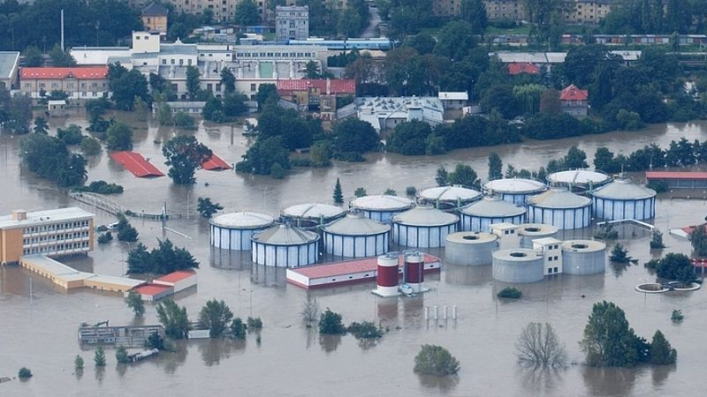
Figure 1: Example of nature hazard in the form of floods. Photo: Central waste water treatment plant in Prague during the floods in 2002 [5]
The effects of these natural forces and phenomena, not the operation of water supply systems neglect, especially when the case of the construction of above-local or strategic importance. At the water supply structures is needed to assess the extent of possible occurrence of an emergency, along with significance given section or part of the system and on this basis, propose appropriate measures to mitigate the possible consequences to an acceptable level, eventually draw the consequences and measures already in the design or repair and adaptations of the buildings so that they are not exposed to this risk at all or only in limited quantities. Between such measures we can arrange to circumvent risks, for example, we will avoid situate buildings into sites with possible occurrence of adverse events, use of non-standard technologies, possibly better material for situating the buildings in these areas, installation of auxiliary monitoring and control systems enabling strategically intervene against an extraordinary event, and so on. Such measures need to be addressed systematically and in the long term. [4]

Anthropogenic hazards
Anthropogenic hazards are hazards concerning the possible occurrence of situations caused by human, either directly by human himself or indirectly by human activities. Compared to natural hazards, anthropogenic hazards are usually long-term and often unpredictable. These hazards can be divided into two basic categories:
- By the origin
  - Human failure hazards – caused by human error or intention
  - Hazards caused by human activity – caused by machines, systems or buildings
    - Technogenic hazards – caused by machine error, system error and so on
    - Environmental hazards – caused by human incorrect handling of a machines or systems
- By the intentions
  - Intentional hazards – war, sabotage or arson
  - Involuntary hazards – human error, system failure and so on. [3]
Anthropogenic hazards may cause many serious troubles in a drinking water distribution and production system and thus considerably complicate water distribution and the functionality of the entire system. Compared to natural influences, these hazards are usually of a more severe nature because many of them cannot be predicted. The number of occurrences of anthropogenic hazards increases proportionally with the development of civilization, which we cannot say in the case of natural influences because natural hazards can be noticed earlier than it was possible in the past due to new knowledge.
Severe, usually absolutely unpredictable anthropogenic hazards can include terrorism, wars, and civilization emergencies caused by industrial, chemical, transport, or nuclear accidents and by accidents which can affect the quality of water and impair the functionality of individual parts of water supply structures. Anthropogenic risks may include a variety of other factors that may also have serious consequences, however, it is sometimes to be expected with a greater probability than the foregoing. Among such risks we can sort faults on individual operating parts, human error and often crash caused by fatigue materials caused by, for example, such as his exhausted life, technological breakdowns due to poor design, handling, inadvertent breach in the repair, reconstruction and so on. [4]

Conclusion
Water supply networks are an integral part of every state, city or town, without which it would not be possible this area nowadays inhabit. These buildings directly affect the setting of the comfort urbanized area throughout its life, it is essential therefore to realize that this continuous functionality we depend and any reduction in functionality brings with it not only the limitations set standards, but also affects public health and hygiene. It is therefore necessary to ensure their constant management, maintenance and renewals, without restricting the sustainable development of the city.
Because these networks are typically located under the surface, it is important to put emphasis on their service life, quality preparation of projects, using modern materials, professional and quality of the work performed, operation, maintenance and eventual restoration of implementing suitable remediation methods. These requirements are inevitable, and if they are not accepted by then leads to breakdowns and accidents, which bring considerable financial costs for their elimination.

Acknowledgement
This work were supported from the funds of the Students Grant Competition of the VSB – Technical University of Ostrava. Project registration number is SP 2015/161.

References
- KROCOVA, Sarka: Strategy of drinking water supply, SPBI Spektrum, Ostrava 2009, ISBN: 978-80-7385-072-2 (in Czech)
- KROCOVA, Sarka: Strategy of urban planning in technical infrastructure, SPBI Spektrum, Ostrava 2013, ISBN: 978-80-7385-128-6 (in Czech)
- SENOVSKY, Michal, ADAMEC, Vilem and SENOVSKY, Pavel: Critical infrastructure protection, SPBI Spektrum, Ostrava 2007, ISBN: 978-80-7385-025-8 (in Czech)
- Teichmann, Marek, Kuda, Frantisek and Proske, Zbynek: Emergency supply of drinking water. Applied Mechanics and Materials. Pfaffikon, Switzerland: Trans Tech Publications Ltd, Vols. 580-583 (2014), pp 2346-2349. ISSN: 16609336. DOI: 10.4028/www.scientific.net/AMM.580-583.2346
- The Czech Environmental Inspectorate. Available from: www.cizp.cz (in Czech)

