Construction Maeconomics Conference 2020

**FINANCIAL ANALYSIS FOR DECISION MAKING IN MID-SIZE CONSTRUCTION FIRM**Ing. Bohdan Povýšil

Abstract

Paper shows financial analysis of one mid-sized construction firm based in Prague, Czech Republic. Based on widely accepted ratings within the financial analysis author describes those results and compares them with the risks that are actual in construction business during 2020 and ongoing Covid-19 pandemic. This financial analysis might be one of the sources for decision making for this construction company, but also will be used as a basis for further studies.

Keywords

Construction firm, financial analysis, decision making, risks.

Introduction

This paper describes financial analysis spreadsheet file made in program MS Excel created for middle-size construction company based in Prague, Czech Republic. This company is oriented in underground and utility constructions with almost 30 years long tradition. Company had about 55-85 employees during recent 5 years and operates with annual turnover around 3,8 to 5,8 mil. € during same period. It is joint stock company owned by one subject.

There were many reasons to make this financial analysis. One of them was the lack of economic performance measurement process. Financial analysis was made externally to be part of required Financial Report but never used as a proper instrument to analyze financial situation inside a company. With this spreadsheet file will the company able to use it as identification system for company’s performance improvement. Also, financial analysis will be able to be used as benchmarking instrument to compare companies’ performance with other similar subjects on the market. Another reason to change strategy around financial analysis was a personal change on the accountant position which is always brings change with accounting policy. Author of this spreadsheet file uses it to educate himself and gain an insight to cash-flows inside a company.

Financial analysis spreadsheet file

This file is in MS Excel format and contains 35 lists which can be divided into 3 parts:

1. **Inputs, absolute indicators.** This part contains data from Balance sheet and Profit and loss statement. This instrument accepts data structure that follows accounting regulations, that are valid from 2016 in Czech Republic. This part contains input data (number of employees, tax rates etc.), Balance sheet, Profit and loss statement, Cash-flow statement, Vertical and Horizontal analysis of both Balance sheer and Profit and loss statement. Those data are then showed as structured data. User can see how divided Assets, Reserves, Liabilities, Revenues and Costs are. Thanks to the accounting regulations’ structure user also can see Costs & Revenues that comes just from operational activity. This part finishes with profit analysis, that contains many widely accepted indexes like EAT, EBT, EBIT, EBITDA, NOPAT & OIBDA.

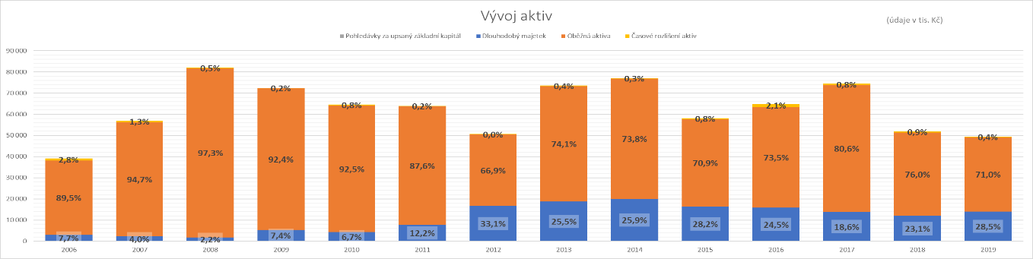

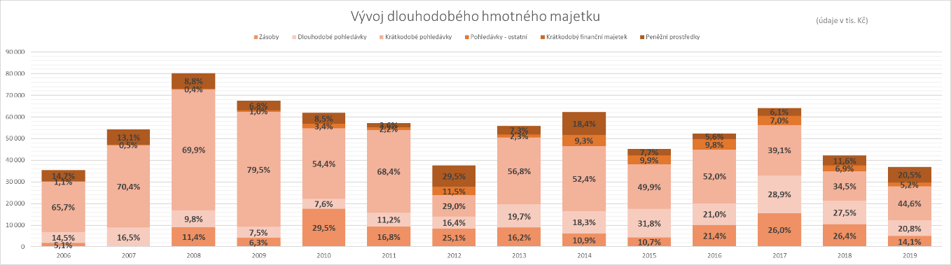

Graph 1: Evolution of assets and long-term material stuff (source: Author, FA spreadsheet file)

1. **Ratios.** Next lists show ratios of input data and indicates some important values to analyze financial situation of researched subject. Those are Profitability ratios, Liquidity ratios, Activity ratios, Indebtedness ratios and ratios based on cash-flow. I also added ratios used on the capital market in case of researching company that operates with stocks (not the case of this company). This part finishes with DuPont analysis as a framework for analyzing fundamental performance.



Table 1: Example of Liquidity ratios (source: Author, FA spreadsheet file)

Graph 2: Example of Liquidity ratios (source: Author, FA Spreadsheet file)

1. **Models and Ratings.** Last part of this spreadsheet file contains Bankruptcy models, Creditworthiness models, Golden rules and employee and productivity data. There are bankruptcy models like Altman Z-score with two additional variations, one made for small firms, one with added influence of not-repaid debts. I also added Indexes IN95, IN99, IN01 and IN05 created by Ivan and Inka Neumaier. Last Bankruptcy model is Aspekt Global Rating. There are also creditworthiness models like bonity index, Kralick Quicktest and Grünwald bonity model. There are indexes on the next list to be used to follow Golden rules. Those are Goden rule of financing, Golden rule balancing risk, Pari rule and Golden rate rule. I plan to add more models to extend the range of indexes. Last list contains data about employees and labor costs, then productivity and performance data per employee and total for whole company.

Graph 3: DuPont analysis (source: Author, FA spreadsheet file)



Graph 4: Employees and labor costs (source: Author, FA spreadsheet file)

According to financial analysis this company has good, but also bad results depending on the index that is used. Altman model and indebtedness showed positive results. IN95, IN99, IN05 & Aspekt Global Rating showed irresolutely results and Kralick QuickTest showed negative worrying results. There was also a negative trend of higher labor cost even when number of employees declined.

Weaknesses of financial analysis spreadsheet file

Results, that spreadsheet file showed, must be analyzed carefully because those numbers does not show many other important values that has to be taken on board. Those numbers depend on the quality of accountants’ reports. Those reports also do not care about the change of those values in time. Same with technologies. Many companies do not value intangible assets properly like qualifications, licenses etc. Results of financial analysis can be also influenced by non-operative activities that are not part of the core of company business. Risks are not part of this instrument. For example, even though ROE is meant to be one of the profitability ratios it does evaluate from accounting profit, but not from the economic profit, that contains opportunity costs. Another weakness of this financial analysis instrument is that leased assets are not showed as foreign capital.

Another important issue with data from Balance sheet and Profit and loss statement is that especially in case of smaller businesses any unusual situation can influence the result and might show unrealistic values. Smaller businesses also do not fill those statements properly which embarrasses the possibility of benchmarking other businesses.

Conclusion

This file will be used for future evaluation of productivity of the company. Also, it is great basic instrument to future updates. Models can and will be added to specify current results, but also to project the future development of the company. If there will be possibility to find data from competition across the market this file can help with benchmarking. Financial analysis provided by this instrument can be valuable during innovation a modernization process as a source for inputs for feasibility study.

References

[1] Neumaierová Inka: Řízení hodnoty, Praha : VŠE, 1998, 137 pg., ISBN 80-7079-921-8

[2] Neumaier Ivan - Neumaierová Inka: Výkonnost a tržní hodnota firmy, Grada, 2002, 215 pg., ISBN 80-247-0125-1

[3] Altman Edward: Financial ratios, diskriminant analysis and the prediction of corporate bankruptcy. The Journal of Finance, 1968

[4] Knápková, Adriana Finanční analýza : komplexní průvodce s příklady / Adriana Knápková, Drahomíra Pavelková, Daniel Remeš, Karel Šteker. 3., complete updated release. Praha: Grada Publishing, 2017. 228 pg, ISBN:978-80-271-0563-2

[5] Grünwald Rolf - Holečková Jaroslava: Finanční analýza a plánování podniku, 1. vydání Praha: Vysoká škola ekonomická v Praze, 1997, 197 s., ISBN 80-7079-257-4

[6] Kislingerová, Eva. Manažerské finance. 2. přeprac. a dopl. vyd. Praha : C.H. Beck,

2007. 745 s. ISBN 9788071799030.

[7] Kislingerová, Eva. Oceňování podniku. 2. přeprac. a dopl. vyd. Praha : C.H. Beck, 2001.

367 s. ISBN 8071795291.