Construction Maeconomics Conference 2020
development profit in residual method of real estate valuation
Josef Kupec
Czech Technical University in Prague, Faculty of Civil Engineering, Thákurova 7, 166 29 Praha 6 – Dejvice, Czech Republic, kupecjos@fsv.cvut.cz

Abstract
In real estate valuation it is essential to understand the modelling of the economic potential of the property. The residual value is in many cases the only possible way how to determinate market value of the undeveloped land or property under construction which is important for investors, banks or auditors. The methodology of calculation for residual method is described in several valuation standard. These standards are usually very general so they can be applied in different markets. The residual method of valuation is very sensitive to changes in key inputs. Small changes in variables such as sales volumes or build costs will have a disproportionate effect on residual value. The aim of the article is to illustrate the possible method of calculation of the level of the development profit and how is realized in time.

Keywords
Development profit, Development property valuation, Residual method, Real estate valuation;

Development property valuation
According to the Internal valuation standards (IVS) there are two main approaches in relation to the valuation of the development property [1]. These are market approach and residual method. Obtaining comparable evidence of development land values is very difficult. Each site will differ widely in location, possible use determined in zooning plan, size, permissible density of development, restrictions, technical infrastructure and so on, making adjustments to a standard value per comparable unit almost impossible. The residual method is used to value development sites and existing properties that have potential to be redeveloped [2] and in many cases the only possible way how to determinate market value of the undeveloped land or property under construction.
The residual method is so called because it indicates the residual amount after deducting all known or anticipated costs required to complete the development from the anticipated value of the project when completed after consideration of the risk associated with completion of the project. Changes in key inputs may influence the residual value of a piece of land to an extent that competition may increase the value of the land for reasons that have little to do with its current use, and it is the valuation of these potential development rights [2].

Methodology
The residual method is a hybrid of basic valuation approaches. For commercial properties the combination of income and cost approach is used. For the correct determination of the residual value is necessary to consider a significant amount of valuation assumptions. The residual method is based on a simple economic concept – that the value of the land is calculated as a surplus remaining after all estimated development costs have been deducted from the estimated value of the completed development [3].
This is based on the completed “Gross Development Value” and the deduction of development costs and the developer’s return to arrive at the residual value of the development property [1].
The residual method is based on the following equation:
Gross Development Value
Development Costs
Development Profit
Value of
Undeveloped Property

Figure 1: Logic of residual method calculation (source: author)
One of the possibility how to determinate the ordinary level of developer´s profit is to modify the calculation procedure.
We can determine the Development profit by a simple consideration:
Development Profit
Gross Development Value
Development Costs
Value of
Undeveloped Property

Figure 2: Calculation of development profit (source: author)
For the correct determination of level of Development Profit is necessary to accurately calculate the key inputs of the equation. The residual method of valuation is very sensitive to changes in key inputs. Small changes in variables such as sales volumes or build costs will have a disproportionate effect on residual value.

Use of the residual method during the life cycle
Developer profit is associated with risks reflecting the project completion, so they change over time. For a proper understanding, the use of a residual method during the life cycle of the project should be considered
Every real estate asset, regardless of its purpose of use and size, is going thought development over the time. From the initial idea, planning, construction, use, up to disposal. This development is based on the fact that the lifetime of all buildings and constructions is limited. The limited lifespan is a necessity for renewal. This brings us to the gradual obsolescence of the whole process, which we call the "life cycle".
The life cycle of real estate can be divided into the basic stages from the point of view of solved problems. Each stage has its own specificities and activities that characterize it for the part of the life cycle. According to the Royal Institution of Certificated Surveyors [4], which are world's leading professional body for qualifications and standards in land, property, infrastructure and construction, the main stages of the life cycle are:
- Land
- Investment – Planning
- Investment – Construction
- Occupation and Use
- Demolition/Brownfield
According to the International valuation standards [1] there are three basic and generally accepted valuation approaches used for the valuation of real estate; the market (comparative) approach, the income approach and the cost approach. The use of single basic valuation approaches is particularly appropriate for objects that are in accordance with their best and highest use, generating adequate returns or are commonly traded on the market.
From the point of view of real estate valuation, the life cycle can be divided into 4 main phases:
Phase I starts with the live cycle and ends by obtaining of zoning permit. A typical example of such a property is a land intended for construction or brownfield, which is a land use plan for revitalization. The potential of the property has not already been developed. The property does not generate any or very limited income hence the Income approach for property valuation is not applicable. On the publicly available information sources (land register, real estate advertising, press information, etc.), it is often possible to find sufficient information about comparable transactions. Based on this fact the comparative method is the most appropriate. A Property at this phase may have significant potential for development, so the residual method can be used to support the comparative method. However, at this phase the scope of the future project is not precisely defined and the outcome of the permitting process cannot be determined in advance. Considering the sensitivity of the residual method is not suitable as the main valuation method.
Phase II begins with obtaining the zoning permit and ends with the occupation of the completed property. A typical example of such a property is a development property. This is the period when the investment costs are drawn and the value changes rapidly in a relatively short period. A zoning permit is generally considered to be critical in the realization of a development project and clearly defines the intended scope. On the basis of project documentation for zoning proceedings, it is possible to more accurately determine investment costs. Due to the rapid changes in value during construction the only possible method of property valuation in this phase is the residual method. However, it should be noted that the residual method is really sensitive to key inputs. Only small changes in variables such as Estimated rent, Capitalization rate or Construction costs will have a disproportionate effect on the Residual value. The use of a comparative method is also possible until a building permit is obtained and the actual implementation commences. From this milestone the use of a comparison method is already problematic. The residual method is main valuation technique at this stage.
Phase III is the longest throughout the life cycle and corresponds to the Occupation and Use stage defined by RICS. The phase begins with the occupation of the completed property and ends with the termination of its use. At this phase, the Property is usually consistent with its best and highest use and generates appropriate income. Valuation methods based on available information about comparable transactions or modeling future income are most commonly used at this Phase. In general, a comparative approach is more appropriate for the valuation of residential properties and an income approach is more appropriate for the valuation of commercial properties such as offices, retail, warehouses, etc. However, in case of sufficient information both valuation approaches can be taken into account.
Phase VI starts after the end of property use period. In this phase, properties are usually in poor technical condition which do not allow other economically interesting uses. If there is a new and better possible use, there is usually a smooth transition between Phase VI and Phase I and the Property begins a new life cycle. The cost of ecological disposal is then part of Phase 1 of the new life cycle. The property in this phase no longer generates sufficient revenue. The valuation approach used for the Property valuation at this phase is practically the identical as in Phase I.
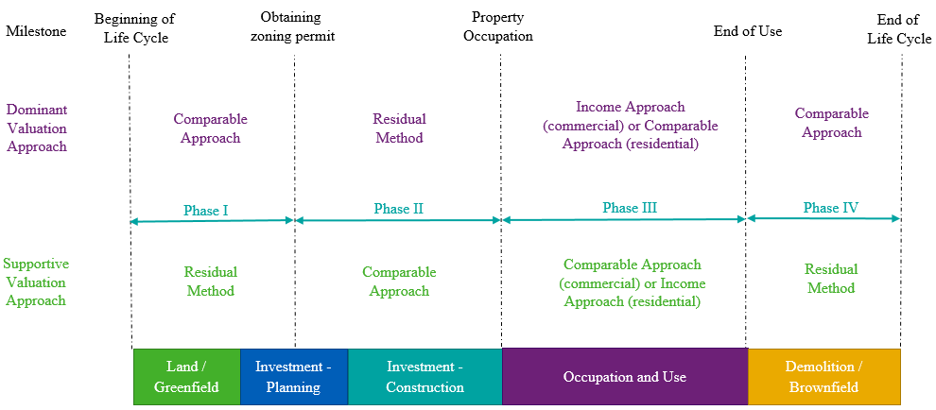
Fig. 2. Appropriateness of valuation methodology in a life cycle context (source: author)

Key inputs determination

Gross Development Value
At the beginning is necessary to determinate the Gross Development Value (GDV). Based on the fact that the property will be in the state of the best and highest use we can use the basic valuation approaches. Used valuation approach to determinate the GDV depends on the type of property. In the case of most commercial properties, the GDV will be calculated using the investment method of valuation.
This will require an estimation of the unit rent of the future property and the likely investment yield [5]. In practice the GDV is calculated as annual Estimated Rental Value p.a., after non recoverable costs deduction, divided by Equivalent Yield. Both key inputs reflect current market conditions and are usually determined based on a market comparison. The non recoverable costs include cots that are not normally charged to the tenants (etc. property tax, insurance, incidental costs).
The RICS Code of measuring practice defines Net Internal Area as the usable area with a building measured to the internal face of the perimeter walls at each floor level [6]. NIA express property areas which generate revenues. Due to this fact they are used for the needs of Property Managers, Marketing, Real Estate Agents and Appraisers.

Development Costs
Development costs always depend on the type of developer's intention and are unique for each project. The following basic elements require consideration in any application of the method to estimate the market value of the development property. Development costs consist of Construction costs, Soft costs and Financial costs.

Construction cost
The costs of all works required to complete the project to the defined highest and best use. The construction costs depend on the type and the phase of the construction project and include the construction cost (new object, reconstruction, utilities, landscaping, etc.), costs for ecological, demolition, disposal of ecological loads, off-site enabling work. The best possibility how to determinate the construction costs is a valid construction contract. If the contract is not available, the price indicators can be used to determine construction costs. For example, reference may be made to the Price indicators of the Czech construction standards [8]. Construction costs of commercial properties are divided to into Hard Costs and Fit outs. To include areas that cannot be rented the GEA/NIA Ratio is used. Gross External Area (GEA) is the area of a building measured externally at each floor level. To cover the risk connected with the additional cost is necessary to calculate the contingency fee.

Soft costs
  - Professional fees - These represent the cost of project studies, stages of the project documentation and the costs obtaining statutory premises and approvals. The level of professional fees depends on the difficulty of the project and are usually calculated as 5 – 10% of construction costs but may be a fixed sum.
  - Project Management - These include the professional a project management costs that would be reasonably incurred by participants at various stages through to completion of the project. The level of Project Management fee depends on the difficulty of the project and are usually calculated as 5 – 10% of construction costs.
  - Marketing – The cost of marketing may be entered as an estimated figure. Proper marketing is a part of the Market Value definition. It is normally to be appropriate to allow for the costs associated with appropriate marketing and would cover items such as advertising, opening ceremony, brochure design and production. Marketing is usually calculated as 2-4% of construction costs.
  - Letting fee - Letting fees include the costs of legal services associated with the lease and services of real estate agents who provide for the lease of the future property. Letting fee is usually calculated as 10-20% of estimated rental value.
  - Disposal fees - Disposal fees include the costs of legal services associated with the sale and services of real estate agents who provide for the sale of the future property. Disposal fee is usually calculated as 1-3% of gross development value.

Financial Costs
These represent the cost of finance for the project through to the completion of the project, including any period required after physical completion to either sell the property. The traditional assumption is that the development and site purchase are financed using 100% borrowed money [2]. The amount of the financial costs depends on three key inputs – Interest rate, duration and amount borrowed. The Interest rate is usually constant through the whole project. The duration is usually divided into three separate periods in which the amount of the loan is changed. The figure 2 shows the calculation of Financial costs.
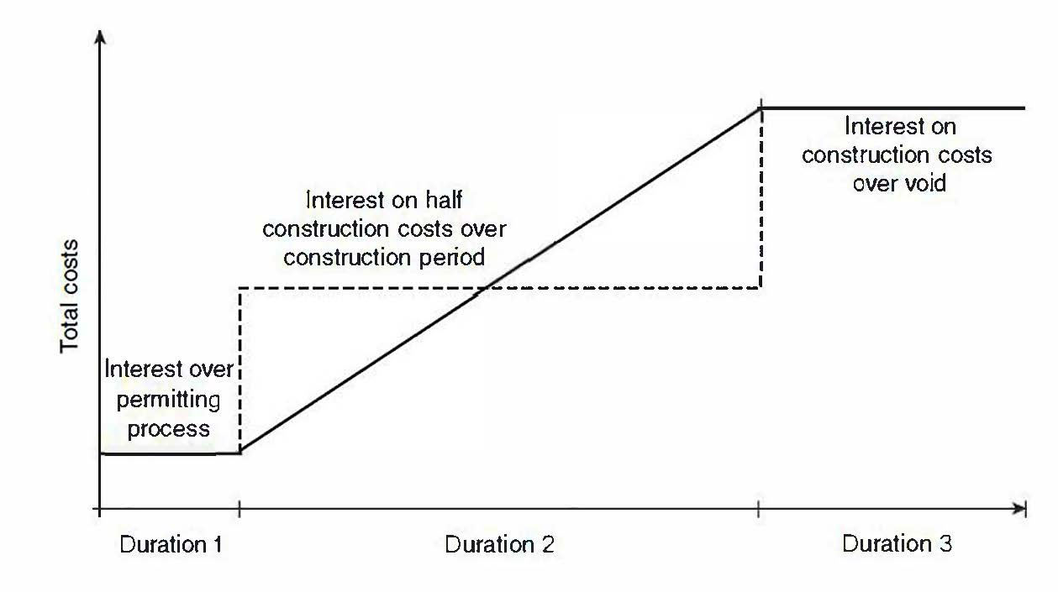
Figure 2: How interest is calculated (source: Wyatt)
The Duration 1 represents the period from the purchase of land to the obtaining a construction permit, the Duration 2 represents the period of the construction and the Duration 3 represents the process of occupation. The amount borrowed during permitting process and void period is constant and easy to calculate. The interest over construction period could be calculated as the annual interest on half of the costs over the construction period [3]. Total Financial costs are calculated as the sum of all periods.

Development Profit
The level of development profit depends on the type of property and is related to the amount of risk associated with achieving the expected return or capital value after the physical completion of the project. Development profit is the reward for initiating and finishing the development and is dependent upon the length and type of development, the size, the degree of competition for the site and whether it is pre-let or sold before construction is complete [7]. The level of developer profits is among the know-how of developers operating in the real estate market. Appraisers usually use for their valuation the level of the developer´s profit based on the information provided by the developer and have only limited ability to assess its adequacy. Development profit is normally related either to the costs of the development or the completed development value; typically this might be 20-25% on Total cost, or 15-20% on Gross Development Value [5].

Conclusion
The aim of this research is to find the reasonable level of development profit which can be used in residual method to determine residual value which is in many cases the only way how to determinate the market value as is defined in IVS.
The obtained information about the level of development profit will be compared with the ordinary level of development profit used in development properties valuations by the biggest valuation companies operation on the Czech market.
Another investigated unknown will be the timing of the development profit realization. During the development project there are several important milestones. Once these milestones have been reached, the value of the property increase significantly. This increase of the value is caused by the cost and profit transformation (and the associated decrease in risk) in to the value of the property. As the main milestones are generally considered the obtaining of building permit and the sale (lease) of the property.
The author is aware that real estate is a specific kind of asset and is unique in many ways. There can be considerable differences between real estate, especially in the locality, size, standard of the property, demand and supply and other key factors which have a significant impact on the level of the development profit.

References
- INTERNATIONAL VALUATION STANDARDS COUNCIL. International valuation standard 2017. EKOPRESS, s.r.o., 2018. ISBN 978-80-87865-44-6.
- SAYCE, Sarah et al. Real estate appraisal: from value to worth. 1st ed. Oxford: Blackwell, 2006. 340 s. ISBN 1-4051-0001-X.
- WYATT, Peter. Property Valuation in an Economic Context, First edition. Blackwell Publishing Ltd, 2007, ISBN 978-1-4051-3045-5
- ROYAL INSTITUTION OF CHARTERED SURVEYORS (RICS); Sustainability and the RICS property lifecycle, first edition, June 2009, ISBN 978-1-78321-136-4
- BAUM, Andrew, Nick NUNNINGTON a David MACKMIN. The income approach to property valuation. 5th ed. London: EG Books, 2006. xiii, 334 p. ISBN 0-7282-0464-9.
- ROYAL INSTITUTION OF CHARTERED SURVEYORS (RICS); Code of measuring practice, 6th edition, May 2015, ISBN 978-1-84219-332-7
- ENEVER, Nigel., David ISAAC a Mark. DALEY. The valuation of property investments. Seventh edition. London: Routledge, Taylor & Francis Group, 2010. xii, 220 p. ISBN 978-0-7282-0550-5.
- CZECH CONSTRUCTION STANDARDS In: Price indicators in construction 2018 [online], RTS [2018]. [see 11.12.2019]. available at: http://www.stavebnistandardy.cz

