Construction Maeconomics Conference 2020
Types of construction contracts with emphasis on change management
Zdeněk Kahoun*¹
¹ CTU in Prague, Thakurova 2077/7, Prague 6, 160 00, Czech Republic, zdenek.kahoun@fsv.cvut.cz

Abstract
In the construction industry, various types of contracts are used and their selection directly influences the entire course of the project. Due to the diversity of construction projects, a different type of contract is suitable for each project. It is especially depends on how the risks are allocated between the contract parties and how the price of the project is determined.
The article describes the types of construction project contracts and specifically focuses on the influence of the type of contract on change management. Change management procedures are very different for each type of contract and therefore it is essential to choose the proper variant.

Keywords
Change management, construction project pricing, cost plus fee, lump sum, unit price.

Introduction
As the construction industry is a diverse business, which includes a variety of projects from construction such as highways or gas pipelines to constructions of hospitals or apartment buildings, the types of construction contracts are very different and the type of contract varies from project to project.
The type of contract also has a significant effect on project changes, which are a standard part of them. In the following chapters, for each type of project, the process of change and typical complications that may occur in these situations will be described. At the end of the chapter, for each type of contract, there will be a discussion on how best to deal with change project according to the type of contract.
In this article, I indirectly follow up on my diploma thesis [4], which focused on change management and claim management without describing how these areas are related to the types of contracts and project pricing. The following chapters describe the forms of contracts, especially from the general contractor point of view.

Types of construction contracts
The choice of the type of contract depends on various criteria that need to be well considered, because the form of the contract fundamentally affects the process of construction and may affect post construction activities, such as the fulfillment of guarantees by the contractor.

The three main criteria that affect the type of project are the following [2]:
- What kind of project it is. (e.g., highways, real estate, power plants…)
- How the risk is allocated between the contract parties. Figure 2
- The way in which the project price is determined.

Figure 1: Criteria for choosing contract type (source: author)
Mainly due to the method of determining the price of the project, the contracts are divided into:
- Lump sum
- Unit cost
- Cost plus fee
  - Guaranteed maximum price
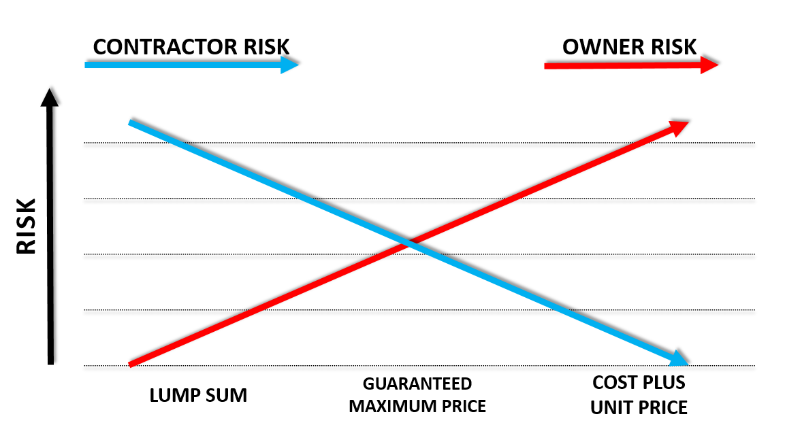
Figure 2: Risk allocation between contract parties (source: author)

Lump sum

Description
The Lump-sum pricing method of contract award is traditional and it is widely used throughout the construction industry. This type of contract award is usually called as “hard money contracting”. Using this method is good in cases where at the time of selecting the contractor, the scope of the construction is completely clear and detailed documentation is prepared. The contractor for such a project can be selected based on a tender, which is preferred mainly for public projects. Another selection option is negotiating with preferred suppliers.[2]
In essence, lump-sum contracts can be used on projects that meet the following two main factors:
- Clearly defined work scope.
- Relatively straightforward completion.

Process through project life
Lump-sum is typical in that the contractor, based on the documentation, determines the price at which it undertakes to deliver the project in the appropriate quality and time. The contractor is usually chosen in a tender procedure, that is typical for a public projects or it could be chosen by the owner with other different processes.[2]

Advantages disadvantages
If the contractor will do miscalculation during preparing to offer to a tender process, it could be very harmful effects for the economic results of the project. Because the price is fixed in a contract at beginning, unexpected obstacles or changes during the project could directly cut the contractor’s profit margin. The larger the project, the greater the room for loss. In the usual work with a number of subcontractors, there is a risk that subcontracting costs will be higher than those considered in the tender and this may be due to many reasons. For example, it can easily happen that the cost estimator overlooks the material specification and includes in to the budget lower costs for a subcontractor’s work. Such an error can cause considerable difficulties. Therefore, it can be said that a human error during preparing an offer to a tender is one of the biggest risks of lump-sum projects.[5]
Based on the source [1, 6], the most common fundamental advantages and disadvantages are these:

Advantages
- Low risk to the owner,
• Owner knows a relatively exact project price already at the signing of the contract,
• Low probability for change orders,
• Accepted widely as a contracting method,
• Bidding analysis and selection process are relatively easy.

Disadvantages
- This type of contract has the greatest risk for the supplier,
- It is relatively time consuming to determine project changes,
- The owner can deny call for change order,
- The project design must be finished before the start of the construction works
- Higher project cost due to unforeseen conditions

As can be seen from the previous description, this type of contract involves relatively large risks for the contractor. It is mainly due to possible unforeseen costs or time delays that may occur during the project after the contract has been signed or construction started. A contractor's error may cause he makes less money or, worse, loses money on a project. As already mentioned, the larger the project is, the greater space for errors arises. Therefore, the lump sum type of contract is suitable for smaller projects with clearly defined scope.

Relation to change management/Making of project changes
In cases where it is necessary to change the scope of the project, it is necessary to issue a change sheet. The whole procedure, which includes the method of notifying the change, the dates by which the change must be processed, and, above all, the manner in which the change must be priced and determined, must be clearly stated in the relevant paragraphs of the work contract.

Unit price

Description:
Unit-price contracts are ordinarily used on roads, construction projects, and earthwork cut-and-fill projects. The principle of this method is that the contractor, who is usually selected in a tender (competitive bidding), will award the unit prices of work for which the scope is known only in general. Therefore, this contract award method is applied on projects where it is complicated to determine the exact scope of work and the lump sum method would be able to use with great difficulty and time consuming to issue numerous change orders.
This type of contract suites on projects that include repetitive work or working hours. These projects include several unit prices for works, e.g., cubic meter of excavation work, square meters of paved areas, or hourly rates of workers (welder, mechanic, locksmith…)
Unit price type of contract is typical in a project where the technology supplier delivers only machinery, but does not provide montage work. In this case, the owner or technology suppliers should ensure a company who will have assembly a technology whose scope of work is unknown at the start of assembling. Thus, the unit prices at which the company will work are determined and the work can start faster without determining the final price.

Advantages disadvantages
The main advantage of this type of contract is that work can start without the requirement to calculate the total price, which allows the contractor to avoid the lengthy valuation of the project similar to lump-sum contracts. That is, on the one hand, good for the owner that the work can start faster, but on the other hand he does not know the final construction costs, which can be a problem in some situations.
Selection of the contractor by the tender is easier than in the case of lump sum contracts. Contractors prepare offer filling “only” unit prices. Based on the sum of these prices, the winning company is selected.
Another advantage of this type of contract is simple invoicing, where the scope, which is proposed by the supplier and agreed by the owner or his representative, is simply multiplied by the unit prices that are set at the beginning of the project in the contract.
As the total final scope of the work is not determined, it is therefore not necessary, due to the nature of the contract, to issue change sheets when increasing the scope.
Based on previous text the most common fundamental advantages and disadvantages are these:

Advantages
- Lower risk for contractor,
- Easy to choosing contractor in the tender procedure,
- An earlier start of project work is possible,
- Save heavy costs for preparing change orders because of scope changes,
- Contractors could be easily chosen in a tender procedure (based on unit prices),
- Easy invoicing for the contractor – multiplication of scope and unit price.

Disadvantages
- Final price of the project is not known from the beginning,
- Owners need to check finished quantities,
- Invoicing is based on a measure on which the parties do not always easily agree,
- Higher risk to owner.

Relation to change management/Making of project changes
By the nature of the project, no extra work should arise. Only the volumes of work agreed by the owner or his representative changes. The problem arises if work needs to be done on the project, their unit prices have not been agreed in contract. In such a case, the procedure for valuing these changes should be described in the contract. In this situation, the change order is done on similar basis as in the lump sum project.[3]

Cost plus fee

Description:
Cost-plus contracts, sometimes referred as cost-reimbursable contracts, are commonly used for various types of projects. In simple terms, the contract works as follows: the owner pays or reimburses the construction costs of the project to the contractor (as defined in the contract) and, he pays the agreed fee or amount of money to the contractor for his services.
This type of contract includes several variations, depending on the method of determining the fee. Two basic variants are described below, but there are many others, which are well described in publications [1, 6].

Cost plus a fixed fee
In this type of cost plus contract, the owner reimburses the construction costs of the contractor. These costs are proposed by contractor and agreed by both contract parties. In addition to these costs, the owner pays the contractor an agreed fee. In addition to these costs, the owner pays the contractor agreed fee, usually monthly, together with construction costs.[5]

Cost plus percentage of cost
The owner reimburses the construction costs of the contractor and, in addition, pays the contractor the agreed percentage of all defined project costs.[6]
This form of contract is very useful if it is not possible to determine the exact scope of the work in advance or when construction needs to start as soon as possible and there is no time to wait for a complete specification of the scope and detail design. Due to the nature of the contract, it is widely used for restoration, renovation, remodeling.[1]

Modification of contracts about maximum price and contract savings
Guaranteed maximum price statement in a contract ensures that the owner has to pay only the limited amount of money specified by the contract at the beginning of the project, regardless of the contractor's costs. This adjustment very well motivates the contractor to carry out the construction for a certain amount, because the costs that exceed this limit will have to be paid by the contractor.
A good idea for this type of contract, how to motivate the contractor to reduce costs, is a clause in the contract that stipulates that the money saved will be divided between the owner and the contractor in a certain ratio.[1]

Advantages disadvantages
Cost-plus contracts are flexible. Cost-plus contracts allow owners to make design changes along the way, and contractors know they’ll be paid for the extra time or materials those changes incur.
Miscalculations aren’t devastating. Since cost-plus contracts are flexible by nature, inaccuracies in the initial bid are’t as detrimental as they are with lump sum contracts which is a problem especially for stakeholders who participate in the financing of the project, which are financial institutions and the owner. [1]
A serious disadvantage of this type of contract is nonexistence of an upper limit of total construction costs. , which is often unpleasant for the owners and for the financial institutions that provide financing for the construction and permanent financing of the project, is the fact that the form of the contract does not limit the upper limit of total construction costs. This form of contract is called open-end contract.[6)
Based on previous text, the most common fundamental advantages and disadvantages are these:

Advantages
- Lower risk for the contractor,
- The project price covers all contractor costs.

Disadvantages
- The final price is not known and cannot be predetermined,
- As well as the price, the date of completion of the project is considerably unknown,
- Agreement on construction costs between the owner and contractor might lead to disputes,
- The contractor must report its costs to the owner in detail.

Relation to change management/Making of project changes
Due to the nature of the project, no changes arise because the scope of work is planned operatively and the owner pays for what is actually done.

Conclusion
The cost plus fee including variant with the addition of a guaranteed maximum price seems to be the most advantageous. The risk for both parties is acceptable and similarly high. The disadvantage of this variant is that the contractor needs to reveal his project costs so that the owner can transparently add a fee to them. Change management of this contract type basically does not exist, because the owner pays for the scope that is actually done.
Unit price contract type is good to use only on a specific type of project. It suits on projects, where at the beginning, the detail design is not completed yet and there is no time for waiting until documentation will be done. The best places where to use this type of contract are projects where repetitive works are performed, the unit prices of these works are stated in a contract, and works that are outside the scope of the contract should arise minimally. Change orders of this contract type should include only works that are not in the range of the initial contract and their unit price is not agreed.
The most globally used contract types are lump-sum, which are tested for most participants and can work with them. The advantage of this type of project is known fixed price at the beginning of the project, but it can suddenly become a disadvantage if the tender documentation is not well prepared. This situation leads to the creation of many change orders and thus the fixed price of the project grows.
The influence of the type of contract on the change management during construction is fundamental and the work on change differs greatly for individual types of contracts. It is therefore necessary to know about the differences and consider them when choosing the type of contract.

References
- JACKSON, Barbara J., c2010. Construction management jumpstart. 2nd ed. Indianapolis: Wiley. ISBN 978-0_470_60999-6.
- SEARS, S. Keoki, Richard H CLOUGH a Glenn A SEARS. Construction project management: a practical guide to field construction management. 5th ed. Hoboken, N.J.: John Wiley, c2008. ISBN 978-0-471-74588-4.
- LEVY, Sidney M. Project management in construction. 6th ed. New York: McGraw-Hill, c2012. ISBN 978-0071753104.;
- KAHOUN, Zdeněk. Claim Management of EPC/Turnkey Projects. Praha, 2019. Master thesis. Czech technical university in Prague. Vedoucí práce Doc. Ing. Aleš Tomek, CSc.
- Construction-contracts-5-main-types [online]. Virginia: Levelset, 2020 [cit. 2020-09-26]. Dostupné z: https://www.levelset.com/blog/construction-contracts-5-main-types/
- Investopedia. Investopedia [online]. Investopedia, 2020 [cit. 2020-10-07]. Dostupné z: https://www.investopedia.com/terms/c/cost-plus-contract.asp

