Construction Maeconomics Conference 2020

**The similarity of localities within the real estate market in the Czech Republic**

Jakub Holcman1, Jiří Kozel2

1Faculty of Civil Engineering, CTU in Prague, Thákurova 7, 166 29 Prague 6, Czech Republic, [jakub.holcman@fsv.cvut.cz](mailto:jakub.holcman@fsv.cvut.cz)

2Swietelsky stavební s.r.o., Sokolovská 192/79, 186 00 Prague 8, Czech Republic, [j.kozel@swietelsky.cz](mailto:j.kozel@swietelsky.cz)

Abstract

This work deals with the analysis of 11 regions in the Czech Republic. The similarity of these regions is examined on the basis of selected 14 indicators. These indicators and their values are provided from the public database of the Czech Statistical Office. This is not the maximum list of indicators available in this resource. The basic attributes for tuning similar regions are used, which will be worked with in the next phases of research. The economic, social and construction-technical indicators are mainly compared. All these indicators must be monitored when assessing localities in terms of real estate prices and in general when determining the situation on the real estate market. For each indicator, two values close to each other from individual regions are selected. In each case, always two pairs. The result is a degree of similarity within all regions. Another result is two combinations of regions that are most similar. These will be subjected to further analyze. This is an initial analysis suitable for the selection of solved local real estate markets and their comparison. Two combinations follow from this work. The first is a neighboring region and the second is not. For a theoretical basis on this issue, a short research is presented here. The research takes into account the results of studies from Australia, China and the United Kingdom. This theory is linked to data from the Czech Republic. This research follows up on the solution of the problem of the dependence of real estate prices on individual microeconomic and macroeconomic factors, including the computational model.

Keywords

Aspect, Conditions, Differences, Locality, Price

Introduction

Ongoing research deals with the factors that affect property prices and vice versa. It is therefore necessary that the analysis of real estate prices does not take place only in one place, ie in one local market. The real estate market differs slightly in the case of neighboring regions. However, it can already become completely different at the national or international level. It can also be said that general data at such levels can be skewed. These dates must therefore be approached with some caution. This article addresses the similarity of individual regions in the Czech Republic. In other words, regions with comparable parameters are searched. In the next phases of the research, the influence of selected factors on real estate prices will be assessed in these regions. It will therefore be possible to adequately draw conclusions about the ways in which real estate prices are affected and what attributes they themselves affect. This is based on similar input conditions.

The subject of a 2017 survey from China was the analysis of real estate prices in 69 cities [1]. The result was the dependence of real estate prices on the interconnectedness of the surveyed cities, transport accessibility, politics, urban GDP and education [1]. However, it is not an examination of all factors that have an impact on real estate prices, or some effect. The solution of specifically selected localities is essential here. However, another finding was only the local influence of some factors, thus without any impact on the region's economy or on property prices in neighboring cities [1]. It can therefore be stated that micro and macro factors are assessed in the area of real estate prices.

The interconnectedness of prices and other circumstances was confirmed by an analysis of property prices in ten regions in the United Kingdom, including, besides, all household operating costs [2]. The study concluded that price increases in one region may increase prices in another due to low-priced migration [2].

Not only thanks to these studies, the ongoing research works with the hypothesis that the degree of correlation between the identified factors and real estate prices in different regions is not the same.

The claim that a smaller and specific area should be examined first, followed by an extension to the whole territory, is supported by a model evaluating historical data with predictive assumptions for sellers and buyers in Melbourne, Australia [3]. The authors mention the possibility of using the model throughout Australia [3].

The authors of the article on local aspects of real estate transactions have created a model that assesses the impact of sales by location in the US [4]. The authors found that the characteristics of real estate do not explain the pattern of transactions, and therefore additional information on the neighborhood is included, etc. [4]. A regression model and ArcGIS application were used for evaluation. Local data are compared with the house price index - HPI [4].

There are many studies and analyzes of individual conditions in given localities depending on real estate prices in professional publications. Article [5] provides a simple overview of the topics found and input factors, including the number of articles found by the relevant research team. An overview is shown in Figure 1. More complex solutions to individual input conditions and factors for the price of real estate have not been found. However, the above information is required to work with specific parameters, and not only with the general concept of locality.

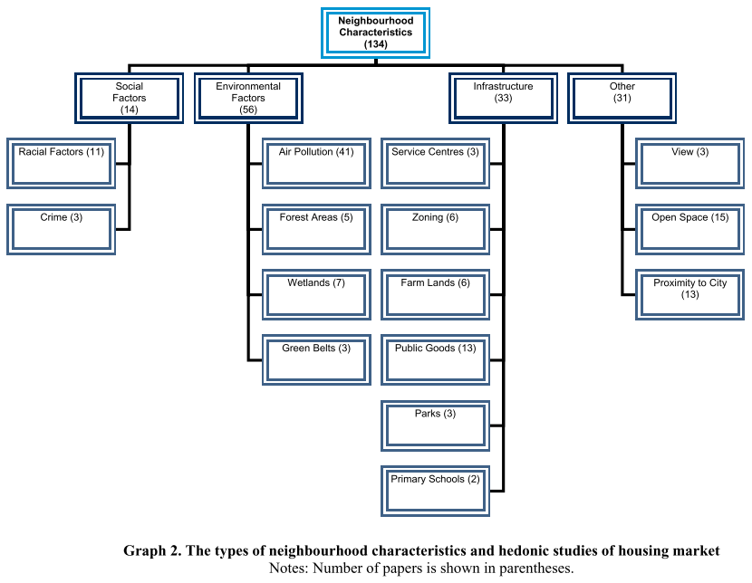

Figure 1: Studies dealing with the analysis of the locality within the real estate market (source: authors, [5])

To assess real estate prices, various studies have addressed the impact of the outlook on real estate, the distance to the city, crime, air pollution or, for example, the presence of parks and greenery near the properties [5].

The assessment of the similarity of purchase prices of real estate in individual regions is also important. The degree of positive or negative effects on the price must therefore always be compared in similar places. Figure No. 2 shows the development of purchase prices of real estate in selected regions in the Czech Republic.

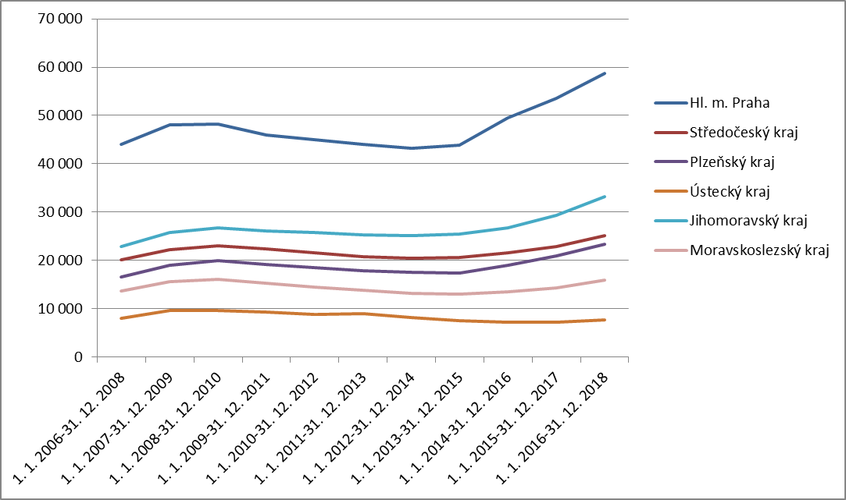

Figure 2: Purchase prices of real estate of older apartments in CZK/m2 (source: authors, [6])

Figure 2 shows data from the public database of the Czech Statistical Office [6]. Data from selected regions were downloaded from this database. The content includes unit prices for older housing units. This development demonstrates the importance and essence of research into regional conditions that affect real estate prices. From a macroeconomic point of view, it can be stated that the growth rate is less different. This is evidence of a nationally similar pace of development and at the same time of local disproportions. There has been no enormous fluctuation in prices over the years, not least because of the prices of older properties. At the end of 2018, unit prices are beginning to rise in most regions, with the steepest increase in the capital. The causes of property price volatility will be addressed in the next phases of research.

Methodology

There are 14 regions in the Czech Republic. Eleven of them were selected for similarity analysis. Regions with extreme values and also regions with a direct influence of these values were excluded. It is the capital city of Prague and the related Central Bohemian Region. It is also the South Moravian Region, which is influenced by the presence of the second largest city Brno. The source of data was the public database of the Czech Statistical Office [6]. Here you can create your own tables based on selected indicators and areas. There is therefore a possibility to extend this analysis with other indicators. At the moment, these seem too detailed to the authors for the basic determination of similarity and redundant for the added value of this analysis. The following attributes were compared for selected eleven regions: GDP, GDP per capita, GDP per employee, number of inhabitants, number of dwellings started under construction, number of completed dwellings, average real estate price, number of accommodation facilities, average age, and regional area and rate unemployment.

Two values close to each other were always found for each attribute under consideration. Due to the number of regions, two pairs of values were selected. This is in order to create a greater basis for the model being created throughout the research. For clarity in MS Excel, close values were marked. The sum of the marked indicators for individual regions determined the most similar regions, which will most likely be the subject and basis for the creation of the model in the next phases. In general, this is a very simple analysis based on statistical data. However, this initial analysis of the sites is very important as an exclusion method. Therefore, not all areas in the Czech Republic will be examined. Further analysis will find smaller administrative units. This will be the districts in the regions, which are the result of the first step of the overall analysis of localities.

Results

The monitored indicators and their values are shown in Figure 3. The similarity of values is always highlighted in light gray or dark gray. The selected color has only distinctive properties. The richest regions were eliminated immediately at the beginning of the analysis. This was because real estate prices in these regions are often caused by population migration for work and generally higher average monthly wages and salaries. However, this assumption could not be applied to the opposite side of the scale, namely to the poorest regions. It was not possible to identify less developed regions before starting the analysis, as there is a thin line. The authors did not want to avoid possible similarities between the two regions at these price and economic levels. On the contrary, it was possible that research in these regions would be carried out with fewer burdens on the influence of the behavior of individual entities in the real estate market.

The lowest degree of similarity with other regions occurred in the Karlovy Vary Region and the Moravian-Silesian Region. Both of these regions have only two identical indicators out of the total number of 14. The Vysočina Region follows with three similarity features. The Královehradecký, Liberec and Zlín Regions show four similar indicators. The Pardubice Region has five similar features with some of the other regions, which is the same number as in the Ústí nad Labem Region. The Pilsen Region has seven similar indicators with other regions. The highest degree of similarity is shown by the South Bohemian and Olomouc Regions, in which eight similar features were recorded with some of the selected regions. The overall overview is shown in the following Figure 3.



Figure 1: Overview of the analysis of the similarity of individual regions with the results (source: authors, [6])

Thus, the degree of similarity of individual regions from the national point of view was determined. It was therefore necessary to always assess the individual pairs of regions as they are similar. The minimum number of matches was, of course, 0. The maximum number of matches was 4. There were also three matches between regions, so this variant will be assessed in the next phases of research.

The highest agreement appeared between the Ústí nad Labem and Olomouc Regions. The three indicators matched between the South Bohemian and Pilsen Regions.

The first combination is interesting because it is not a neighboring region. This is the case with the second variant in the case of the South Bohemian Region and Pilsen Region. For neighboring regions, the impact of labor migration will be included. For remote regions, there is a high probability of obtaining isolated data for a given region. However, aspects based on neighboring areas will be included.

Conclusion and discussion

Within this work, an analysis of individual regions in the Czech Republic was created. The analysis sought the similarities of the selected indicators. Already in the theoretical part of this article, it was found that it is necessary to monitor the development of various factors in solving real estate prices and their development. Factors that have some effect on price levels in the real estate market and vice versa. The real estate market is very complex. It must also be approached in this way. From regional data and analyzes, it is possible to access models that cover several regions up to the national level. According to the authors, there are a large number of ambiguities and different conditions behind the solution of price relations at the international level. For this reason, too, there are not many studies on such topics. Only the results of regional analyzes are generalized.

Fourteen indicators were selected from the public database of the Czech Statistical Office and 11 regions in the Czech Republic. These are regions that have their own elected council. By comparing the values of individual indicators, two pairs were always selected. These selections were recorded in a table. The regions with the lowest number of records were Karlovy Vary Region and Moravia-Silesian Region. These regions therefore showed the slightest signs of similarity with other regions. The highest degree of similarity was again recorded in two regions, namely in the South Bohemian and Olomouc Regions. In the next phase of data evaluation, it was found that the highest agreement between only two regions is between the Ústí nad Labem and Olomouc Regions. Similar values were found for 4 indicators. The Pilsen Region showed similarity with 3 indicators with the South Bohemian Region. The first mentioned regions are not neighboring, as in the case of the second case. These two combinations of regions will be the basis for further, more detailed analyzes and for the creation of a model, a real estate market evaluation model.

This is the beginning of research that has certain phases. It is already known that this analysis will also be specified in smaller administrative units. This will also specify information about price relations in the given localities and their links with surrounding factors. Now it is appropriate to think about other aspects of site assessment. These can be the level of indebtedness of municipalities, the amount of investment in a given micro-region, the probability of changes in the urban plan, transport accessibility, noise level, the number of vacant building plots, etc. In general, this is a topic understand and interpret correctly.

Acknowledgement

This work was supported by the Grant Agency of the Czech Technical University in Prague, grant No. SGS19/100/OHK1/2T/11 The assessment methodology for supplier selection in terms of building information modeling.

References

1. YANG, J., YU, Z. a DENG, Y.. Housing price spillovers in China: A high-dimensional generalized VAR approach. *Regional Science and Urban Economics*. vol. 68. 2018, **68**, 98-114. DOI: 10.1016/j.regsciurbeco.2017.10.016. ISSN 01660462. Available at: <https://linkinghub.elsevier.com/retrieve/pii/S0166046217301837>
2. TSAI, I-Chun. Relationships among regional housing markets: Evidence on adjustments of housing burden. *Economic Modelling*. vol. 78. 2019, **78**, 309-318. DOI: 10.1016/j.econmod.2018.09.026. ISSN 02649993. Available at: <https://linkinghub.elsevier.com/retrieve/pii/S0264999318303134>
3. PHAN, T. D.. Housing Price Prediction Using Machine Learning Algorithms: The Case of Melbourne City, Australia. *2018 International Conference on Machine Learning and Data Engineering (iCMLDE)*. IEEE, 2018, , 35-42. DOI: 10.1109/iCMLDE.2018.00017. ISBN 978-1-7281-0404-1. Available at: <https://ieeexplore.ieee.org/document/8614000/>
4. PACE, R. a ZHU, S.. The influence of house, seller, and locational factors on the probability of sale. *Journal of Housing Economics*. vol. 43. 2019, **43**, 72-82. DOI: 10.1016/j.jhe.2018.09.009. ISSN 10511377. Available at: <https://linkinghub.elsevier.com/retrieve/pii/S1051137718300640>
5. HERATH, S. a MAIER, G.. The hedonic price method in real estate and housing market research. A review of the literature. *SRE - Discussion Papers*. 2010, (201003), 1-16.
6. *Český statistický úřad: Veřejná databáze* [online]. Praha, 2020 [cit. 2020-10-11]. Available at: https://vdb.czso.cz/vdbvo2/faces/index.jsf?page=statistiky&katalog=31782