Construction Maeconomics Conference 2019
Possibilities of using Drones in the Architecture, Engineering and Construction
Ing. Zbyněk Škoda*¹, Ing. arch. Sandra Bešťáková*²
*¹CTU in Prague, Faculty of Civil Engineering, Department of Construction Management and Economics, Thakurova 7, Prague, 166 29, Czech Republic, zbynek.skoda@fsv.cvut.cz
*²CTU in Prague, Faculty of Civil Engineering, Department of Construction Management and Economics, Thakurova 7, Prague, 166 29, Czech Republic, sandra.bestakova@fsv.cvut.cz

Abstract
Drones have instantaneously become a natural appurtenance in the construction projects crosswise the globe. It helps improve reality capture and traditional exploration by providing a safe, swift and most importantly very cost-effective way to capture data about current construction sites using high-resolution photos. Subsequently, it is possible to process images into point clouds, orthomosaics, and other data output through photogrammetry.
If we want to use this data effectively in the architecture, engineering and construction industries (AEC), we have one quantity that we cannot do without. It is accuracy. This quantity is critical when capturing data by using photogrammetry – accurate high-resolution captures taken by drones. It is essential that these images are taken with the same accuracy as alternative survey methods so that they can be relied on by 100% in that data. Accuracy is defined by other standards. These are mainly ground control points, camera sensor resolution, flight speed, flight height, type of air machine and much more. The author of this paper would like to point out what possibilities can be used in photogrammetry with drones and how to initialize the data capture mission.

Keywords
UAV, photogrammetry, 3D model, drones

Introduction
In most industries, the word automation is the order of the day, the construction industry is different. Digital technologies are used in design, projection and preparation, but once we jump to implementation, there are still the same principles and procedures as they were years ago. This seems to be due to the crisis of previous years. There is little investment in innovation and digitization (R&D) in the construction process, and there is no improvement. Nevertheless, automation and digitization would be most useful in building constructions, as there is a complete lack of manual workers on the market. And it is automation that could replace many activities and thus save a great deal of cost and time and thus use human labor in an efficient way.
The use of technology is a key factor in technological transformation. At this time, we come across the term BIM, which serves all stakeholders throughout the construction life cycle. The key difference is that each object is depicted in a digital 3D model and describes the variety of information and guarantees the interconnection of all this information. However, most construction companies try to reduce costs, speed up the project or increase the safety of their own work. And here is the huge potential for the use of unmanned aircraft.
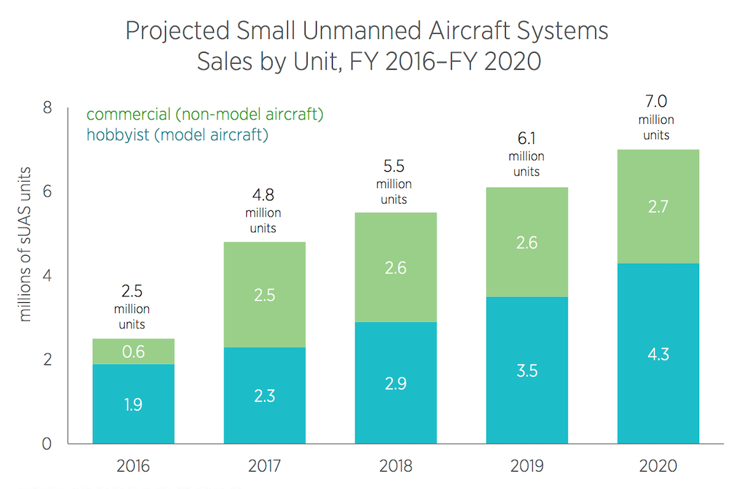
Abroad, the use of drones in construction is a common practice. Construction is one of the fastest growing industries in terms of drone use. The graph below shows drone sales for each year from 2016 to 2020. The change in sales is an incredible 280% between 2016 and 2020.
Figure 1- Projected Small Unmanned Aircraft Systems [3]
With the increasingly rapid development of UAVs, the use of drones for data collection is more than reasonable. This use has become effective not only in terms of time, but also in financial terms. UAV data collection can cope with poorly accessible areas where there may be a danger to a person who would have to take pictures.

History and present of UAV
The first mention of the UAV dates back to the end of the First World War, specifically in 1918. The first ever unmanned aircraft capable of independent flight originated at the request of the US Army and called the "Kettering Bug". This sophisticated predecessor of drones was not used in action but gave the opportunity to ignite a new industry that awaited great future. The origin of Kettering Bug was invented by Charles. F. Kettering, who worked with O. Wright, inventor of the world's first functional aircraft.
Most of the time, development focused on risk-free survey. Because of the long hold in the air and the acquisition of quality photographic material in real time. For all that at the beginning of the 21st Century, development shifted to application in direct combat. Drones at that time mostly developed for military use. However, today the use of drones is extended to the civilian sphere and is experiencing a huge boom around the world.

Distribution of drones
We can distribute drones according to various specifications such as price, size, number of rotors, equipment, stamina, flight capabilities and many more. In this paper the basic division of drones into 3 departments will be presented - according to the planned use in the building industry, according to the technology that will bring UAV into the air and according to the design solution.
Distribution by type of use
Drones can be divided into many categories. However, the basic division is based on the type of use. Different shapes, sizes, and most importantly prices from a few dollars to tens of thousands of dollars. The price is influenced by the quality, the number of components used, the device control software, which is capable of, for example, autonomous flying or can perform complex operations within the flight itself and in data acquisition. Figure 2 shows the basic division.
- Toy drones – these are mostly for amateurs or hobby pilots. These drones often do not have a GPC module that makes it easier for the pilot to maintain direction or height, making piloting considerably more complicated.
- Racing Drones - specific to their dynamics and controlled through the transmission of video to First Person View (FPV) glasses.
- Consumer camera drones – most often used by experienced hobby pilots. These drones can already be used for commercial or experimental activities.
- Prosumer Camera drones – drones capable of capturing very high-resolution photographs that are used for commercial purposes. They are also much more sophisticated and include many autonomous programs.
- Industrial drones – they normally have a camera other than a standard RGB camera. E.g. scanners, sensors, thermal cameras, multispectral cameras and more.
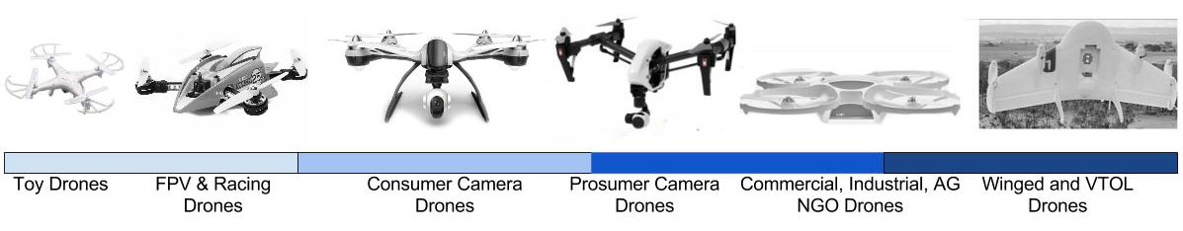
- Winged and VTOL drones – drones designed to map large areas. These machines are very expensive and are used for professional work.
Figure 2 - Basic civilian drone categories [15]

UAV Photogrammetry
Photogrammetry is a scientific discipline that deals with obtaining information (mainly geometric relations) from image records in a contactless way. There are many definitions, but according to Mr. Pavelka, photogrammetry is a science, a method and a technology that deals with obtaining further usable measurements, maps, a digital terrain model and other products that can be obtained from image, mostly photographic material.
Photogrammetry deals with the measurement evaluation of points on the image, where, based on their mutual position, it is possible to derive the shape, size, location of an object in space, mutual spatial position of individual points, evaluate planimetry and altimetry and determine their other properties.
Nowadays, purely digital methods are used thanks to the creation of satellite photogrammetry and laser scanning in connection with digital photogrammetry, the view of three-dimensional documentation of object and space is changing.
Basic distribution of photogrammetry
- The position of the standpoint
- Number and configuration of evaluated images
- Technological way of processing
Distribution according to the standpoint
The standpoint is a point on the earth's surface above which the machine is centered. In photogrammetry, this is the position of the camera relative to the subject during the imaging. Best of all, this way of getting a picture is characterized by the question - Where? There are two types of division according to the opinion, namely ground and aerial photogrammetry.
In ground photogrammetry, the standpoint is usually stationary, placed on the ground. There is a sufficient amount of time to accurately determine the coordinates of the standpoint and the spatial orientation of the image. Ground photogrammetry is suitable for documentation of objects that are approximately the same distance (facades, roofs, etc.)
In aerial photogrammetry, the imaging standpoint is located in a moving aircraft. Therefore, it is difficult to determine the geodetic coordinates of the position of the image at the time of taking it, and therefore the processing must be performed more comprehensively. The images show larger areas than ground photogrammetry.
Distribution according to the configuration of evaluated images
It can be measured using one frame photogrammetry to determine the plane coordinate of the object of solution and not the position of objects. Multiple photogrammetry is used to measure non-planar objects. However, there is a need for two overlapping images, and the object of measurement must be displayed on both images. Then you can calculate the coordinates of the object (X, Y, Z).
Distribution according to technological method of processing
According to the technological method of processing can be further divided into analog, analytical and digital methods. The difference is the method of processing by different devices when inputting different forms of images. For example, with a digital method, all evaluations are performed on a computer.

Photogrammetry successful uses
The question is where to use photogrammetry. If we do not focus only on construction, the following examples can be mentioned:

- Aerial Photography
- Mapping
- Rail Monitoring
- Damage Assessment
- Inventory Management
- Pipeline Inspection
- Stockpile Measurement
- Agricultural
- Sporting Event Coverage
- Construction reporting
- Real estate
- 3D Imaging
- Disaster Response
- Infrastructure Monitoring
- Power Line Inspection
- Surveillance
- Freight Transport
- Movie Productions
- Flare Stack Inspection

Software for creating 3D models using photogrammetry
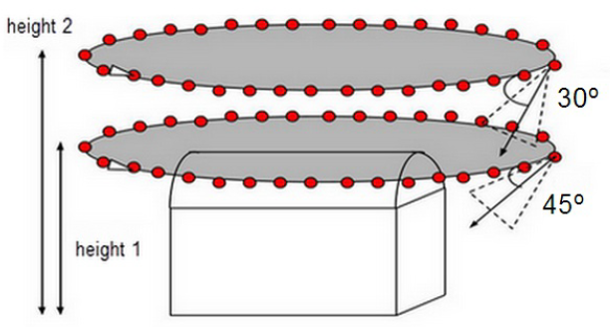
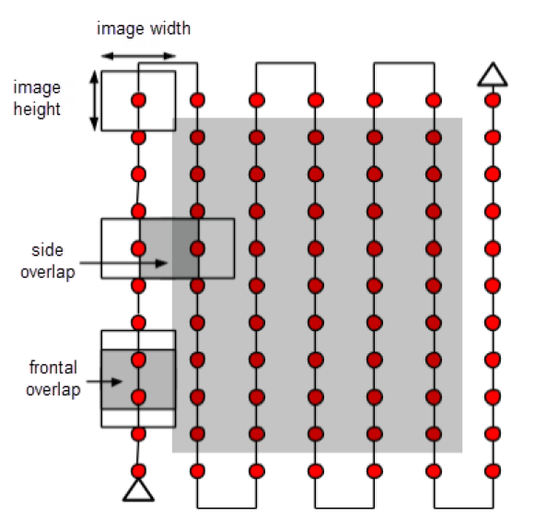
The modeling process is mostly based on SFM - Structure From Motion. This method calculates the location of a point in three-dimensional space using photos of an object captured from multiple angles using photos. Basically, the object is photographed from different angles, from which a set of photographs of a particular object is taken, which is then uploaded to a specialized program. This program calculates the position of common elements in photos and then creates a point in 3D space. A large number of these points are calculated, and a 3D model of the object is created.
Figure 3 - Ideal image acquisition horizontal and vertical plan [10]

Practical use of capturing spatial reality in industries such as construction requires software that can create 3D images with high detail. Currently, the software market offers several dozen. A shortlist will be introduced below.

Software | Automatic modeling | Input data option | Platform
Pix4D | YES | Digital photos | Web, Desktop app
3DF Zephyr | YES | Digital photos, videos | Desktop app
ContextCapture | YES | Digital photos, videos | Desktop app
PhotoScan | YES | Digital photos | Desktop app
Colmap | YES | Digital photos | Desktop app
Autodesk ReCap | YES | Digital photos. Lidar | Desktop app
Figure 5- Examples of selected software for photogrammetry [author]

Methodology of flight mission preparation
The following figure shows the methodology of preparing for a flight mission using the commercial Mavic Pro 2 drone. This methodology was developed on the basis of data collection through controlled interviews with professional UAV pilots. It is therefore a version of best practices from the commercial sphere.
Figure 6 - Scheme of preparation of flight mission by commercial drone [author]
The first step was to determine the required level of detail of the resulting output. On this basis, the exact flight level for data collection was calculated. Of course, there is a percentage of overlapping of frames for data synchronization. Horizontal and vertical scanning was used for the imaging process itself. Based on the collected data it is possible to create a 3D model of the examined object.

Conclusions
The main objective was to present a comprehensive view of the possible use of unmanned aircraft to create 3D models in selected software. The use of UAVs in combination with this photogrammetry software has enormous potential and this potential can be noticed in the market sizing for drones. Thanks to these technologies, specific and accurate data can be provided very quickly from the field. If we focus on construction, working with UAV is very perspective in terms of time savings.
Follow-up research will focus on improving methods for the preparation of flying mission and bring more under stable functionalities to ordinary users. Subsequently, the research will deal directly with scanning the object in a real environment and creating a 3D model according to the outlined methodology.

Acknowledgement details
This work was supported by the Grant Agency of the Czech Technical University in Prague, grant No. SGS19/015/OHK1/1T/11.

References
- TheBoredEngineers. The quadcopter : control the orientation. TheBoredEngineers. [Online] 30. 05 2012. [Accessed 25th October 2019.] http://theboredengineers.com/2012/05/the-quadcopter-basics/.
- Aerospace, Krossblade. History of Quadcopters and other Multirotors. Krossblade. [Online] 2016. [Accessed 25th October 2019.] http://www.krossblade.com/history-of-quadcopters-and-multirotors/.
- Dourado, Eli; OSullivan, Andrea. AA Projections Reflect Deep Uncertainty about the Effect of Regulations on Drone Adoption. Mercatus [Online] 2016. [Accessed 25th October 2019.] https://www.mercatus.org/sites/default/files/Dourado-Drone-Projections-chart-1.png
- Stødle, D.; Borch, N.; Solbø, S.; Storvold, R. High performance visualisation of UAV sensor and image data with raster maps and topography in 3D. Int. J. Image Data Fusion 2014
- Weakley, Lucas. Build your first tricopter. Acknowledgment. [Online] 2015. [Accessed 25th October 2019.] makezine.
- Liang, Oscar. How to choose Motor and Propeller for Quadcopter and Multicopter. quadcopter:. [Online] 10. 10 2013. [Accessed 25th October 2019.] http://blog.oscarliang.net/how-to-choose-motor-and-propeller-for-quadcopter/
- Microdrones. Microdrones products. Microdrones. [Online] 2005. [Accessed 25th October 2019.] https://www.microdrones.com/en/products/.
- Newman, Lily Hay. Border Patrol Drones. Slate. [Online] 06. 01 2015. [Accessed 25th October 2019.] http://www.slate.com/blogs/future_tense/2015/01/06/homeland_security_s_border_patrol_drones_cost_12k_an_hour_to_fly_and_don.html.
- Macdonald, Cheyenne. The drone that will CHASE thieves: Security UAV. Dailymail.[Online]14.12.2015.[ Accessed 27th October 2019. ] http://www.dailymail.co.uk/sciencetech/article-3359624/Drones-CHASE-thieves-Security-UAV-follow-invaders-make-sure-camera.html.
- Pix4D. Products. Pix4D. [Online] 2016. [Accessed 25th October 2019.] https://support.pix4d.com/hc/en-us/articles/204272989-Offline-Getting-Started-and-Manual-pdf
- Autodesk. Autodesk Recap. Autodesk . [Online] 2016. [Accessed 26th October 2019.] https://recap.autodesk.com/.
- Technology. 3DFlow. [Online] 2016. [Accessed 25th October 2019.] http://www.3dflow.net/technology/.
- Polytechnic, Ngee Ann. Basic Movement of a Quadcopter. Flight Theory – Multi-rotor. [Online] Aerospace Electronics. [Accessed 27th October 2019.]

- Commercial Drone Industry Trends. DroneDeploy blog [online]. -: -, 2018, 30.5.2018 [Accessed 25th October 2019]. Available from: https://blog.dronedeploy.com/2018-commercial-drone-industry-trends-70b83e0a2e6f?fbclid=IwAR3Tuvd_2dtEpo1IZaFdIuZj80bGz7MIZh_GysUyEHEvByM8NkqfSVz_UJM
- CRAIGI. 2016 Overview of the Civilian Drone Market. DroneFlyers [online]. -: WordPress, 2018, 11.1.2016 [Accessed 26th October 2019]. Available from: https://www.droneflyers.com/2016-overview-of-the-civilian-drone-market/
- CHAPMAN, Andrew. Types of Drones: Multi-Rotor vs Fixed-Wing vs Single Rotor vs Hybrid VTOL. Australian UAV [online], 2018 [Accessed 26th October 2019]. Available from: https://www.auav.com.au/articles/drone-types/
- HODGKINS, Kelly. Best underwater drones. Digital Trends [online]. 2018, 21.7.2018 [Accessed 26th October 2019]. Available from: https://www.digitaltrends.com/cool-tech/best-underwater-drones/
- Factors Affecting Accuracy in Photogrammetry. PhotoModeler [online]. -: PhotoModeler technologies, 2018 [Accessed 26th October 2019]. Available from: https://www.photomodeler.com/kb/factors_affecting_accuracy_in_photogramm/

