Construction Maeconomics Conference 2019
Methodology of real estate valuation in a whole life cycle context
Josef Kupec
Czech Technical University in Prague, Faculty of Civil Engineering, Thákurova 7, 166 29 Praha 6 – Dejvice, Czech Republic, kupecjos@fsv.cvut.cz

Abstract
Valuations of real estate are widely used in financial and other markets. Valuation methodology is based on the workings of a free market economy. The value can be determined by a single valuation approach or by a combination of multiple approaches. In real estate valuation it is essential to understand the modelling of the economic potential of the property during the life cycle. The combination of theoretical knowledge with valuation practice has been implemented through cooperation with an international audit and consulting company operating on the Czech market.
The aim of the project is to describe the life cycle of real estate from the point of view of the appraiser and identify the key assumption affecting the valuation methodology used for real estate valuation.
The outcome of the project could be used by real estate valuation experts as a guideline for choosing the appropriate valuation approach.

Keywords
Real estate valuation; Life cycle; Valuation methodology; Change in value; Development property valuation

Introduction
During the life cycle of the property there are significant changes in key assumptions which cause a change in the valuation methodology. The valuation standards must be adapted to global conditions, and due to this fact, are usually very general. Property valuation is a subjective matter. Each appraiser may have a different opinion and may use different valuation approach for the property valuation. At present, market value price is mostly valuated by comparison with other similar buildings, cost and yield analysis of the real estate. [1]
According to the International valuation standards [2] there are three basic and generally accepted valuation approaches used for the valuation of real estate; the market (comparative) approach, the income approach and the cost approach. The use of single basic valuation approaches is particularly appropriate for objects that are in accordance with their best and highest use, generating adequate returns or are commonly traded on the market. For the valuation of development property where work on improvements has commenced but is incomplete, the application of single valuation approaches is not sufficient. For the property valuation under construction or refurbishment the residual method is generally used.
One of the most common differences in values between two independent appraisers is caused by the different assessment of key assumptions determining the valuation methodology. The land for construction can mentioned as an example. One appraiser can take into account comparable transactions in the locality and apply for the valuation comparative approach. Another appraiser may see stronger development potential and apply the residual method. Although both appraisers proceeded in accordance with the appropriate valuation standard the difference in values between these valuation methods could be significant. This paper should summarize the best market practice used for the selection of the appropriate valuation methodology.

Valuation approaches
According to IVS 400 Real Property Interest [2] the three basic valuation approaches can be applied for real estate valuation and all of them are based on market principles.
- Market approach – The market approach provides an indication of value by comparing the asset with identical or comparable asset for which price information is available [2]. The principle of comparison is based on the economic concept of substitution that a knowledgeable and prudent person would not pay more for a property than the cost of acquiring an equally satisfactory substitute [3]. The Comparative Transaction Method is generally used for property valuation. This approach to property valuation is based on the comparison of particular and similar properties, which prices were recently realized in the market, which are known. Due to this information, it is possible to individually value the property price. This method is used when at least three realized sales or offers of similar properties are known. The comparative method gives the most accurate picture of realistically viable prices.
- Income approach - The investment method is used to value properties held as investments [3]. During the income approach the valuation is performed based on the capitalization of the potential net income obtained from the rent of the property based on the investment risks relating to the ownership of the property. When this approach is properly applied, it is considered a solid indication of the value of the property for its capacity to produce an income. A valuation approach which involves any valuation method whereby the capital value is found by capitalising or discounting the estimated future income to be derived from the property [4]. One of the most common methods for establishing yield are these: calculation of eternal fixed income (constant yield over a long period of time), yield value established by means of appraisal norm, and calculations for variable yield. [5]
- Cost approach – Valuation model based on costs calculates all current costs which would be needed to re-build the real estate to valuated state, including costs of allotment purchase. [6] The cost approach recognizes that the value of an asset may be represented by the cost to reconstruct or replace it with another of like utility. To the extent that the utility of the asset appraised is less than that of a new asset, the cost new cost be adjusted to reflect appropriate physical depreciation and functional and economic obsolescence. Simply put, the cost approach consists of an estimation of the land value plus the replacement cost of the building in relation to a comparable property [4].
The use of basic valuation approaches is particularly appropriate for objects that are in accordance with their best and highest use, generating adequate returns and are commonly traded on the market. These three basic valuation approaches are supplemented by the additional valuation method defined in IVS 410 Development property [2].
- Residual method - The residual method combines all three basic valuation approaches. The residual method indicates the residual amount after deducting all known or anticipated costs required to complete the development from the anticipated value of the project when completed, after consideration of the risks associated with completion of the project. This is known as the residual value. [3] The residual value, derived from the residual method, may or may not equate to the market value of the development property in its current condition. The residual method is one of the possible methods for the valuation of development projects and is consistent with assumptions reflected in the current market situation.
It is also possible to use Mass Appraisal Models and Automated Valuation Models (AVM) for appraisal of mutually comparable buildings. Several valuation methods have been developed for such purposes, namely direct market models and comparable sales models. [7]
Proper choice of the valuation approach depends on property types, available information and many other assumptions. Market practice will normally indicate the most appropriate valuation method. Based on the experience of the Author all valuation approaches and methods are generally used.

Property life cycle
Every real estate asset, regardless of its purpose of use and size, is going thought development over the time. From the initial idea, planning, construction, use, up to disposal. This development is based on the fact that the lifetime of all buildings and constructions is limited. The limited lifespan is a necessity for renewal. This brings us to the gradual obsolescence of the whole process, which we call the "life cycle". British Standards Institution define the life cycle as consecutive and interlinked stages of the object under consideration [8].
The life cycle of real estate can be divided into the basic stages from the point of view of solved problems. Each stage has its own specificities and activities that characterize it for the part of the life cycle. According to the Royal Institution of Certificated Surveyors (RICS), which are world's leading professional body for qualifications and standards in land, property, infrastructure and construction, the main stages of the life cycle are:
- Land / Greenfield – Generally is considered as the initial stage of the property life cycle. The land´s possible use is usually defined in the zoning plan / masterplan or other document regulating land use. Investors buy real estate in this stage for further development. Within the RICS property lifecycle this stage recognizes the activities undertaken during acquisition or the management of greenfield areas and estates [9].
- Investment - Planning – The subject of this stage is to initiate and define the scope of the future investment intent in one or more variants. As part of the elaborated variant solutions, the feasibility of the project and the financial evaluation of the effectiveness of the individual options are assessed. The main objective of this stage is to evaluate all realization alternatives and to assess the feasibility of the investment project and to provide all background for the investment decision itself. In addition, this planning stage includes the property permitting process. Successful obtainment of zoning and construction permits is an important milestone in the property life cycle. According to RICS it is possible that the design of a building will affect what someone will pay for it and consequently affect its value. This needs to be considered, particularly when making investment decisions [9].
- Investment - Construction – It is at this stage that the contractor is appointed, given access to the site and carries out the work until practical completion. The Construction stage of the property usually starts with the obtainment of the construction permit and with an investment decision. The Construction stage is the period when most of the investment funds are spent. The investment stage ends with the completion of the construction work and the occupation of the property.
- Occupation and Use – This stage is the longest one in the property life cycle. During this stage the property provides a desired yield. The lifetime of the construction and thus the operational stage of the investment can be prolonged by a possible refurbishment. In the case of a larger investment, intervention that contains elements of the previous stages, it is possible to talk about starting a new investment cycle. An example of such an intervention may be a complete reconstruction requiring a new permitting process.
- Demolition / Brownfield – Due to the limited lifetime the property comes into a stage where technical requirements are no longer met or the property´s continued use is not economically viable. The valuation standards do not explicitly hold the appraiser to a value to the level of sustainability addressed in or by the assets being valued. For new property development it is necessary to begin a new investment cycle. The disposal of old buildings and structures is part of the Investment stage of the new investment cycle.
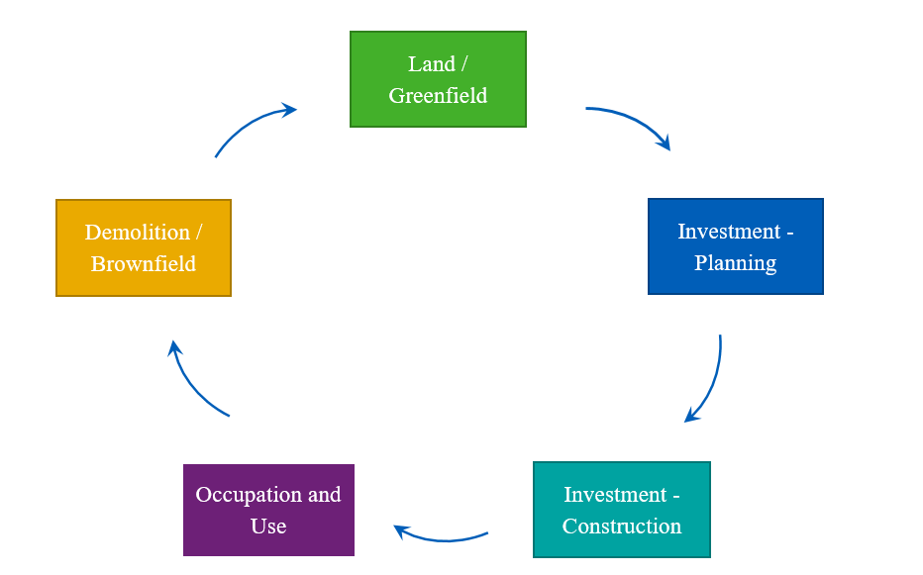
Fig. 1. Property life cycle (source: author)

Valuation methodology in life cycle context
To properly assess the appropriateness of a valuation methodology in its whole life cycle context it is necessary to have a sufficient amount of property valuations and transactions. The internal database of the author is used as a main information source for research.
The internal database includes valuation reports for approx. 300 single properties or property portfolios of different types and locations (mainly Prague and Czech regions but also CEE region). The properties are owned by leading investment groups operating on the Czech market and valued on a regular basis by leading valuation companies in accordance with RICS or IVS valuation standards. The valuation reports are mainly from the years 2015 – 2018. The valuation reports were processed for accounting purposes (fair value) or to support secured lending (market value). The Author´s team is aware of the small differences between Fair value and Market Value of the property however is of the opinion that the impact to valuation methodology is negligible for this research.
Properties with value higher than 1 million € for which the life cycle stage could be clearly identified, and which were valued two years in row (in 2017 and 2018), were selected from the database. In total, 282 individual properties were selected. The selected properties were divided into groups according to their life cycle stage. Subsequently it was investigated which valuation methodology was used for the property valuation. The frequency of valuation methods with respect to life cycle stages is shown in the table below.
Table 1. The frequency of valuation methods with respect to life cycle stages
 | Stage | Income | Comparable | Residual | Multiple methods
 | Land/Greenfield | 0 | 14 | 4 | 2
 | Investment - Planning | 0 | 13 | 13 | 0
 | Investment - Construction | 0 | 0 | 16 | 0
 | Occupation and Use | 146 | 26 | 22 | 18
 | Demolition/Brownfield | 0 | 6 | 2 | 0
Subsequently it was examined what milestone was considered as a trigger of methodology change. Based on the data obtained the life cycle was divided into phases according to the appropriateness of valuation methodology. A detailed description of each phase is given below.
Phase I starts with the live cycle and ends by obtaining of zoning permit. A typical example of such a property is a land intended for construction or brownfield, which is a land use plan for revitalization. The potential of the property has not already been developed. The property does not generate any or very limited income hence the Income approach for property valuation is not applicable. On the publicly available information sources (land register, real estate advertising, press information, etc.), it is often possible to find sufficient information about comparable transactions. Based on this fact the comparative method is the most appropriate. A Property at this phase may have significant potential for development, so the residual method can be used to support the comparative method. However, at this phase the scope of the future project is not precisely defined and the outcome of the permitting process cannot be determined in advance. Considering the sensitivity of the residual method is not suitable as the main valuation method.
Phase II begins with obtaining the zoning permit and ends with the occupation of the completed property. A typical example of such a property is a development property. This is the period when the investment costs are drawn and the value changes rapidly in a relatively short period. A zoning permit is generally considered to be critical in the realization of a development project and clearly defines the intended scope. On the basis of project documentation for zoning proceedings, it is possible to more accurately determine investment costs. Due to the rapid changes in value during construction the only possible method of property valuation in this phase is the residual method. However, it should be noted that the residual method is really sensitive to key inputs. Only small changes in variables such as Estimated rent, Capitalization rate or Construction costs will have a disproportionate effect on the Residual value. The use of a comparative method is also possible until a building permit is obtained and the actual implementation commences. From this milestone the use of a comparison method is already problematic.
Phase III is the longest throughout the life cycle and corresponds to the Occupation and Use stage defined by RICS. Around 75% of the properties in the Internal database are in this phase. The phase begins with the occupation of the completed property and ends with the termination of its use. At this phase, the Property is usually consistent with its best and highest use and generates appropriate income. Valuation methods based on available information about comparable transactions or modeling future income are most commonly used at this Phase. In general, a comparative approach is more appropriate for the valuation of residential properties and an income approach is more appropriate for the valuation of commercial properties such as offices, retail, warehouses, etc. However, in case of sufficient information both valuation approaches can be taken into account.
Phase VI starts after the end of property use period. In this phase, properties are usually in poor technical condition which do not allow other economically interesting uses. If there is a new and better possible use, there is usually a smooth transition between Phase VI and Phase I and the Property begins a new life cycle. The cost of ecological disposal is then part of Phase 1 of the new life cycle. The property in this phase no longer generates sufficient revenue. The valuation approach used for the Property valuation at this phase is practically the identical as in Phase I.
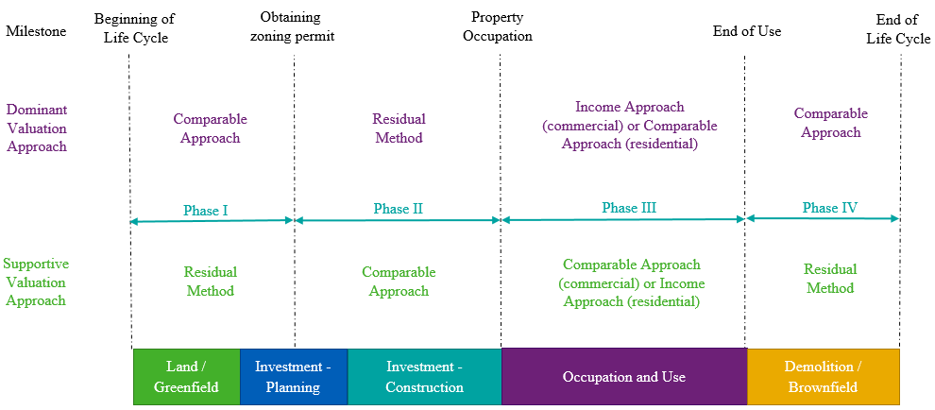
Fig. 2. Appropriateness of valuation methodology in a life cycle context (source: author)
In addition to the valuation reports, the Author´s team collected reports of market research prepared and published by different real estate agents for the Czech Republic. This information mainly relates to the prime yields, prime rents, occupancy level, occupancy level or residential prices. Further, this market research is used as a source for market trends and information of the details of actual transactions on the market. According to the publicly available benchmarks the general year-to-year increase in values on Czech real estate market was 5% -10% [12,13].
Properties with a significant annual difference in value were selected from the surveyed sample. Year-to-year changes (increase or decrease) in value higher than 25% is considered as the significant annual difference. In total 51 properties were identified. The research was focused mainly on properties where the valuation methodology comparing to the prior year was changed due to the progress in the property life cycle. These groups are highlighted in grey.
Table 2. Triggers of significant annual difference in value
Number of properties | Valuation approach used 2017 | Phase 2017 | Valuation approach used 2018 | Phase 2018 | Key trigger of change
13 | Residual | Phase II | Income | Phase III | Progress in development/Occupation and use
7 | Residual | Phase II | Residual | Phase II | Progress in development
6 | Comparable | Phase I | Residual | Phase II | Zoning/construction permit obtainment
6 | Income | Phase III | Income | Phase III | Property refurbishment
4 | Residual | Phase I | Residual | Phase II | Zoning/construction permit obtainment
4 | Income | Phase III | Income | Phase III | New rental contract/significant change in occupation
3 | Comparable | Phase I | Residual | Phase I | Change of valuation methodology
2 | Income | Phase III | Residual | Phase VII | Abandonment /planning of new development
1 | Income | Phase III | Income | Phase III | Change of Appraiser
5 | Diversified |  |  |  | Multiple reasons
The survey shows that approximately 50% of the significant annual changes in value are caused by the progress in the life cycle of the property. Key triggers of the significant change in value in life cycle context are: progress in development, property occupation, zoning/construction permit obtainment and abandonment of the property. Based on this fact, the Author´s team notes that the suitability of valuation methodology regarding the life context has a significant impact on the property valuation.

Conclusion
Real estate valuation is indispensable for investors, banks, auditors and other institutions. Valuation methodology is based on the workings of a free market economy. Proper choice of which valuation approach depends on property types, available information and many other assumptions. Market practice will normally indicate the most appropriate valuation method.
During the property life cycle there are several milestones that can be seen as breaking points which determine appropriate valuation methodology. Achieving these milestones in valuation practice results in a change in valuation methodology. A change in valuation methodology implies a number of new assumptions or key inputs and often leads to a significant change in value. The Author´s team examined the valuation methodology during property life cycles and focused mainly on significant year-to-year changes in value. An internal author´s team database was used as a source of information. The database contains a sufficient number of properties valued on a regular basis. The valuation reports were processed by leading valuation companies in the Czech Republic.
The most significant year-to-year changes in value were caused by the change in valuation methodology due to the progress of real estate to the next phase in the life cycle. For these changes a trigger for a shift in methodology was investigated. The most significant milestones in real estate valuation context are considered progress in development, property occupation, zoning/construction permit obtainment and abandonment of the property. These milestones can be seen as the boundaries that separate the suitability of using valuation methodology over the life cycle.

Acknowledgements
This work was supported by the Grant Agency of the Czech Technical University in Prague, grant No. SGS19/011/OHK1/1T/11.

References
[1] HERALOVA, R. Building's value assessment using the utility and the LCC. CESB 2007 PRAGUE International Conference – Central Europe Towards Sustainable Building. Prague 2007, volume 1, pp. 126-131. ISBN 978-80-903807-8-3.
[2] INTERNATIONAL VALUATION STANDARDS COUNCIL, International valuation standard 2017. EKOPRESS, s.r.o., 2018. ISBN 978-80-87865-44-6.
[3] PETER WYATT, Property Valuation in an economic context, First edition. Blackwell Publishing Ltd, 2007, ISBN 978-1-4051-3045-5
[4] THE EUROPEAN GROUP OF VALUERS ASSOCIATIONS, European valuation standards 2016, eighth edition. TEGoVA 2016. ISBN 978-90-819060-1-2
[5] HLAVINKOVA, V. The market valuation of real estate. Brno University of Technology, 2012, vol. 1, pp. 19-22. ISBN 978-80-214-4568-0.
[6] FRENCH, N. The discounted cash flow model for property valuations: Quarterly in advance cash flows. Oxford Brookes University,
Oxford, United Kingdom. Journal of Property Investment and Finance, volume 31, Issue 6, 2013, pp. 610-614. ISSN 1463578X.
[7] THE APPRAISAL FOUNDATION. Identifying Comparable Properties in Automated Valuation Models for Mass Appraisal. APB
Valuation Advisory, The Appraisal Foundation, Washington, DC, 2013, pp. 1-5.
[8] BRITISH STANDARDS INSTITUTION; ISO 15686-5:2017, Buildings and constructed assets — Service life planning — Part 5: Life-cycle costing
[9] ROYAL INSTITUTION OF CHARTERED SURVEYORS (RICS); Sustainability and the RICS property lifecycle, first edition, June 2009, ISBN 978-1-78321-136-4
[10] BRITISH STANDARDS INSTITUTION; Standardized Method of Life Cycle Costing for Construction Procurement; first edition; ISBN 978-0-580-62662-3
[11] IFRS FOUNDATION, IFRS Standards required 1 January 2018, ISBN 978-1-911040-67-5
[12] CBRE, Czech Republic Property Investment Q4 2017 Snapshot, February 2018, available online at www.cbre.cz/en/research-and-reports
[13] CBRE, Czech Republic Property Investment Q4 2018 Snapshot, February 2019, available online at www.cbre.cz/en/research-and-reports

